Delivering a Hybrid Mobile Application Featuring a Simple Video Game to Facilitate Engagement with and Delivery of Promotional Materials.
By Daniel Cavin
K4782084

Contents
1. Problem Description…………………………………………………………………page 3
2. Account of Related Literature……………………………………………………….page 4
2.1 Games Development……………………………………………………………..page 4
2.2 Application Development………………………………………………………. page 5
2.3 Database Design…………………………………………………………………page 5
2.4 LSEP issues………………………………………………………………………page 6
3. Resources…………………………………………………………………………....page 6
4. Account of Project Work…………………………………………………………….page 8
4.1 Analysis Stage One – Initial Research, Requirements and Ideation……………page 8
4.2 Analysis Stage 2 – Formal Requirements, LSEPI, Planning and Risk…………page 10
4.2.1 Formal Requirements...……………………………………………………….page 10
4.2.2 LSEPI………………………………………………………………………….page 14
4.2.3 Planning and Risk…………………………………………………………….page 15
4.3 Synthesis…………………………………………………………………………..page 17
4.3.1 Game – Prototype 1…………………………………………………………...page 17
4.3.2 Game – Prototype 2……………………………………………………………page 18
4.3.3 Game - Final Version………………………………………………………….page 20
4.3.4 Database……………………………………………………………………….page 21
4.3.5 Application – Prototype Version………………………………………………page 23
4.3.6 Application – Final Build……………………………………………………..page 25
4.4 Evaluation…………………………………………………………………………page 26
4.4.1 Test Method……………………………………………………………………page 26
4.4.2 Test Summary…………………………………………………………………page 32
5 Review of Current Stage of Project Work………………………………………….page 32
6 Review of Project Management……………………………………………………page 33
7 Review of Personal Development………………………………………………….page 34
8 Epilogue……………………………………………………………………………page 36
9 References………………………………………………………………………….page 36
10 Bibliography………………………………………………………………………page 38
Appendices……………………………………………………………………………page 39
1. Problem Description
The aim of this project was to create a hybrid mobile application to help a small café compete with larger fast-food outlets located nearby. The aim was for the application to contain a simple video game allowing users to compete for a daily prize of a free cake and hot drink as well as a yearly grand prize of a £100 voucher for the cafe.
A new office complex is on the verge of completion which will bring an influx of potential new customers to the area. The café, Linda’s Lite Bites, is ideally placed to capitalise on this opportunity as it is the nearest eatery to the complex with several major fast-food restaurants a further 200 yards away. As these competitors have large advertising campaigns, their own loyalty apps, and are featured on other takeaway apps the café is at a disadvantage when it comes to attracting new customers.
The café owner requested a promotional mobile application that she believes will help attract new business by facilitating engagement with prospective customers including potential customers from the new office development. It is hoped this will benefit the business through increased revenue.
The key ICT aspects of the problem were the development of the game, the development of the front-end application through which the game is presented to the user, the back-end application logic and database that provide the functionality of the app and hold the user’s data respectively, and the connecting API’s.
Prior to the start of the project, I had no experience in games development and had to build my skills up from scratch supported by textbooks, online documentation and tutorials.
I had some previous experience with front-end and back-end web development including application logic, UI design and API’s. Throughout the project I gained experience using the React Native framework through examination of the React documentation and textbooks, further supplemented by tutorial articles and videos.
Lastly, I began with previous knowledge of various database solutions, including relational and NoSQL databases, acquired through the Open University module Data Management and Analysis. I used this in conjunction with textbooks, articles and tutorials pertaining to node.js to help develop the backend server.
The solution I aimed to deliver was a React Native hybrid mobile application which initially presents the user with a login screen featuring the company logo as well as promotional information. After signing in the user is taken to the home screen, again featuring promotional information which gives the user the navigation options to play the game, view the menu, or view the leaderboard. A hand drawn design of the various user interface screens is included in the Appendices, as are screenshots of the various application screens of both the prototype and final version.
The game itself is a 2-D platformer featuring obstacles adorned with the café logo in which the player must attempt to avoid said obstacles and collect confectionary items to accumulate points. At the end of the game a random number generator applies a multiplier between 1 and 1000 to the points total ensuring that a combination of skill and luck determines the winner of the daily prize. The unmultiplied score is then added to the players cumulative total meaning the yearly prize is solely skill based. The player’s data is held in a document database server provided via express.js and MongoDB.
The final project output was the full application including the game. The decision on whether to deploy the application and how the application would be hosted was left to the discretion of the client.
2. Account of Related Literature
Literature pertaining to the project falls broadly into four categories, game development, app development, database design and LSEP issues.
2.1 Games Development
The most important early piece of literature in this area of the project was Games Development Lifecycle Guidelines by Rido Ramadan and Yani Widyani (2013), the article features a critique of some known game development procedures culminating in the recommendation of a new lifecycle guideline. The article itself is widely cited and the authors have a combined total of 45 publications.
One of the strengths of the article was the fact it referenced the development of a mobile game using the lifecycle, claiming that the lifecycle “showed that it could successfully create and deliver a good game” (2013) however, it did not relate the development lifecycles critiqued at the beginning of the article to specific games which may have undermined their conclusions.
The development lifecycle posited in the article was perfect for this project as it was well suited to my initial lack of experience, the lifecycle championed a prototyping approach that aimed to deliver the game in functional iterations with each prototype undergoing playtesting to determine the aims of the next stage. This was helpful as it allowed me to build my knowledge of games development up in stages along with each iteration of the game.
Challenges in Requirements Engineering for Mobile Games Development: The Meantime Case Study by Carina Alves, Geber Ramalho and Alexandre Damaceno (2007) was one of the first articles I read before work commenced on the project. The article deals with the process of gathering requirements for mobile games and challenges in the need for mass market appeal among a diverse target audience.
The article introduced me to Games Design Documents and concept art which was very useful in helping me find a starting point for designing my game however, it must be noted that the article was published prior to the mainstream popularity of the iPhone which perhaps lessens its relevance.
The main technical sources of information I have used in producing the game have been the Pixi.js Documentation (2024) which featured helpful guides and tutorials and Learn Pixi.JS by Rex Van der Spuy (2015). The former was my main starting point for learning to code using the Pixi animation framework whereas the latter introduced me to some of the main concepts in games production including canvass, containers and sprite sheets. Both sources are official sources relating to my chosen development framework (Pixi.Js), Rex Van der Spuy is a respected games designer who has worked on games for BBC Bitesize among others. The sources were useful in conjunction with online tutorials in producing my initial game prototype.
Other sources which while not directly helpful were sources of inspiration for design choices included Mobile Games Usability using the idea of Mark Overmars by Farawahida Mohd et al (2016) and Game Design Workshop: A Playcentric Approach to Creating Innovative Games by Tracy Fullarton (2014).

2.2 App Development
I used React Native for Mobile Development by Akshat Paul and Abhishek Nalwaya (2019) as a starting point for learning the React native framework, the textbook is perfect for those new to the framework as the authors assume the reader only has prior knowledge of JavaScript. This was a crucial resource as it introduced me to, concepts such as State and Props as well as Expo which has been an invaluable tool for testing and debugging on a physical device throughout the development.
One issue with the text however is that many of the code fragments are dated and no longer work. To overcome this, I consulted the official React Native (2024) and Expo (2024) documentation which are authoritative sources and contain up to date examples for each area of development using the React Native framework. I also perused many tutorial articles and blogposts to help fill gaps in my understanding of the framework, one particularly helpful article was React Native Webview: A Complete Guide by Kevin Tomas (2022) which was an essential resource for launching my game in the app.
My initial reading on UI design began with Usability Studies on Mobile User Interface Design Patterns: A Systematic Literature Review- Punchoojit, L. & Hongwarittorm, N. (2017), which provided a collation of sources on UI design along with conclusions and recommendations of each source. This led me to Designing Mobile Interfaces by Steven Hoober and Eric Berkman (2011) which provided some useful guidance regarding handling advertising on screen which informed my thinking on how to display the café’s promotional material. Another resource on UI design I found this way was Evaluating One Handed Thumb Tapping on Mobile Touchscreen Devices (Perry, K. and Hourcade, J. 2008), which presented studies on the effectiveness of interface design regarding one handed use. The article informed my thinking on button sizing and placement and its effect on user experience when designing the various app screens.
Finally, Jakob Nielsen’s 10 Usability Heuristics for User Interface Design (2024) was a helpful resource for thinking about all aspects of the applications UI design. The article sets out 10 guidelines for UI design which have remained relevant for 30 years despite huge advances in technology and I referred back to these guidelines numerous times during development.
2.3 Database Design
Seven Databases in Seven Weeks by Redmond, E. and Wilson, J. (2012) served as a starting point for comparing the types of database solution which would be best suited to the project. The book covers seven SQL and NoSQL databases, detailing their various strengths and weaknesses and providing exercises and tutorials for each. I was familiar with this book prior to the project from another Open University module.
Using Node.JS to Build High Speed and Scalable Backend Database Server by Bangare, S et al. (2017) is a short article which covers the basics of building a backend server using node.js, express.js and MongoDB, its lead author is an associate professor of IT, and the article has been cited 63 times.
The text espouses the advantages node.js has over PHP, which was another option I considered for building the server, and also contains example code for configuring API endpoints which were useful in helping me decide to use this database solution.
In addition to the aforementioned article, MongoDB: The Definitive Guide: Powerful and Scalable Data Storage (Bradshaw, S. Brazil, E. Chodorow, K. 2019) was a useful resource in helping develop the backend database. The book was heavily featured in another university module and as such I had a good understanding of its contents; the book contains detailed instructions on constructing MongoDB queries which helped in the construction of API endpoints.
Finally, I referred to the official Express Documentation (2024) at various times throughout development of the database to help with constructing API’s and serving files.
2.4 LEPS Issues
The BCS Code of Conduct (2024) is an essential text in understanding the importance and expected standard of professionalism with regards to IT projects. This text particularly informed my behaviour towards my client in requirements elicitation activities, helping me to ensure I am clear in what I believe I can deliver in the way of project output at all points throughout the project.
UK GDPR Guidelines (2024) is an equally important LEPSI source as it covers the legality of storing user data. Running afoul of these guidelines could have serious consequences for myself and the client, a fact which helped shape the decision making on the data collected from users.
The WACG22 guidelines featured on W3.org (2024) features all of the standard guidelines regarding accessibility requirements for web content. This text highlighted some accessibility issues with the application regarding impaired sight and colour recognition which informed some of the final refinements for the finished application. W3 is an internationally recognised authority.
Finally, Designing Games that Foster Equity and Inclusion: Encouraging Equitable Social Experiences Across Gender and Ethnicity in Online Games (Richard, GT. 2013) introduced me to issues related to representation in gaming which I was able to raise with the client and use as a basis for deciding on the character sprite for the game.
3 Resources
Android Studio – Emulation software used to test the application in an android environment in lieu of physical hardware. Provides a wide array of different devices to download and test, however the memory demands of devices provided by this software restricted the number of devices available to me to one device: the Google Pixel 8.
Chrome Developer Tools – Used as a testing environment for the first two iterations of the game. Essential in helping to device test dynamic screen sizing to ensure the game would work on an array of different devices.
Client – Linda, the owner of the café, was consulted at various stages over the course of the project and helped shape requirements throughout development.
Coolers Colour Contrast Checker – Online resource which provides contrast measurements regarding two selected colours. Used in conjunction with W3 accessibility standards to inform final decisions on font sizes and font/background colour schemes to ensure the final deliverable was accessible to the widest possible range of potential users.
Expo Go (iOS) & iPhone 12 Pro – Development environment and device used to test the application on physical hardware. The environment allows developers to make changes to the codebase on the fly with saved changes appearing almost immediately. Excellent in identifying the source of errors and implementing look and feel changes to the application UI.
Gamedev.land – Gamedev.land is a website for games developers to share their projects and knowledge with the wider community. Everything on the site is free and readily available. There is a section on Pixi.js, containing several tutorials which were invaluable in helping to produce my prototype game as they provided practical examples which supplemented the material featured in the Pixi.js textbook and documentation.
Github – Online code repository used for software version control. Used primarily as a secure back up for the project code base.
Kenney.nl – Kenney.nl is an online resource which provides various games development assets including full sprite sheets featuring various types of sprites and tile sets. Most of the assets on the site are free to download and are licenced under the creative commons CC01 deed which states that the work has been committed to the public domain and as such I can “copy, modify, distribute and perform the work, even for commercial purposes, all without asking permission” (2024). Sprites from this resource were used at every stage of the game’s development process including the final build.
MongoDB – MongoDB is a document database which is open source and which I have recent experience working with. Using a document database allowed me to store user data without defining a relational schema which would require extra effort and is unnecessary due to the small amount of data held on each user (name, email, username, password, scores). Schema-less databases also make it easier to store additional data at a later date should functionality be added which changes the data model (Redmond, E. Wilson, J. 2012).
Node.js – Node.js is an open-source JavaScript runtime environment which is popular for developing backend servers. The database server for the application was built using node.js in conjunction with the Express.js framework.
StackOverflow – Online forum for posting questions regarding coding issues allowing members of the community to help identify problems and suggest solutions. An essential resource for resolving coding issues with React native. Specifically, this resource helped resolve problems with logging players scores and displaying the competition winner on the application home page.
Testers – I utilised friends and family members to help with testing. Those selected cover a wide variety of demographics as the target users of the app are café customers and not necessarily gamers. Testers contributed feedback for the game three times during the project and also took part in usability testing at the end of the development process.
Visual Studio Code – Served as the IDE for all parts of the development.
YouTube – Source of tutorial videos which helped greatly in building my understanding of several areas of development for both the game and React application. This resource especially helped with understanding react native concepts and components, building custom components, and setting up the database server.
Piksel* - Piksel is a free sprite editing program made provided via their website and is readily available to use. The aim was to use Piksel to create original sprite animations of the main characters shown in the Games Design Document.
CT.JS* - 2-d game engine with integrated code editor and visual tools featuring language support for Javascript and Typescript. Was intended to be the development environment for building the game.
(*resources with an asterisk were used early in the project but did not feature in the final product)
4. Account of Project Work
4.1 Analysis Stage One – Initial Research, Requirements and Ideation
The analysis of the aims of the project began with a brief informal requirement gathering conversation between myself and the client. The client expressed their desire to create a loyalty app for their café which would feature a contest for a daily free giveaway, the application would also allow the client to convey promotional messaging regarding the cafés products and would also grant users access to the menu. The form of the contest was not discussed in detail however the word ‘game’ was used several times in the conversation.
After the meeting I began to research possible solutions. Having no experience in games development I initially considered suggesting a quiz for the contest element as I thought this may be simple to implement. Ultimately, I decided this could be a backup strategy and began looking at literature relating to the game development process. One of the articles I found introduced me to Games Development Documents and showed examples of concept art (Figure 1, below). The article also featured a section on ‘Idea Generation’ which suggested using an existing game mechanic as a starting point for developing an idea, coming up with a concept surrounding the mechanic and seeking feedback from gaming enthusiasts, refining the idea into the finished concept (Alves C, Ramalho G and Damasceno A. 2007). After reading this article I began brainstorming ideas and produced the first sketches for what would become the game concept, running the ideas past family and friends before settling on the concept. I then began producing a games design document (Appendix A) and scheduled a formal meeting with the client.
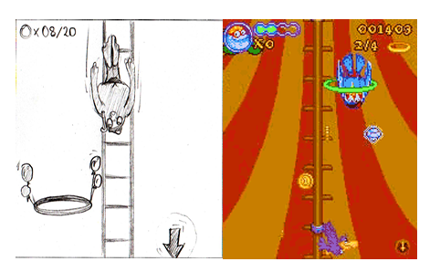
Figure 1 - Concept art example (Alves C, Ramalho G and Damasceno A. 2007)
I presented my concept for the game to the client, which was well received. I explained that I would need to acquire skills necessary to produce the game which may prove to be a significant obstacle to success and that an alternative would be to use a quiz format for the contest, but the client liked that the concept I produced was tailored thematically to her business and preferred that I attempt to implement the game this way. We then had a detailed discussion regarding what a complete solution may look like, several important aspects of a potential solution came to the fore during this discussion.
Firstly, it was decided that the contest could not be purely skill based to prevent it from being dominated by a small number of users as the client thought it might discourage some users from playing. It was decided that a bonus system should be included to achieve this and the implementation of this would be at my discretion, it was also decided that a yearly prize would be included to act as an added incentive to the more skilled players.
Secondly, the client wanted the app to be available to both Android and iPhone users to maximise the number of potential users meaning that a hybrid framework would need to be utilised for the development.
Lastly, the issue of how the application would be deployed was discussed in depth. I explained to the client that the application could be hosted via a cloud provider but that the cost of these services can be difficult to quantify until the number of users is known and is also dependent on the number of data transactions committed which meant it could be difficult to estimate the cost of this solution in the early stages of the project. I further explained that hosting the application on premises using physical hardware would require running hardware around the clock which depending on energy prices could be more costly. Also, should the hosting device suffer a failure the application would be unavailable until the device is restored whereas cloud solutions offer protection against this scenario.
Ultimately, the client decided to delay the decision on how the application would be deployed until after the delivery of the application and therefore this would not be part of the project meaning the scope of the project output included the application, database server, API’s and game only.
During this conversation we took the first step towards documenting formal requirements by producing user stories shown below in table 1. The reason I chose to produce user stories at this stage was to begin to form the basis of acceptance criteria for the project output.

User Stories
- As a player I want to play my daily attempt to compete for the daily prize.
- As a player I want to check my cumulative score to see my position on the leaderboard.
- As a player I want the opportunity to practice the game to improve my skills.
- As a café customer I want to peruse the menu to help me decide on an order.
Table 1 - User Stories
At this stage, on the advice of my tutor, I decided on a lifecycle model for the project. I chose to treat the application and game as two separate projects to be completed sequentially, with a final phase of the project dedicated to integrating the game and app. I had previously identified a games development lifecycle in my preliminary reading which I believed was well suited to my lack of experience going into the project. The model uses a prototyping and iterative refinement approach shown in the diagram below:
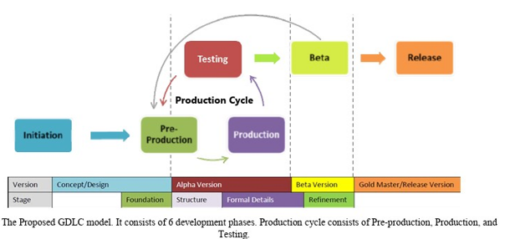
Figure 2 - Games Development Lifecycle (Ramadan & Widyani, 2013)
For the application I decided to use an Agile approach because at the time I believed the type and number of functions required of the application were limited and therefore well suited to an approach light on documentation. A basic project work plan was drawn up shown in Appendix K.
4.2 Analysis Stage 2 – Formal Requirements, LSEPI, Planning and Risk
4.2.1 Formal Requirements
Work on the project began immediately after the initial meeting with the client however, progress on the game prototype was much slower than I had initially expected. The first prototype was still incomplete when work on the second was scheduled to start. This prompted me to seek the advice of my tutor who suggested that I review my lifecycle and project plan, and also formally capture the projects requirements in the form of a Volere template.
I changed the lifecycle model I had chosen for the application, pivoting to a two-stage iterative model with the aim of producing a functional prototype application with the prototype game used for integration, followed by a refined final version. This also meant switching from tackling the game and application sequentially to treating them as a single project although I retained the prototyping and playtesting cycle posited by Ramadan and Widyani’s for the development of the game (2013).
After a period of around two months, I scheduled a meeting with the client to present my early design decisions for the application UI (Appendix C); and to show the first prototype of the game (figure2 below). The initial version of the game had some functional issues regarding screen sizing and collision detection; however, it did serve to allow the client an early look at the type of game I was attempting to produce. The client was encouraged by the game prototype and decided I should forge ahead with this concept.

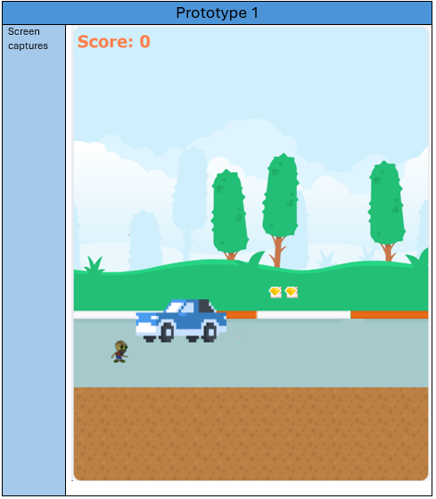
Figure 3 - Game Prototype Screenshot
I presented my Volere template (table 2) to the client, the contents of which the client agreed were appropriate and we added further user stories to the original list to complete the acceptance criteria. These were used throughout the rest of development to ensure all necessary functionality was included and was also amended in response to issues encountered. The final version and full list of user stories with amendments highlighted in bold is featured in Appendix D.

Volere Template
- Purpose of the Project
Background - Lindas Lite Bites is a small café competing for business with major fast-food chain outlets. The owner would like to commission a dedicated mobile application to promote the café.
The owner plans to capitalise on the influx of potential customers provided by a local office development project which is close to completion in close proximity to the café. The plan is to use the application as a promotional tool to draw customers to the business.
Goals -The aim of the project is to deliver a hybrid mobile application featuring a simple, points driven game which allows users the opportunity to win a daily prize of a free drink and cake. The application will also allow the user to peruse the café menu.
The idea is to encourage users to play before lunchtime each day for a chance to win a daily prize, as well as competing in an overarching yearly competition. In using the app they will be exposed to promotional materials which is hoped will drive sales. The menu availability on the app will help facilitate large orders which can be placed over the phone for collection.
Independent of the prize element the game should, through gameplay and design, encourage players to play each day.
- Stakeholders
The Client - The owner of the business, involved in requirements process and eventual determinant of project success.
Users – The two user roles are player and customer although in most cases the roles will overlap.
Employees- The employees of the café. Will benefit from increased business.
The developer – me.
Testers – Friends and family and potential customers of the café, involved in refining the game through prototyping.
- Mandated Constraints
The application must be ready by mid-August 2024.
The system must be available for iOS and Android users.
The application should require no day-to-day maintenance and minimal maintenance overall. The client should be able to simply add or remove promotional messaging.
The application shall ensure the winner of each day’s prize is decided partly at random using a score multiplier.
- Naming conventions
None at present
- Relevant facts and assumptions
Deployment of the finished product will be at the discretion of the client.
- Scope of the Work
The application will be developed for a café with one location.
- Business Data Model and Data Dictionary
Not yet considered.
- Scope of the Product
The product will be aimed at customers of the café, each user shall through interacting with the application UI:
- Access the café menu.
- View their place on the yearly scoreboard.
- Play the game/Practice the game.
- Functional Requirements
The application shall:
- FR1 - Register users.
- FR2 - Register users scores.
- FR3 - Apply arbitrary multiplier to daily scores.
- FR4 - Display daily scores.
- FR5 - Display Menu.
- FR6 - Display promotional messages.
- Non-functional Requirements
Look and Feel
- LF1 - The application UI should be colour coordinated to match the café signage.
- LF2 – The application UI should be simple with minimal buttons.
- LF3 – The game scenery should be based on the café storefront.
- LF4 – The game should have a retro feel to match the gameplay type, characters and art should have 90’s aesthetic.
Usability and Humanity Requirements
- U1 – The application should be simple to navigate.
- U2 – The game controls should be simple and intuitive.
Performance Requirements
- P1 – Each screen shall load within 2 seconds.
- P2 – The game shall load within 2 seconds.
- P3 – The game shall run at a consistent frame rate.
- P4 – The game shall respond immediately to user input.
- P5 – The game shall be available to play/practice offline.
- P6 – The game score shall register immediately after the days playthrough.
Operational Requirements
- O1 – The system shall operate on iOS and Android mobile devices.
Maintainability Requirements
- M1 – The system shall allow simple updating of promotional materials.
- M2 – The maintenance of scores and daily prizes shall occur automatically.
Security Requirements
- S1 – Only the client can access and change promotional materials.
- S2 – The only details held on each user will be a username and email address, which should be securely managed.
- S3 – Each user can register one account; one email address can be linked to one and only one account.
Cultural Requirements
- C1 – The application shall promote Linda’s Lite Bites as a friendly, happy establishment. The client shall also be portrayed in the game as friendly and happy.
Legal requirements
- The application shall hold email addresses only to verify that each user has a single account, no other data shall be held on each user without the user’s permission.
Table 2 - Volere Template version 1
4.2.2 LSEPI
During the meeting I also discussed issues with the client relating to legal, social, professional and ethical concerns. I explained in brief the data protection rules in the UK and the potential consequences should data provided by users become compromised. I also explained what I had read regarding competition law and how it was important to ensure any competition offered by the application could not be construed as gambling.
The client and I agreed that only minimal data should be held on users because it was never the intention to gather data to be used for other purposes. This way the risk of a data breach would not include the disclosure of sensitive personal information which can cause serious legal repercussions (GDPR, 2024).
It was decided at this point that the yearly prize should be a £100 voucher to be spent in the café as this removed any legal concerns regarding whether the competition element may be considered gambling (Boyce, C. 2024).
Lastly, we discussed issues of representation in video games and the importance and potential benefits to promoting diversity where possible. It was decided that the character sprite used in the prototype which depicted a mixed-race individual would be retained to make the final product more diverse and inclusive. Previous to this it was my intention to replace with a custom sprite matching the early concept art,

4.2.3 Planning and Risk
In response to early feedback from my tutor I produced a full risk assessment and formal project plan. This consisted of a financial risk assessment and a qualitative risk assessment of the remaining major tasks still to be completed. The full financial risk assessment and an excerpt from the qualitative risk assessment are shown below in tables 3 and 4 respectively, the full risk assessment featuring updates in bold is available in the Appendix E.

Financial Risk Assessment
The financial cost of the failure of individual project subtasks is not quantifiable as the project is being delivered using free resources. The project as a whole however represents potential monetary gain for the client and therefore can be quantified as potential gain should the project be successful:
- Client hopes that with the help of the app, the new offices could bring 100-300 additional transactions per week. An average of £5 per transaction would represent roughly £25k- £75k per year in revenue.

- Around 12% of sales revenue are profits making the potential profit generated by the application £3k-£9k annually.

- Linda has estimated the cost price of the daily prize at around £2, roughly £720 per year assuming all prizes are claimed.

- If the project is successful and the client decides to deploy the application, the estimated cost of running the application on physical hardware based on the current average electricity price would be approximately £1,073.10 (Sust-It, 2024).

This means the potential yearly profit increase generated through a successful project would be approximately between £1,636 - £7,636.

*It may be cheaper to deploy the application using cloud services however deployment is outside the project remit, the above is an estimation for illustrative purposes.
Table 3 - Financial Risk Assessment
Major Task Risk Assessment Table
Project Task | Risk Level | Explanation | Action Taken
Produce Second Game Prototype | Medium | Games Development was initially the highest risk task, having produced the first prototype there is now a platform to progress lowering the risk factor.  The technology used (Pixi.js) is now in version 8 and so is well established as a viable technology.  There is some essential functionality which was not achieved in the first prototype meaning there is still a level of risk | Next scheduled task, giving more time to address issues that may arise.
Produce React Native Application | Medium | As with the technology used to produce the game React is a well-established framework making this a low-risk technology.  My time working with React is limited so there is a possibility that lack of experience will lead to delays completing this task. | I have changed the development model from an agile approach to an iterative model and have moved the task forward in the schedule to begin immediately. The idea is to attempt to build a basic functioning version of the application. Using the first game prototype I can experiment with integrating the game and the app during the development process, incorporating a high-risk task rather than leaving it until the end of the project as I had initially intended.
Table 4 - Excerpt from Qualitative Risk Assessment
The Gannt chart below shows the schedule for the tasks identified in the qualitative risk assessment. Anticipating delays and the possible identification of additional subtasks, the schedule ran until the end of July leaving August free to cover any remaining work. A further Gantt chart was later produced detailing the schedule for August and is available in Appendix E.

Figure 4 – Project Schedule
4.3 Synthesis
4.3.1 Game – Prototype 1
The first task in developing a solution for the game was choosing a game engine, I limited the engines under consideration to JavaScript based engines as my previous experience with that language lessened the learning curve. Several engines were considered, the final choice was between Phaser and Pixi.JS. I chose the latter for two main reasons, firstly, it is suited to 2-D animation and secondly Phaser has poor support for mobile development (Eseme S, 2022).
In order to test Pixi I followed along several tutorials on the Pixi.js official website (2024) as well as tutorials demonstrating how to build a simple platform game (GameDevLand, 2024), the latter showed me a how to produce a scrolling background, moving obstacles and collision detection. From here I sourced sprite assets to produce my first prototype, the assets used in the video tutorial were taken from the resource Kenney.nl (2024), which featured assets free to use under the creative commons license and I was able to find suitable sprites here.
Using what I had learned I produced a prototype which featured a character sprite, moving vehicles as obstacles, and collectable items tied to the containers holding the vehicle sprites. Images of the prototype are featured in the GDD (Appendix A).
The first prototype featured several significant issues to be resolved including broken item collection and inconsistent behaviour depending on screen size causing separation between the background and game platform. This meant that the game only worked on some devices however, the core game mechanics were present namely the character sprite jumped in response to clicks and moved when colliding with the vehicle sprites.

4.3.2 Game – Prototype 2
After playtesting prototype 1 work began on the second prototype. The main focus of this phase was to correct the collision and screen issues and to implement the game ending which would be triggered when the character sprite was knocked out of the screen.
The collision issue was solved using console.log messages to track the source of the issue which turned out to be a trivial coding mistake in the Game class which meant the collect functions were never called. After remedying this a new issue arose regarding multiple functions calls occurring when a single object was collected. The effects of this were ameliorated by adding a preceding if statement that pre-checked collisions to the collect function calls however on occasion the problem persists. I concluded that since the problem was now sporadic it may be caused by multiple identical sprites positioned in the same place.
The screen sizing issue was a result of using a base platform with a set position and physics enabled and setting this against the background container which held the vehicle and item sprites. This was leading to a gap between the two elements on some screens.
Figure 5 shows a code snippet added to the game class which uses the window property of the host device to set the position of the base platform.
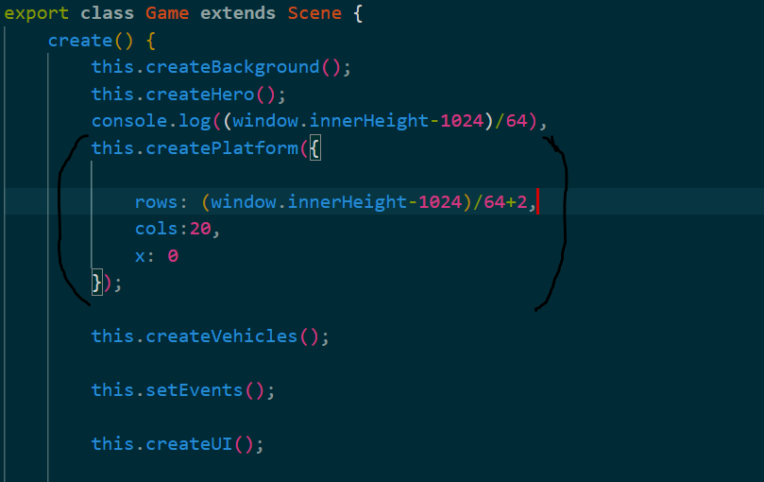
Figure 5 - Dynamic Screen Sizing

Using the window.innerheight device property and extending the number of columns to an amount capable of filling the rest of any screen with ground tiles I was able to produce the result shown in Figure 6.
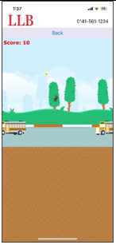
Figure 6 - Screen Sizing using Window.innerheight
I tested this solution using the Edge Developer tools, cycling through all of the available device types, I found that the solution worked on all but three of the devices offered (Microsoft Lumia 550, Nesthub & Nesthub Max). The extra ground tiles stretching to the bottom of the device screen was not an optimal solution however as this was a minor aesthetic complaint I decided to move on and return to this later if possible.
The final feature added during the second prototype development was the game over screen class, which shows the players score on screen as well as the bonus multiplier and multiplied score (see Appendix A). The game over sequence is initiated by the Hero class alerting the Game class when the character sprite is knocked off screen. The score is then displayed on screen to the player and also logged to the console.
As I now had a basic fully working version of game I moved on to playtesting and shifted focus to completing the development the hybrid application using this prototype version for integration attempts.
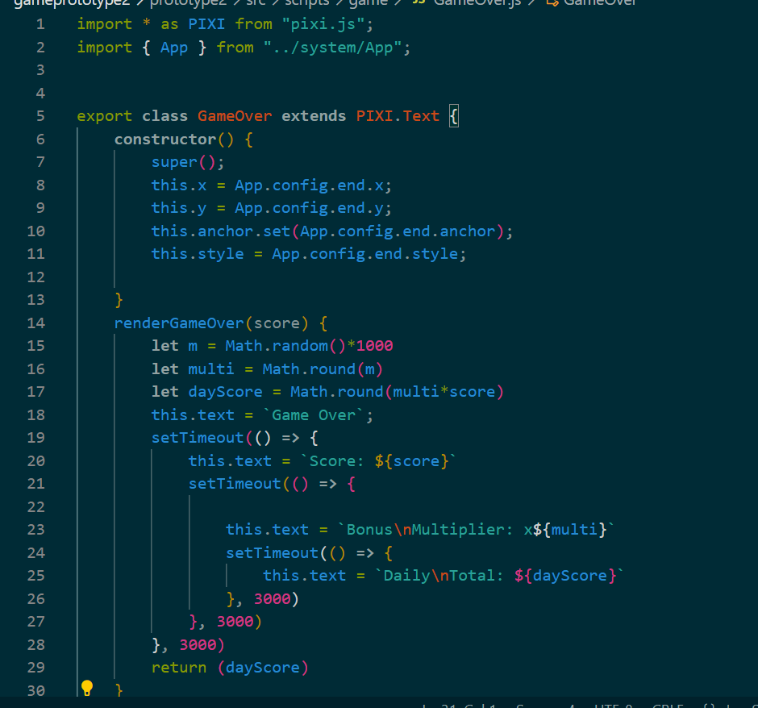
Figure 7 - Game Over Class
4.3.3 Game - Final Version
Work on the final version of the game was unfortunately delayed significantly due mainly to issues with integrating prototype 2 with the application. This meant that some intended features had to be left out, including adding further obstacles and background features, and adding an ending animation depicting the café and the client.
The eventual integration solution produced performance issues which slowed the gameplay making it too easy, this became the focus of much of the changes for the final version. Vehicle sprites were removed to reduce the file size of the game leaving only the truck sprite while the rate of movement of the vehicle sprites was drastically increased. To account for the new vehicle speed, changes were made to the jump mechanic switching from a double jump to a single jump between landings, item positioning also had to be amended to account for the jump changes.
A version of the abbreviated café logo was added to the truck sprites in lieu of the ending animation to ensure the company featured in the game.
Finally, after consulting with the most recent accessibility standards regarding text, the colour contrast of the score and game over text was found to be around 3.1* (coolers.co, 2024) which was close to the minimum contrast level for large text (W3, 2024). Accordingly, the text colour was changed to black giving a colour contrast of around 14. Figure 8 below shows a screenshot from the final game reflecting the aforementioned changes, further details and screenshots are in the GDD (Appendix A).
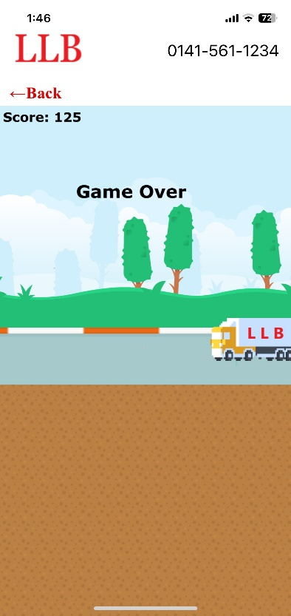
Figure 8 - Final Game Version Screenshot
*exact hex colour values tested #E71313 and #BFD7EB
4.3.4 Database
The decision was made early on in the project to use node.js and MongoDB to construct the database server, as node.js is a JavaScript based framework which performs up to twice as fast as PHP and 6 times faster than Python, and interfaces well with MongoDB (Bangare, S. et al. 2013).
I had acquired experience with MongoDB prior to starting work on the project so was confident constructing MongoDB database queries and, aside from the performance benefits, I felt my existing knowledge of JavaScript would make node easier to work with than PHP.
Work on the database began in conjunction with work on the app screens and was continually updated as new screen components and their related functions were developed.
Using documentation and tutorials (The Debug Arena, 2024) I was initially able to create and connect to a basic server and create a MongoDB collection and data model definition shown in the table below.

User Data Schema
Name | String
Username | String (unique)
Email | String (unique)
Cumulative score | Integer
Daily score | Integer
Played | Boolean
Table 5 – Data Model Definition
Using this basic set up I implemented the login and register screens and with help from the aforementioned tutorials I was also able to add JWT token authentication for secure login and to hide password details in the database. I also constructed an API endpoint to facilitate the score information requested by the leaderboard screen.
The Boolean value in the table above was not initially included in the schema, this was added later as part of logging the players scores. The Boolean value is set to false each day and when the player plays their first game of the day the API call to log the scores checks that the value is false before updating the database and setting the value to true.
The final phase of constructing the server was to schedule various changes to occur at specific times. My initial attempts involved creating and updating a Date object on the application side that would trigger an API call to the database at the appropriate time however this slowed the applications performance to an unacceptable level. After some research I found a tutorial article explaining how to schedule tasks using the node-cron dependency (Nwamba, C. 2021).
With this I was able to schedule the winner details to be set at 11am allowing plenty of time for the competition winners to collect their prize before the close of business at 6pm. Two other tasks were scheduled at 6pm, one to reset the winner details and one to reset the daily_score parameter of each user document in the database. An example is shown in the code snippet below.
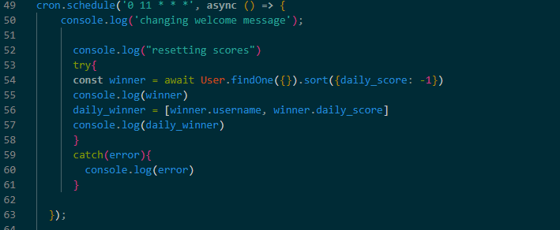
Figure 9 - Retrieving the Winners name and score

4.3.5 Application – Prototype Version
My experience in web development prior to the project was with the Cordova hybrid framework however, after some research I found that ongoing support for the framework ended several years ago (Eom, J. 2021). For this reason, I opted to use a different hybrid framework to prolong the life of the project output. Several were considered however I settled on React Native as the Pixi.JS documentation featured a section dedicated to React Native indicating compatibility between the technologies (Pixi.JS 2024).
After some initial reading and react tutorials (Codevolution, 2023), I started work trying to create the first version of the app in keeping with my initial UI Sketches shown in Appendix C. I first produced an activity diagram to model how the flow of communication between the user and the application screens should work and began working through the components.
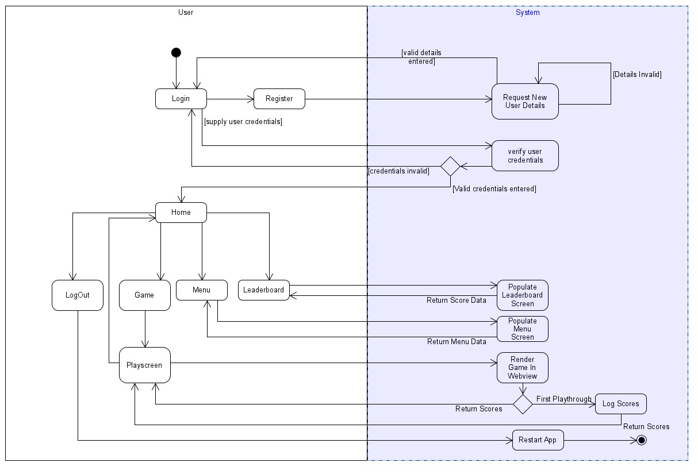
Figure 10 - Activity Diagram for Hybrid App

The original UI design (Appendix C) was comprised of 6 screens with an implied 7th screen delivering the game. The button dimensions on each screen are maximised laterally for ease of use as larger target sizes improve user accuracy (Perry, K.and Hourcade, J.P. 2008) the purpose of which was to improve the experience of average users and improve accessibility for impaired users. The UI required no special navigation elements like hidden tabs or toolbars, screen navigation was achieved with a simple stack navigator. Back buttons are available on every screen and are located in the top left corner similar to Gmail and YouTube. Screens are also simple and uncluttered. These design elements were inspired by Nielsen’s heuristic principles 3, 4 and 8 which espouse ease of control, consistency and minimalism respectively (2024).
The login and register screens were simple screens featuring the café logo and a form to capture the user details, with promotional information displayed at the bottom of each screen.
The home screen featured the café logo, three navigation buttons and some promotional info. In the prototype the users score stats were featured at the top of the screen as a placeholder for what would be the competition winners’ details in the final build.
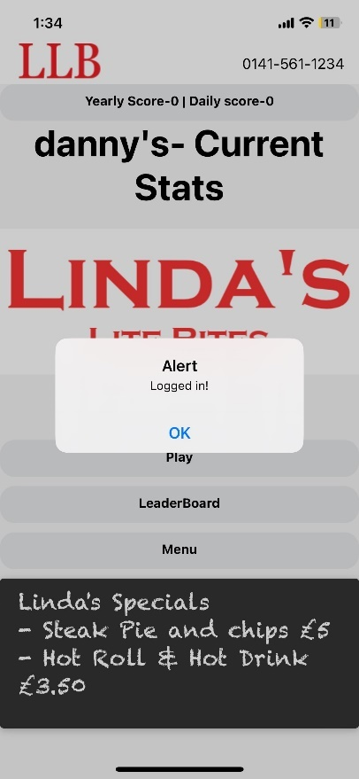
Figure 11 - Prototype Home Screen
The leaderboard and menu data are rendered on screen using a flat list and section list components respectively. The menu screen was developed with the data held in a JSON file in the Application folder to allow users to view the menu offline, while the leaderboard data was stored in a document database on the backend server and rendered in order of highest score.
The Game screen featured a title image for the game and a play button taking the user to the game which was delivered by rendering a Webview component on screen, essentially an in-app browser. Significant effort was expended trying to run the game file in the Webview from the application folder as it was stated in the initial requirements template that the game be available to practice offline. Unfortunately, I was unable to find a working solution and after consulting with the client this requirement was scrapped, with the game being hosted on the backend server.
Logging the scores to the database was the final stage of the prototypes development. This was achieved by including a call to log the scores in the console in the Game Over component of the game. Scraping the console data from the Webview on the application side was challenging, eventually I was able to locate some custom code on StackOverflow for logging console messages from the React Native Webview and I was able to add my own code to this snippet which cast the console data to an array variable. I then added a call to log the scores on the database using the data in this array along with the users’ details which were collected at login and accessed via prop drilling.
4.3.6 Application – Final Build
For the final version of the app, several key features required implementation: utilising the phone API, displaying the winner’s information, logout and password retrieval. Unfortunately, password retrieval proved to be too difficult to achieve due to the time constraints of the project. Connecting the app to the phone API to facilitate calls using the phone number button in the header proved to be trivial using the React Native component, ‘Linking’ as shown in the figure below.
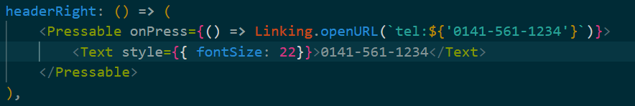
Figure 12 - Linking Telephone Number
Displaying the winners’ details was the most challenging aspect of the final development phase. Due to time constraints, I was unable to implement this feature as completely as I’d hoped. The plan was to send an alert to the winning user as well as displaying the scores however I was only able to achieve the latter.
Displaying the winner was accomplished by scheduling an event in the backend server to query the database and set the username and score of the highest daily scorer to an array variable, whose values were initially set to strings of question marks. On the application side, a call is made to the backend to grab the array using the ‘useEffect’ hook and this is then added to the text component at the top of the screen when the screen renders.
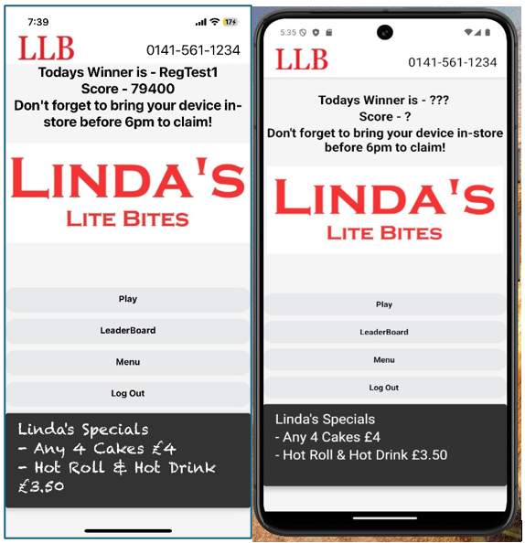
Figure 13 - Winner Display (iOS left, Android right)
Initially, this solution was insufficient as the score props were not coming through in time before the screen rendered which was causing an error when the screen component tried to access the props. I could see no reference to this behaviour in the react documentation however I eventually came across a similar problem on stack overflow. The solution I found used an ‘if’ statement to check if the data had come through and if not, the screen returned empty meaning that the screen would only render as normal once the data was retrieved. This delay is imperceptible to the user as the delay in retrieving the data is only fractions of a second.
The logout feature was implemented simply by making a call to reload the application when the logout button is pressed, this takes the user back to the login screen with the input fields empty.
One of the final tasks was to add an explanation of how the game is played and scored to the play screen. As I was not able to include an alert to the winning user, I included an explanation of when the winner is chosen and how they are displayed, ensuring users are aware that they have to log back into the app after 11am to check if they have won the prize. This solution had the dual benefit of being much simpler to implement and to encourage the users to log in again at lunchtime, further driving engagement with the app’s promotional material.
As was the case with the game, I checked the contrast of all on screen text and amended any colour schemes and font sizes that did not meet the WACG2 accessibility standards (w3.org 2024). This required some platform specific code to be added to ensure font sizes were maximised for both iOS and Android as some of the font sizes had to be made slightly smaller to fit on the screen of Android users.
4.4 Evaluation
4.4.1 Test Method
Testing of the application was conducted at the end of the project and took the form of system and usability tests. The table structure of the tests was derived from the OU Software Engineering block 3 textbook (2022). The system tests were written and conducted by me and were designed around typical use cases for the app, first focusing on the main success scenario before testing deviations from that scenario.
The two tables below show the definition and results one of the system tests performed post-development, the structure of the test cases. The full range of system tests is included in Appendix J
Identifier and Name | UC1 – Register new user
Initiator | New User
Goal | New users’ details are saved in the database
Preconditions | None
Post Condition | A new document will be added to the MongoDB ‘users’ collection containing valid details for the fields, name, username, email, password
Assumptions | The user will be using a mobile device to access the application and register the details. The new user will have no guidance in the registration process
Main Success Scenario
- User presses the sign-up button and is taken to the registration screen
- User inputs valid values into the fields required
- User presses the register button and receives an alert confirming the registration is successful
- User is navigated to the login screen
- Details registered are used to login and login is successful
Extensions
3.a.1. Name is already on record – registration successful
3.b.1. Username is already on record – registration rebuked
3.c.1. Email address is already on record – registration rebuked
3.d.1. Email address invalid – registration rebuked
Table 6 – Example System Test Definition

Test No. | Scenario | Test Data | Expected Result | Actual Result | Test Outcome | Comments
UC1-1 | Main Success Scenario | Name: Reg Test  email: regtest1@gmail.com  Username: RegTest1  Password:  regtestpassword1 | - User will be navigated to the login page  -User will receive alert that registration was successful  -MongoDb cluster will contain a new document containing test data  - username and password will facilitate login | -Alert and navigation to login page occurred immediately  -MongoDB document added to the database  -Login with test data successful | Pass | None
UC1-2 | Name already on record | Name: Reg Test  email: regtest2@gmail.com  Username: RegTest2  Password:  regtestpassword2 | - User will be renavigated to the login page  -User will receive alert that registration was successful  -MongoDb cluster will contain a new document containing test data  - username and password will facilitate login | -Alert and navigation to login page occurred immediately  -MongoDB document added to the database  -Login with test data successful | Pass | This is the expected result as the name field refers to an actual person’s name which could easily be duplicated eg. John Smith
UC1-3 | Username already on record | Name: Reg Test3  email: regtest3@gmail.com  Username: RegTest1  Password:  regtestpassword3 | -User will be alerted that username is taken  -Input fields will be cleared  -No new documents will be added to the MongoDB cluster  -Details will not facilitate login | -Alert presented to user  - registration fields cleared  -No new document created  -Details fail to login user | Pass | None
UC1-4 | Email address is already on record | Name: Reg Test4  email: regtest1@gmail.com  Username: RegTest4  Password:  regtestpassword4 | -User will be alerted that email address is taken  -Input fields will be cleared | -Alert presented to user  - registration fields cleared  -No new document created  -Details fail to login user | Pass | None
UC1-5 | Email address is invalid | Name: Reg Test5  email: regtest5.com  Username: RegTest5  Password:  regtestpassword5 | -Email field will alert user that email address is invalid | -red text appears below email field alerting user | Pass | I would have preferred this red text outcome to be the outcome in tests UC1-3 and UC1-4 however this was more difficult to implement
UC1-6 | Name field under 3 characters long | Name: RT6  email: regtest6@gmail.com  Username: RegTest6  Password:  regtestpassword6 | -Red text will appear under name field to alert user that name data must be at least 4 characters long | -red text appears as expected | Pass | None
UC1-7 | Fields left blank | None | -Red text will appear under each field prompting user to enter data | -red text appears as expected | Pass | None
Table 7 – Example System Test Table

The usability tests were again devised by me and were carried out by friends and family members. As this test required outside participants, I consulted an article on software testing on the IEEE website to ensure that tests were carried out fairly. The article alerted me to the importance of proper test monitoring and guidelines to ensure the testing process “provides value” (IEEE, 2024)
With this in mind I wrote a brief test process by which the various usability tests were undertaken which specified the test environment, monitoring process and test guidelines.
The following two tables show an example usability test definition and result. The full list of usability tests along with the test process and summaries of the results are available in Appendix I.
Scenario 2 | Type of Value | Actual Value
Source | End User | New Registered User
Stimulus | User wants to:  - Login  - Play Game  - Check Score | User logs in; navigates to game; completes playthrough; navigates to leaderboard screen
Artefact | Hybrid App | Linda’s Lite Bites App
Environment | Mobile Device, | iPhone 8, normal use
Response | - Supporting efficient use | Navigation and game playthrough are easily achievable for new user
Measure | - Task time  - Success rate  - User Satisfaction | - Login, playthrough and check score all completed in under 2 minutes  - Less than two mistakes in process (a mistake can be either invalid login details or incorrect navigation)  - User scores experience with process 1-5 (1: Very easy, 5: Very Hard
Table 8 - Usability Test Definition Example

Usability Test – Scenario 2
Name | *Name redacted*
Age | 45
Instructions | -Login using credentials supplied in test scenario 2  -Navigate to game screen and play game  -Navigate to Leaderboard screen and check score
Time Taken | 1:02
No. Mistakes | 1
User Satisfaction | 1

Table 9 – Example Completed Test

Usability Test - Scenario 2 Results
No. of Participants | 10
Best Time | 0:42
Worst Time | 1:47
Average Time Taken | 1:06
Median No. Mistakes | 0
Median User Satisfaction | 2
Table 10 – Example Collated Test Results
Finally, below is an example playtest from the final version of the game, examples from each stage of development are found in Appendix F.

How Are We Doing?
In order to ensure the project stays on track it is important to gain feedback on the quality of each stage of the game’s development.

Please rate the game in terms of fun?
1 2 3 4 5
Disappointing | Exceptional

How likely are you to play this game for one minute each day?
1 2 3 4 5
Very Unlikely | Very Likely

Please indicate which part of the game, if improved, would most improve the fun factor of the game (choose one only).
Gameplay?
Character Animation?
Background Animation?

Please comment on your answer below…
The game could use some method of recovering when hit by the truck, a direct hit almost always leads to a game over.
Figure 14 - Sample Playtest
4.4.2 Test Summary
The results of the system tests show that the application largely functions as it should in respect to the use cases and success scenarios identified as all tests have behaved as expected. There are some minor behavioural issues with the system, which are noted in the comments.
The scenario shown in table 7 notes differences between tests 4 and 5 in which the system behaves differently in response to two types of invalid email (email already in use and invalid email format). This is not optimal as the behaviour is inconsistent and contravenes part Jakub Nielsens 9th principle of helping users recover from errors as it is important to “preserve the user’s input” (Neusesser, T. and Sunwall, E. 2023) to ensure the user isn’t punished too harshly for mistakes. Test case 5 preserves the other fields of input whereas cases 3 and 4 deletes these inputs, all cases adequately alert the user to the source of the problem but in different ways.
The worst example of inconsistent behaviour is found in use case test 2.3 which shows the user is given no feedback when a valid username and invalid password is entered which is not in keeping with the heuristic principles 5 and 9 (Nielsen, J. 2024).
The results of the Usability tests were largely positive. The tests covered three scenarios with the majority of the individual tests completed within the target parameters. The average results for each scenario were also encouraging and the results improve with each scenario showing the participants were able to quickly familiarise themselves with the UI and improved their ability with the UI in a short space of time.
The playtesting of the game showed improved results at each stage however there are still issues with the game, the example in figure 13 shows a comment to the effect that the games obstacles are too unforgiving. Game changes have been included in the remaining tasks at the end of the project.
5 Review of Current stage of Project Work
The majority of the intended project work at this stage has been accounted for. Almost all of the requirements identified throughout the project have been implemented in some way with the notable exception of password retrieval. A work around for resetting accounts manually has been included in the problem record (Appendix H) and it is my intention, should the client choose to deploy the application, to implement this properly at the earliest opportunity.
The game element, while functional, is the area of project output most in need of improvement. Most of the original ideas in the GDD have not made it into the game; namely the animation of the café storefront, and the core game mechanic of catching falling objects with the ability to move side to side as opposed to the delivered version which had fixed objects and one-way lateral movement. With the skills I have acquired using Pixi.js I believe I could now implement these mechanics; however, I believe this may require a couple of months at least to achieve.
The games title screen image is also very basic and was intended as a placeholder until a better one could be created however I was unable to find time to make this change.
The promotional messages on the various app screens are also hardcoded into the screens files when I had hoped these would be held on the backend with API calls randomly selecting items from a list of possible promotions and populating each screen dynamically when rendered. This means changing the promotional messages requires updating the application files on the device side which is not an ideal solution as it makes adding promotional messages more difficult. As is the case with password retrieval, if the application is to be deployed then this change will need to be implemented immediately.
Lastly, I have not created an app icon or splash screen, should the client decide to move forward with the app these would need to be added promptly.
The following table shows an estimate timescale for the aforementioned improvements.
Remaining Tasks
Password retrieval | -estimated timescale: 1 week  -requires changes to application files and server files; recommended to be completed before application is deployed
Dynamic Promotional Messages | -estimated timescale: 4 days  -requires changes to application files and server files; recommended to be completed before application is deployed
Icon and Splash Screen | -estimated timescale: 1 week  -requires changes to application files, essential to complete before deployment
Game changes (including title screen) | -estimated timescale: 2-3months  -requires only changes to the backend game files, can be updated at any stage after deployment

6 Review of Project Management
As mentioned in the analysis section of the report, I changed the project lifecycle early in development in response to delays acquiring the necessary skills to create the game component. I did this as I recognised that although I had chosen different life cycles for each aspect of the project; by treating these aspects as separate projects addressed sequentially, I was in essence employing a type of waterfall model. The scale of delays in creating the game made me realise this was not a suitable solution as I knew I would also run into problems with the application and database. In response I switched to a holistic iterative approach, dividing my time each week between the various aspects of the project and using the prototype game for early integration attempts.
This allowed me to identify difficult tasks at an earlier stage in the project while I still had time to come up with alternative solutions. In my initial project plan the last stage was to integrate the game with the application and as it turned out this was the most challenging task of the whole project. Had I stuck to the original plan and left this to the end I very much doubt I would have completed the project work to the extent I have.
In summation, while my initial project management approach was deeply flawed the changes, I enacted in my approach contributed greatly to the success of the project
One area of my project management approach that I am particularly disappointed in is my treatment of testing which unfortunately was an afterthought for much of the project. I did conduct high level tests at the end of the project which have been included in the report and naturally I did test each stage of the development to at least some extent as the project progressed. However, I didn’t keep a record of any of these tests.
In future projects I will ensure that testing is part of the early planning process and will document any tests performed which are not part of that initial planning.
7 Review of Personal Development
The following table gives a broad outline of the skills required to complete the project, at what stage they were acquired, and by which method.

Project Stage | Relevant Skills | Method/Intended Method Acquired
Pre-Project Skills | -Web development (including JavaScript, CSS, HTML, JSON and REST API’s)  -Software Engineering (including requirements elicitation, project lifecycles)  -Testing | Skills acquired in Level 3 OU modules
Skills Acquired During Project | -NoSQL (including MongoDB set up and querying/aggregation)  -Pixi.js (including image rendering, containers, graphics, game physics, and sprite animation)  -Database configuration (node.js/experess.js)  -React Native  -Project management skills  - Problem Solving/Bug Fixing | -NoSQL skills acquired through TM351 OU module.  -Pixi.js skills acquired though textbook, documentation, and example projects.  -Node.js and React Native skills acquired through documentation, textbooks and video tutorials  -Over the project I gained experience in dealing with various issues and amending my project strategy to help ameliorate them.  - After running into numerous problems and bugs, and after making a great deal of mistakes trying to fix them, I now have a lot more experience in this regard.
Skills Not Acquired | Sprite Design | -I attempted to learn sprite design and watched several instructional videos however the process was too time consuming and ultimately, I was unable to fully develop this skill.
Table 6 - Project Skills
My experience with the project as a whole has been that there is a famine and feast nature to project work. At many points, progress was painfully slow which often gave rise to self-doubt, while at other times progress was rapid which could lead to over-confidence and complacency. Having completed many assignments throughout the course of my degree I have of course experienced setbacks in the past, but assignment work tended to take place over a period of a few weeks at most. The length of the project module and the number of setbacks and triumphs I’ve experienced in that time has helped me develop a better sense of perspective, to keep working in the face of adversity and not to slow down when things are looking optimistic.
I have also learned that the best way to get into a new technology is to get your hands dirty as early as possible. When I began learning the Pixi.js animation framework for the game I spent a lengthy initial period reading up on it before attempting to get to work which was a mistake. It was only when I started attempting to apply knowledge practically that I got a real feel for the type of problems I was going to face and by extension this made the key information in the textbooks and documentation easier to identify.
When I later began developing the React Native application, I started working with this in mind and began building the application as early as possible, referring to the documentation as I went along. As a result, progress was much faster at this stage of the project.
Finally, this project and its eventual output has helped me a great deal in developing a better level of professionalism that I should look to build upon in my work going forward. In my early reading on LSEP issues I read the BCS code of conduct of which one of the core principles states IT professionals should never “claim a level of competence that you do not possess” (2024). I took account of this during the analysis stage of the project, in my meetings with the client and made sure I was clear that I did not yet have the necessary skills in games development that I would require to produce the game I was proposing and that this could be a significant barrier to success. In my opinion, had I not made this clear in the beginning, I think the client would have been much less satisfied with the final version of the game and with the project output as a whole.

8 Epilogue
Since the end of the project, I have met with the client to show her the finished version of the application, testing and remaining tasks. She has yet to make a final decision on deployment but has intimated that she would like the remaining tasks I have identified to be completed beforehand, with the exception of the game improvements I have identified which will require several months work. I have agreed to these conditions and will move forward with the project if required.
9 References
- Alves, C., Ramalho, G. and Damasceno, A., (2007) October. Challenges in requirements engineering for mobile games development: The meantime cas^{e} study. In 15th IEEE International Requirements Engineering Conference (RE 2007) (pp. 275-280). IEEE.
- Bangare, S.L., Gupta, S., Dalal, M. and Inamdar, A., (2016) March. Using Node. Js to build high speed and scalable backend database server. In Proc. NCPCI. Conf (Vol. 2016, p. 19).
- BCS Code of Conduct (2024) Available at: https://www.bcs.org/membership-and-registrations/become-a-member/bcs-code-of-conduct/ (Accessed: 30 April 2024)
- Boyce, C. (2024) Understanding the Legal Landscape of Contests and Sweepstakes in the UK Available at: https://globig.co/blog/understanding-the-legal-landscape-of-contests-and-sweepstakes-in-the-uk/#:~:text=Understanding%20the%20Legal%20Landscape%20of%20Contests%20and%20Sweepstakes,Sweepstakes%20in%20the%20UK%20...%206%20Conclusion%20 (Accessed: 1 May 2024)
- Bradshaw, S., Brazil, E. and Chodorow, K., (2019). MongoDB: the definitive guide: powerful and scalable data storage. O'Reilly Media.
- Color Contrast Checker (2024) Available at: https://coolors.co/contrast-checker/e71313-bfd7eb (Accessed 6 September 2024)
- Codevolution, (2023) React Native Tutorial for Beginners (playlist) Available at: https://www.youtube.com/playlist?list=PLC3y8-rFHvwhiQJD1di4eRVN30WWCXkg1 (Accessed: 10 June 2024)
- Create a Platformer with PixiJS (2024) Available at: https://gamedev.land/runner/ (Accessed: 8 April 2024)
- Creative Commons CC01 Deed (2024) Available at: https://creativecommons.org/publicdomain/zero/1.0/deed.en (Accessed: 11 April 2024)
- Eom, J. (2021) Announcing Apache Cordova Retirement in App Centre, Available at: https://devblogs.microsoft.com/appcenter/announcing-apache-cordova-retirement/ (Accessed: 3 March 2024)
- Eseme, S. (2022) Top 6 JavaScript and HTML5 Game Engines, Available at: https://blog.logrocket.com/best-javascript-html5-game-engines/#phaser (Accessed 5 May 2024)
- Express Documentation (2024) Available at: http://expressjs.com (Accessed: 22 July 2024)
- Expo Documentation (2024) Available at: https://docs.expo.dev (Accessed: 2 May 2024)
- Fullerton, T. (2014) Game design workshop: a playcentric approach to creating innovative games. CRC press.
- Hooberman, S. and Berkman, E. (2011) Designing Mobile Interfaces, O’Reilly Media Inc.
- IEEE (2024) The Importance of Software Testing Available at: https://www.computer.org/resources/importance-of-software-testing (Accessed: 2 September 2024)
- Mohd, F., Noor, M., Daud, E.H.C. and Hasbullah, S.S., 2016, January. Mobile games usability using the idea of Mark Overmars. In Proceed^{in}gs of the 10th International Conference on Ubiquitous Information Management and Communication (pp. 1-6).
- Nielsen, J. (2024) 10 Usability Heuristics for User Interface Design, Available at: https://www.nngroup.com/articles/ten-usability-heuristics/#:~:text=The%20design%20should%20always%20keep%20users%20informed (Accessed: 25 June 2024)
- Neusesser, T and Sunwall, E. (2023) Error-Message Guidelines Available at: https://www.nngroup.com/articles/error-message-guidelines/ (Accessed: 12 August 2024)
- Nwamba, C (2021) How to Use node-cron to Run Scheduled Jobs in Node.js Available at: https://www.digitalocean.com/community/tutorials/nodejs-cron-jobs-by-examples (Accessed: 2 August 2024)
- Paul, A. and Nalwaya, A., (2019) React Native for Mobile Development. Apress
- Perry, K. and Hourcade, J.P. (2008) Evaluating one Handed Thumb Tapping on Mobile Touchscreen Devices, GI’08: Proceedings of Graphics Interface 2008, (pp 57-64)
- Punchoojit, L. and Hongwarittorrn, N., (2017) Usability studies on mobile user interface design patterns: a systematic literature review. Advances in Human-Computer Interaction, 2017
- Richard, G.T., (2013) April. Designing games that foster equity and inclusion: Encouraging equitable social experiences across gender and ethnicity in online games. In Proceedings of the CHI’2013 Workshop: Designing and Evaluating Sociability in Online Video Games (pp. 83-88).
- Ramadan, R. and Widyani, Y., (2013), September. Game development life cycle guidelines. In 2013 International Conference on Advanced Computer Science and Information Systems (ICACSIS) (pp. 95-100). IEEE.
- React Documentation (2024) Available at: https://reactnative.dev/docs/getting-started (Accessed: 28 April 2024)
- Open University (2014) TM354 Software Engineering: Block 3 Units 9-12 From Architecture to Product, The Open University
- Sust-it Electricity Cost Calculator (2024) Available at: https://www.sust-it.net/energy-calculator.php (Accessed: 5 May 2024)
- The Dubug Arena (2023) React Native Tutorial for Beginners || Learn React Native with Node JS and MongoDB (playlist) Available at: https://www.youtube.com/playlist?list=PLS3Cbnye46msryIoZjQ5AQ57nxENwnJfl (Accessed: 22 June 2024)
- Tomas, K. (2022) React Native WebView: A Complete Guide Available at: https://blog.logrocket.com/react-native-webview-a-complete-guide/#communicating-between-javascript-native (Accessed: 15 July 2024)
- UK GDPR guidance and resources (2024) Available at: https://ico.org.uk/for-organisations/uk-gdpr-guidance-and-resources/ (Accessed: 30 April 2024)
- Van der Spuy, R., (2015). Learn Pixi. js. Apress.
10 Bibliography
- Codevolution, (2023) Node.js Tutorial (playlist) Available at: https://www.youtube.com/playlist?list=PLC3y8-rFHvwh8shCMHFA5kWxD9PaPwxaY (Accessed: 12 June 2024)
- Creating PixiJS Project Template (2024) Available at: https://gamedev.land/pixi_project_template/ (Accessed: 5 April 2024)
- How to Optimise Performance fo Webview Apps: Best Practices (2023) Available at: https://appmaster.io/blog/how-to-optimize-performance-for-webview-apps (Accessed: 10 August 2024)
- Martinez, J. C. (2023) How and When to Force a React Component to Re-Render Available at: https://blog.logrocket.com/how-when-to-force-react-component-re-render/#understanding-reacts-rendering-behavior (Accessed: 21 August 2024)
- Mawa, J. (2023) Using Axios with React Native to Manage API Requests Available at: https://blog.logrocket.com/using-axios-with-react-native-manage-api-requests/#creating-axios-instance (Accessed: 24 July 2024)
- Programming with Mosh, (2020) React Native Tutorial for Beginners, Available at: https://www.youtube.com/watch?v=0-S5a0eXPoc (Accessed: 4 June 2024)
- Singhal, Gurav. (2022) How to Create and Style Custom Buttons in React Native Available at: https://blog.logrocket.com/create-style-custom-buttons-react-native/ Accessed (Accessed: 20 August 2024)
- Vanyan, A. (2018) How to Log Out When Using JWT Available at: https://medium.com/devgorilla/how-to-log-out-when-using-jwt-a8c7823e8a6m (Accessed: 8 August 2024)

Appendix A – Games Design Document

Game Design Document
Working Title | Linda’s Lite Bites – Cake Catastrophe!
Game Concept
Player objective | The aim is to catch as many falling cakes as possible in the allotted time.
Player challenges | Each type of cake has a different points value attached and it will be impossible to catch them all so strategizing on the fly is the key to success.  The higher the points total gained the better chance the player has of winning the daily prize.
Game Story
Synopsis | Linda’s Lite Bites is a purveyor of some of the tastiest cakes in the world! Unfortunately, the only way these cakes can be delivered to Linda is via air drop, even less fortunate the only pilot in the area is Dozy Dave in his disastrous dirigible, who spills the cakes more often than not.  Only local kid Brad Radson (Rad Brad to his friends) is fast enough to stop this cake catastrophe. Zooming around on his skateboard with his trusty fishing net he is tasked with catching as many cakes as he can on the promise that if he catches enough, he’ll win one for himself.
Game World
Where does the game take place? | The game unfolds in its entirety outside of Linda’s Lite Bites café. The backdrop will be a cartoon version of the actual store front, complete with neighbouring store fronts, drainpipes, and apartment building doors as they are in the real world.
Concept art | 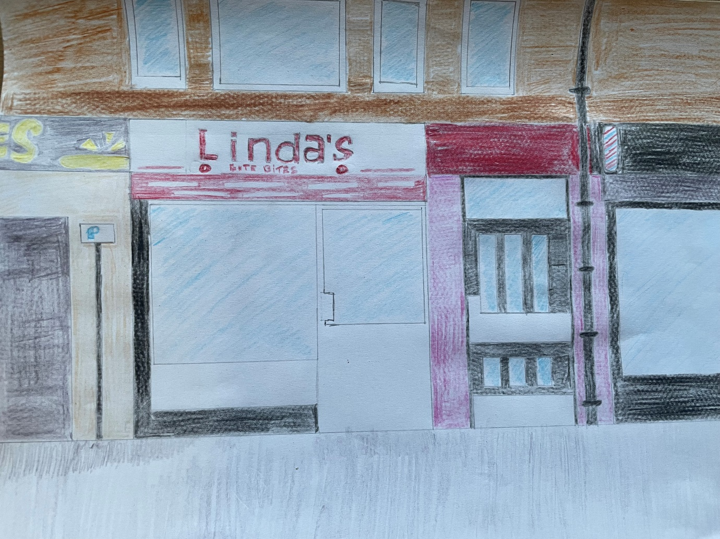
Gameplay and Mechanics
How does the player interact with their environment?  How is the character controlled? | The game mechanics are simple, the player can move left and right across the screen using buttons situated at either side of the screen. The character will carry a net in front of him, only the net will be able to catch the cakes.  The rate the cakes fall at will vary based on the type of cake with more valuable cakes falling slower forcing the player to decide how much time they have to catch the faster moving objects before the higher value objects are in catching range.  At the end of the game the player will have an arbitrary multiplier applied to their final score which will decide their position in the daily standings.
Characters
Lovely Linda | Owner of the Café and all-around lovely lady
Concept Art - Linda | 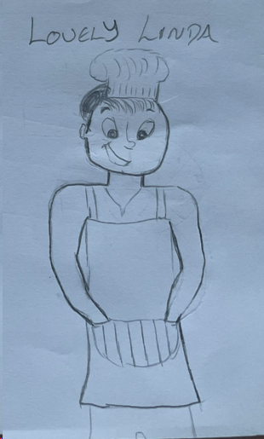
Rad Brad | The hero of the story, Brad is a kick ass skateboarding dude with attitude!
Concept Art - Brad | 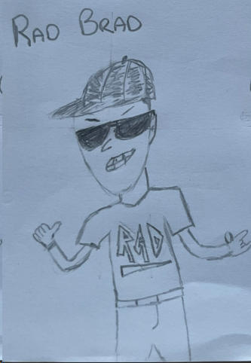  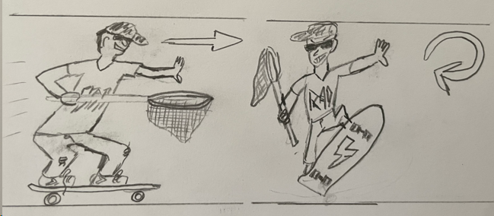
Dozy Dave | Our story’s antagonist, Dave means well he’s just a bit of an oaf.
Concept Art | 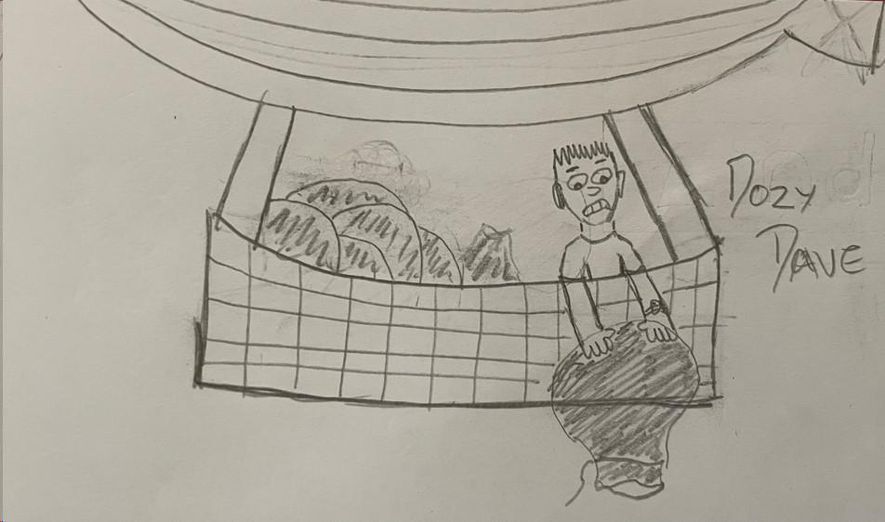
Confectionary | The prized sweet treats that must be rescued.
Concept art | 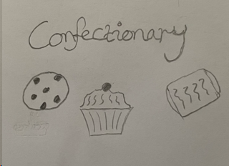
Additional Features
What additional features should be added if possible? | Enemies – Some obstacles for our character to overcome, a stray dog or a stray golf ball from the nearby driving range. Failing to avoid an enemy will briefly knock the player down.  Jump – if enemies are introduced a jump action will be added to our main character.  Weather – The most ambitious extension of the project scope. Create game mechanics to mimic wind, rain and ice and add amended backdrops to match the conditions. Backdrop and mechanics can be decided in accordance with weather API
Prototype 1
Screen  captures | 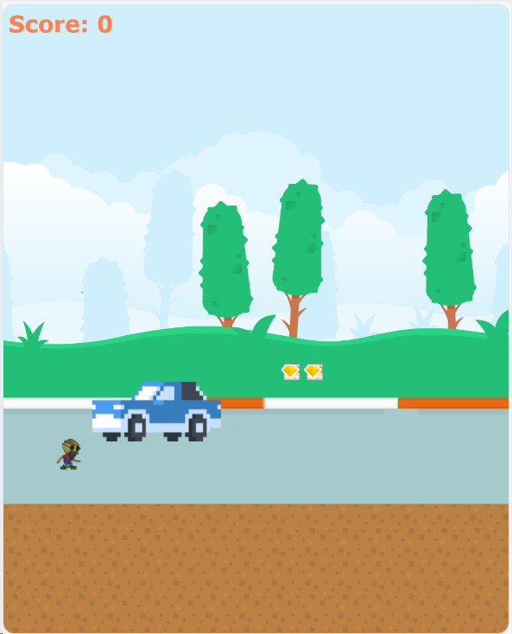  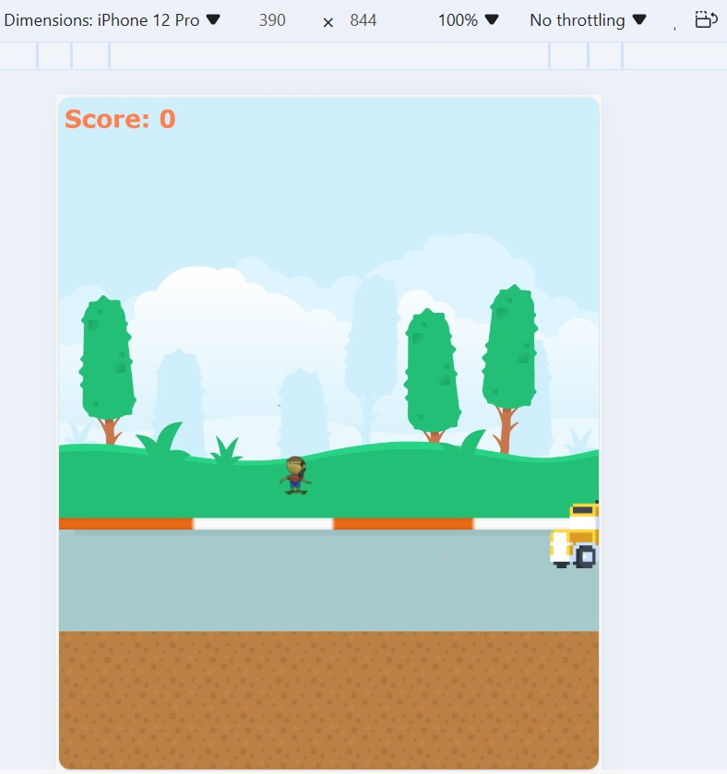
Progress  Summary | The first prototype was difficult to produce, initial attempts to produce a working version using only the textbook and the Pixi documentation were unsuccessful. Eventually I was able to find an example game on which to base this prototype which provided a guide to the configuration files necessary to produce a working game.  The prototype utilises pre-made sprite sheets which I will try to replace in the next iteration of the game, instead of a single static setting, a moving background is featured with vehicle sprites providing challenge to the player.  Progress on this prototype was unacceptably slow, however since working with the example game I now have a better idea of how to implement game features so I hope progress on the next prototype will be faster.
Issues | The most pressing issues which will have to be solved in the next iteration will be:  - Hit detection for item collection not working.  - Vehicle sprite sizes require tweaking.  - Vehicle sprites require animation.  - Score incrementation not working.  - Game ending required.  - Screen Sizing not automatic.
Subtasks of second prototype | Items  - Fix collision detection. (essential)  - Change item spacing. (essential)  - Add third item.  Sprites  - Fix car sprites to avoid significant overlap. (essential)  - Produce custom sprites.  Animate Brad, Create Linda and Dave Sprites, Add Vehicle Animation frame, Change Background, Draw Café front.  Functionality  - Implement Game End. (essential)  - Fix Screen Size Issue. (essential)  - Fix Scoreboard. (essential)  - Implement Score Multiplier. (essential)  - Add UI. (essential)  - Return Score. (essential)
Prototype 2
Screen Captures | 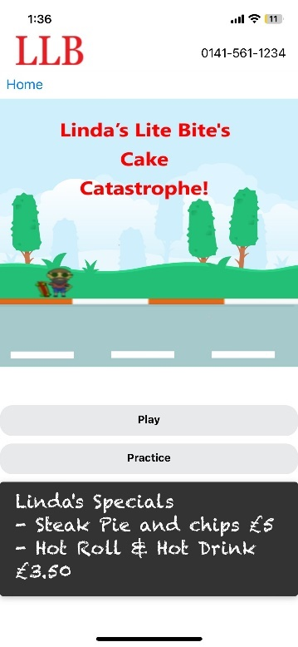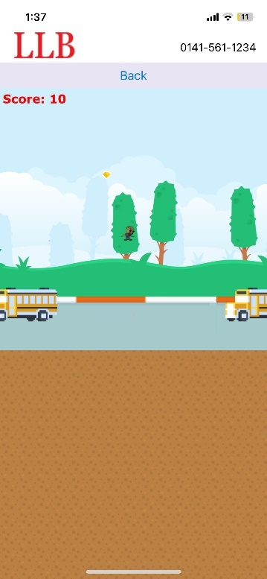  Game Title Screen Item Collected  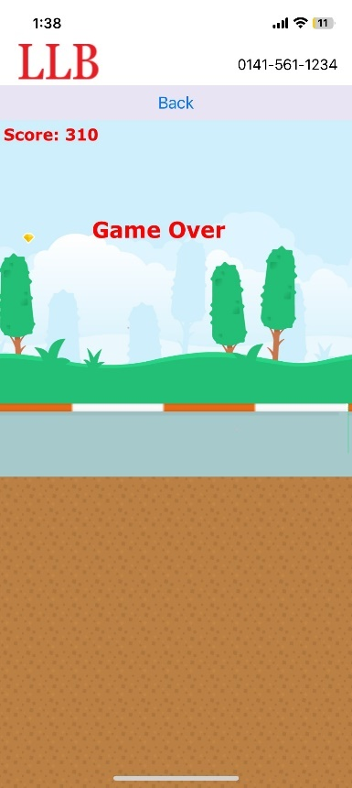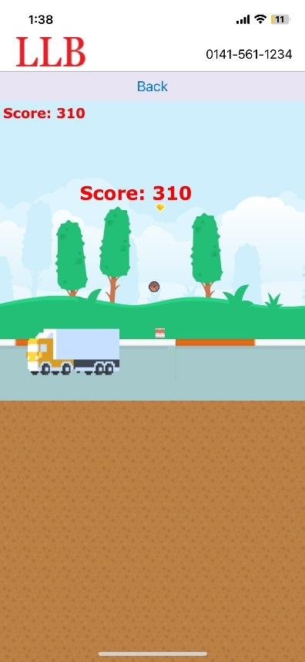  Game Over Screen Score Displayed  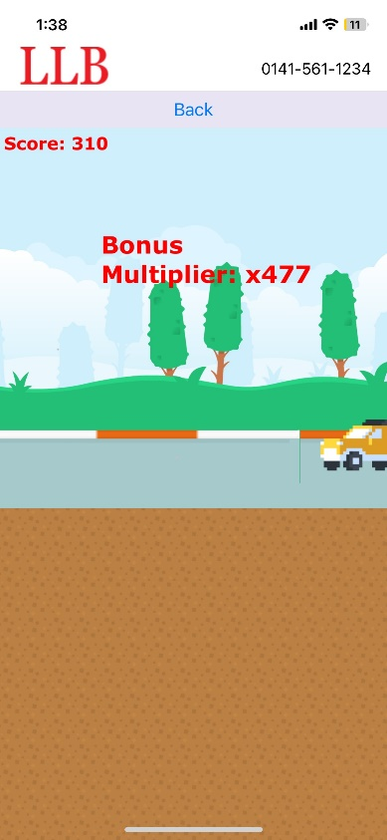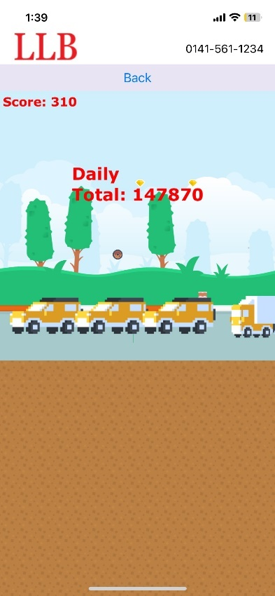  Multiplier Displayed Daily Score Displayed
Progress Summary | All of the essential issues identified in the first prototype were solved or partially solved. Items are now collectable, the scoreboard increments, screen sizing is now automatic and works on most devices. I have removed some of the vehicle sprites to prevent overlap and have added a third item type. A game over sequence now takes place when the character sprite is ejected from the screen which displays the relevant scores. The multiplied and unmultiplied scores are logged to the console which will allow the application to grab these details through the Webviews props although this part of the app functionality is still to be implemented.  One issue that has arisen is that when the game is launched through the application it runs noticeably slower than with the development server. This affects the difficulty as it gives players more time to react to obstacles. In the final version I will try to address this by removing unnecessary assets and cleaning up the code to reduce file sizes. I will also consider changing the gameplay slightly, removing the double jump and slightly lowering the highest items making it more difficult and riskier to attempt to collect them.  Other than gameplay issue the focus of development of the final build will be making cosmetic changes to make the game appear more polished.
Issues | -Performance is slow affecting gameplay  -Item collision is imperfect, occasional missed items and items counted multiple times  -Vehicle sprite animation is imperfect  -Game end is basic
Subtasks of Final Version | Items  - Change Item spacing  - Address Collision Issues (preferred)  Sprites  - Tweak Vehicle sprites  - Add Background sprites  - Remove Unnecessary Image sprites from folder (priority)  - Attempt Game Over Animation (preferred)  Gameplay  - Clean up code files (priority)  - Experiment with Gameplay Changes (priority)
Final Version
Screen Captures | 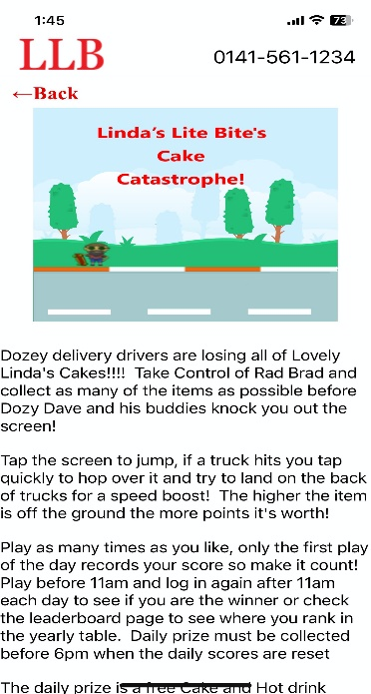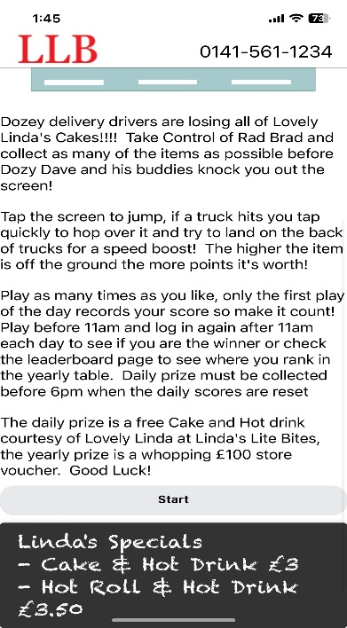  Updated Title Screen with game instructions and competition details  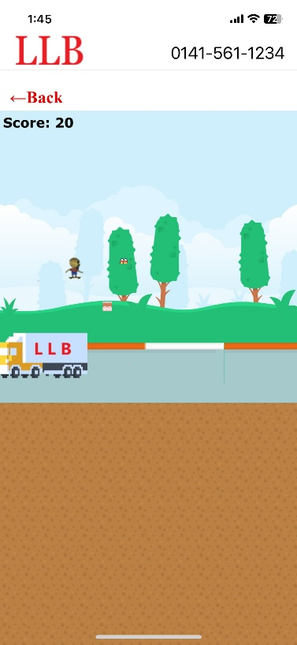  Item sprite, vehicle and text colour changes
Progress Summary | Due to performance issues caused by the embedded webview component, minor changes in gameplay were implemented, this included speeding up the movement of the vehicle sprites and changing the jump mechanic to a single jump between landings. Item sprite positions also had to be amended to take account changes in the jump.  Vehicle sprites were removed leaving the truck sprite only, again to help ease performance issues. The café logo was added to the sprites as insufficient time was left to complete the ending animation depicting the café store front and client.  The scoreboard and game over text colour was changed to increase the colour contrast to a level consist with W3 accessibility standards
Issues | - Basic game ending remains  - Item collision issues remain, not game breaking but not ideal
Conclusion | The game does what it must do to facilitate the competition element required of the mobile application, however it remains too basic in some regards. Plans to change the game after of the end of the project have been presented to the client, these include:  - Changing the game mechanics and scenery to match the original game concept  - Adding ‘wasp’ enemy sprites which can collect items before the game character and knock the character back  - Adding the game ending animation  - Adding background details like lamp posts and road signs
Appendix B – Linda’s Lite Bites Application Summary
Linda’s Lite Bites Application
Version 1
Screen  Captures | 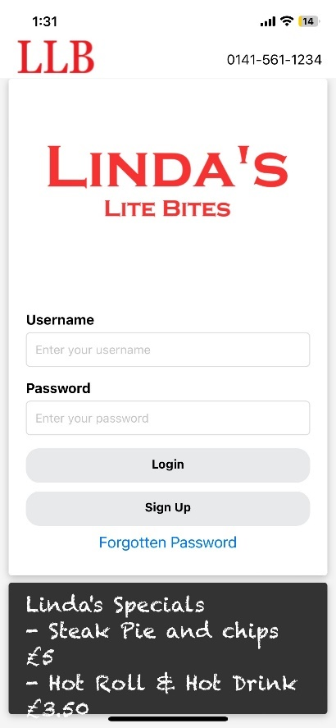  Login Screen Successful Login Alert  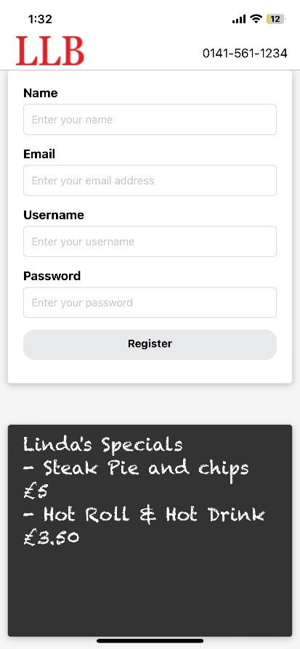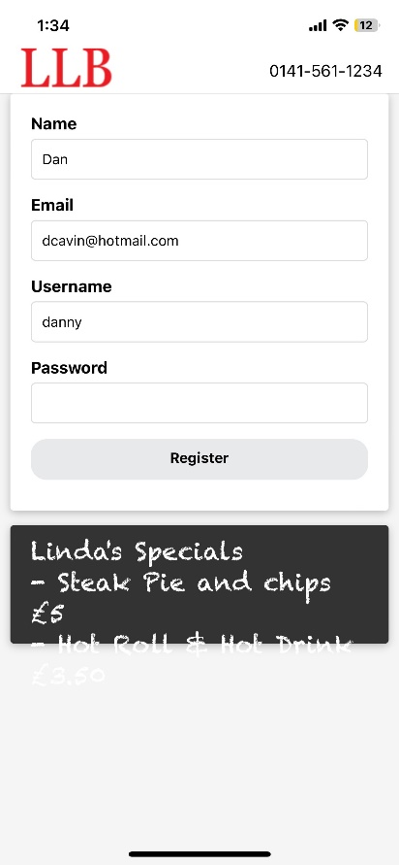  Registration Page Complete Registration Page  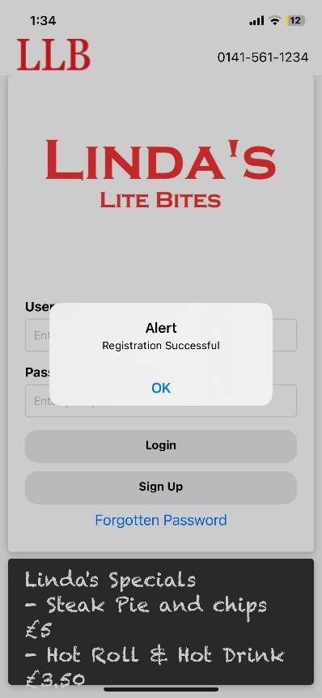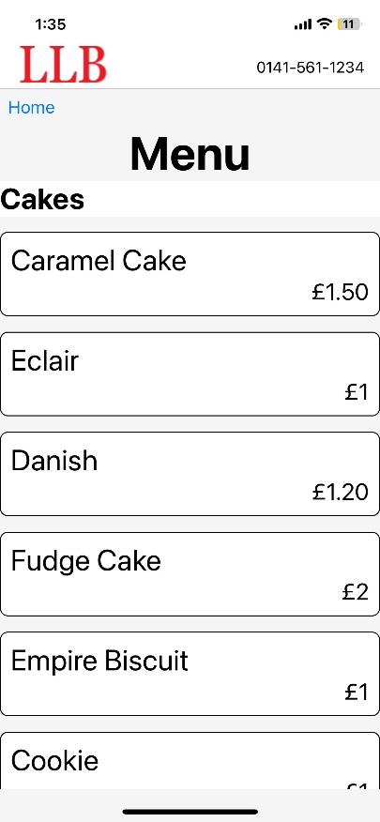  Registration Completion Menu Screen  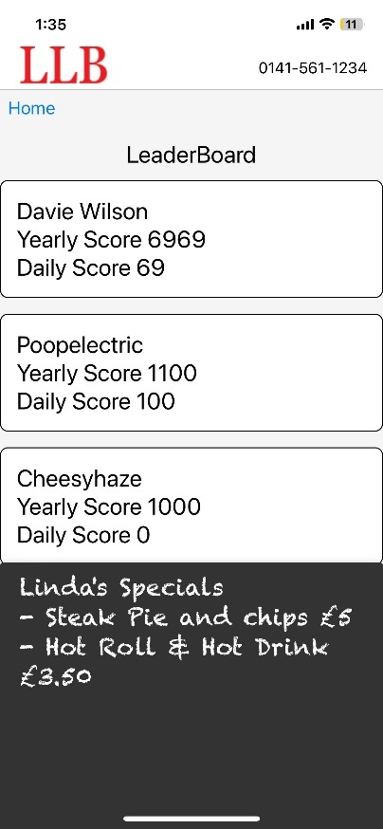  Leaderboard Screen
Progress Summary | Progress with the initial build was largely a straightforward process, most of the screens have no complex functionality and the colour scheme of the café itself was simple to implement here.  The most difficult task was getting the game to run in the Webview, this was a difficult process which ended with the compromise of hosting the game files on the backend server.  Some of the application features are still to be implemented for the final version but now that integration with the game has been dealt with I expect most of this to be straightforward.
Major Subtasks of Final Build | Application  - Include Logout function (priority)  - Get Scores for logging (priority)  - Allow only one play per day (priority)  - Create Custom component for back button (priority)  - Implement Password Retrieval (priority)  - Add Phone from app function (preferred)  Data  - Reset Daily Scores (priority)  - Application should alert current leader/winner (priority)  - Leaderboard should include position on card along with scores  - Menu items could be ordered by price  Game  - Add Game Description (preferred)  - Add Game character images to Game Screen (preferred)
Linda’s Lite Bites Application
Final Version
Screen Captures (iOS) | 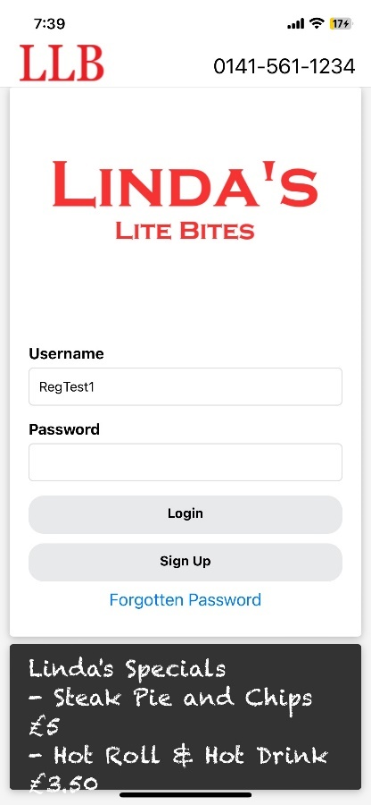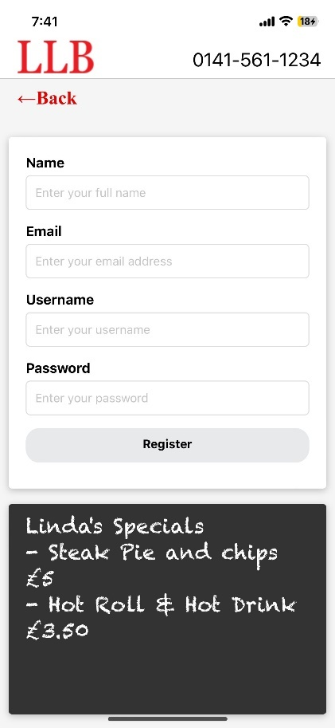  Login Screen Registration Screen  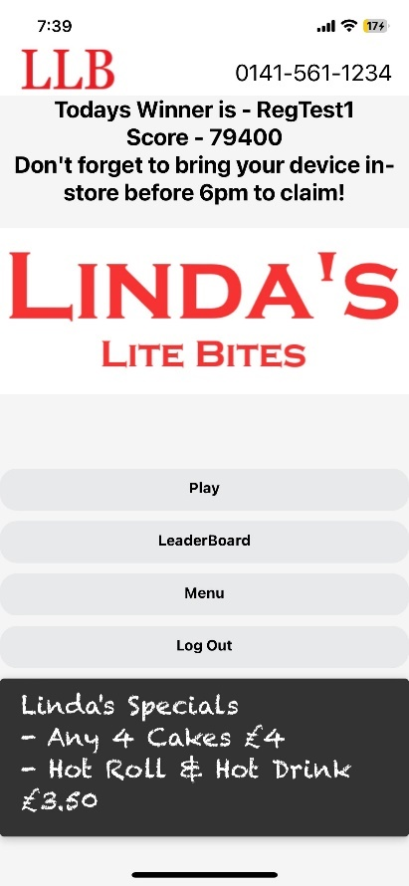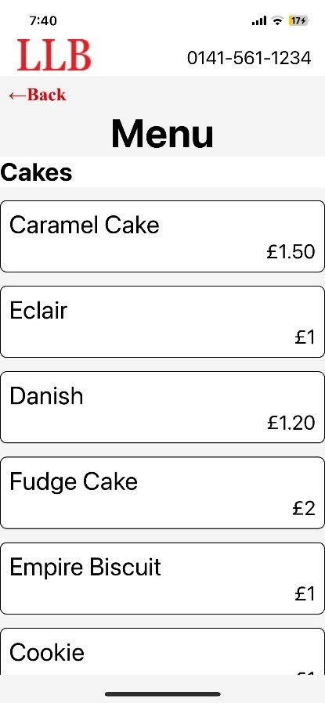  Home Screen (with Winner) Menu Screen  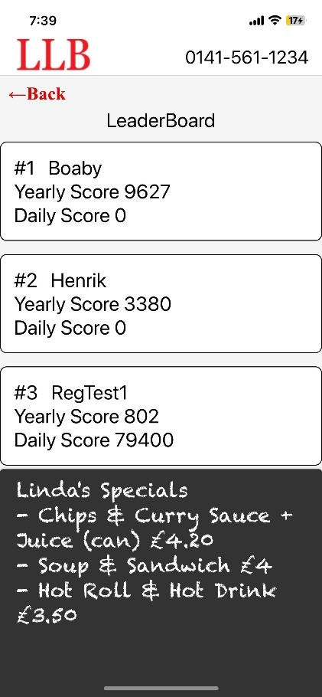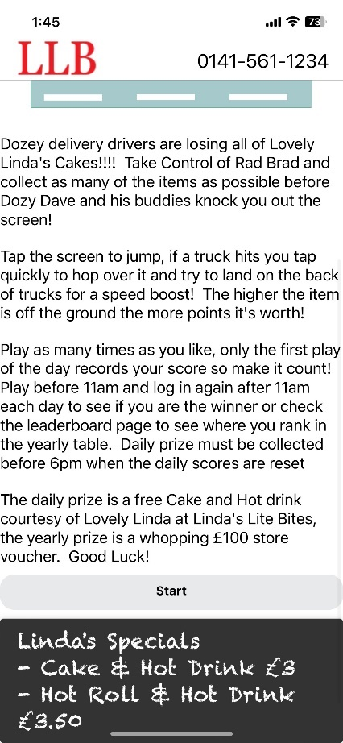  Leaderboard Screen Play Screen  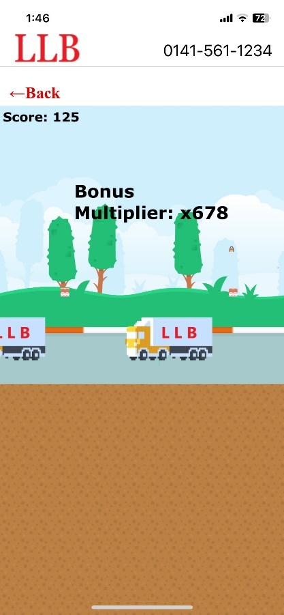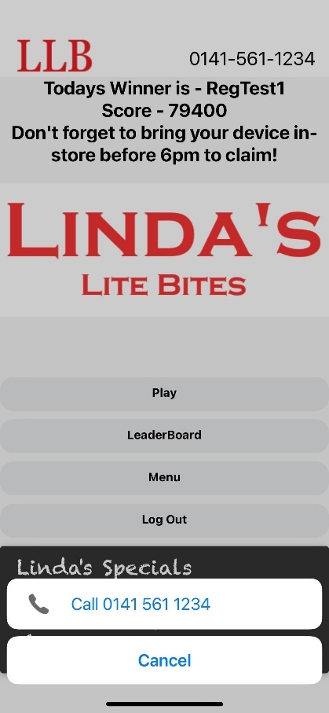  Game Screen Call Screen
Screen  Captures  (Android) | 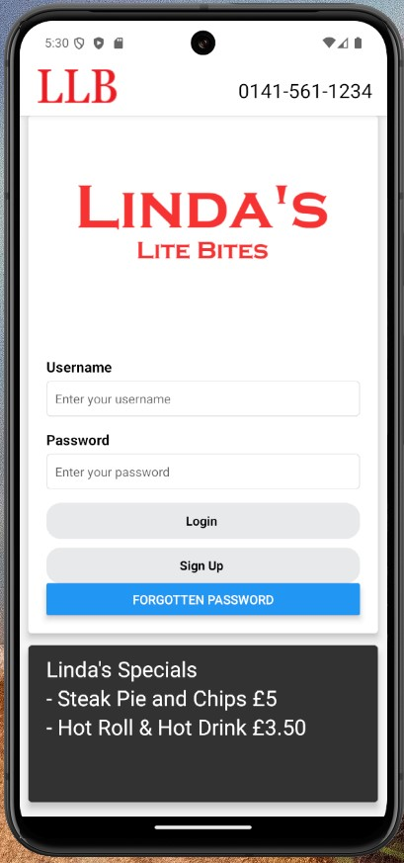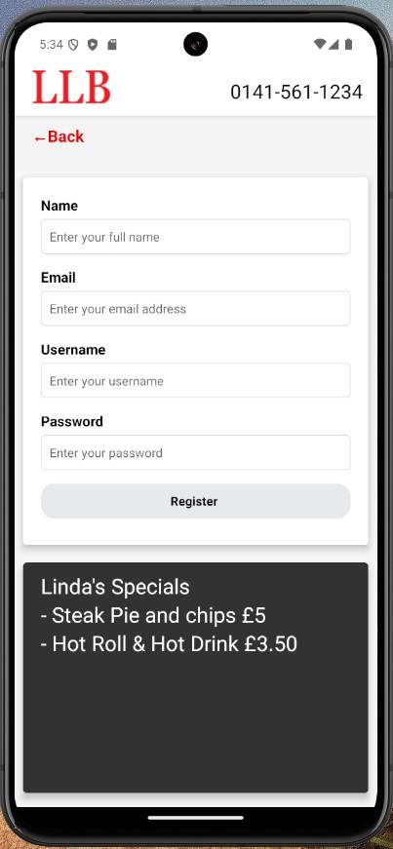  Login Screen Registration Screen  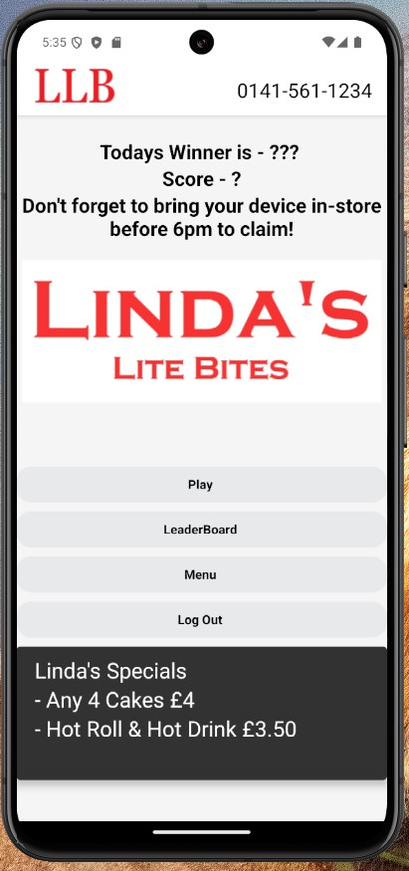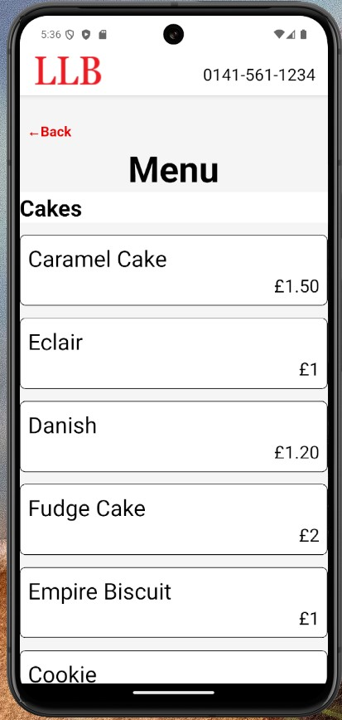  Home Screen Menu Screen  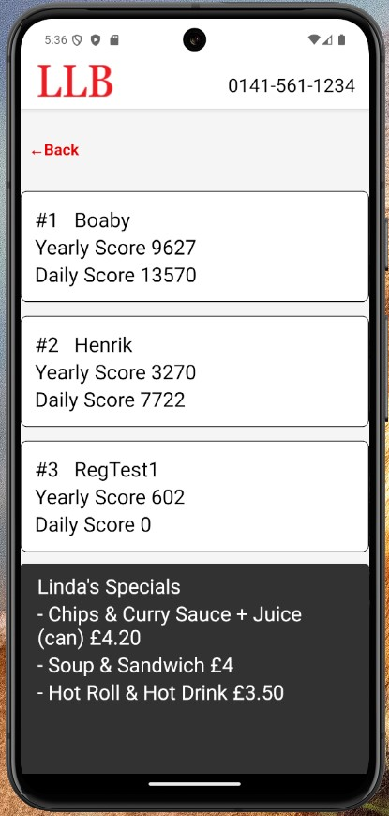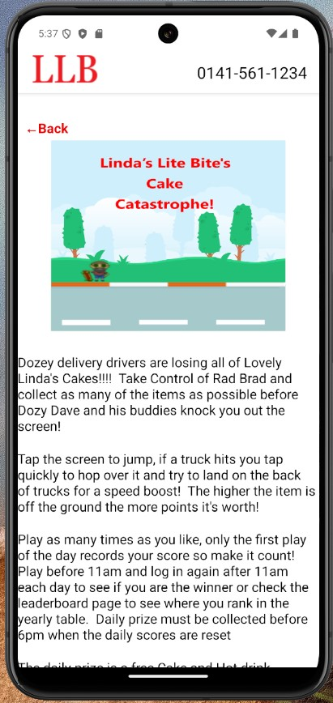  Leaderboard Screen Play Screen  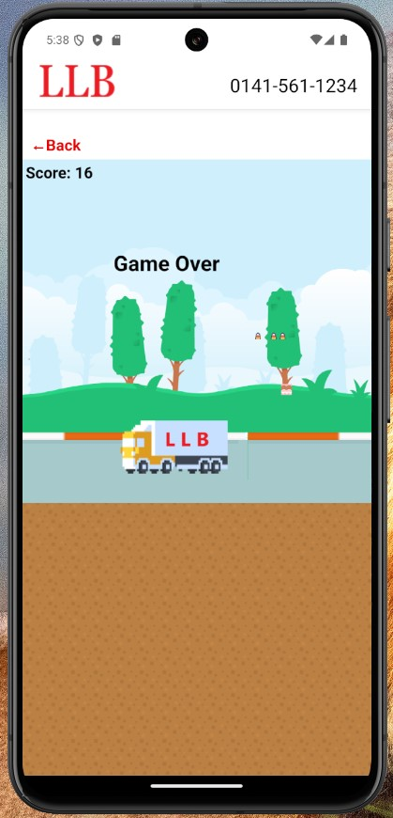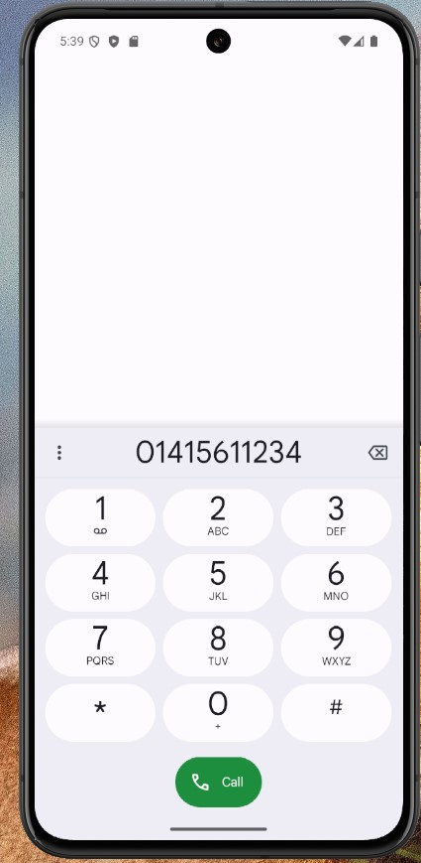  Game Screen Call Screen
Progress Summary | Progress on the final version was relatively straight forward in terms of functional changes. The most difficult change involved displaying the winning users’ details which took several hours to complete but other than that most other tasks were simple complete.  The final stage of the build involved adding platform specific code to ensure buttons and text were fully visible in both version and making changes to font sizes and colours to improve accessibility for sight impaired users. The screenshots for both versions show that the app is largely the same on both platforms.
Incomplete Tasks | - Password retrieval  - Menu Items ordered by price

Appendix C - Initial UI Sketches
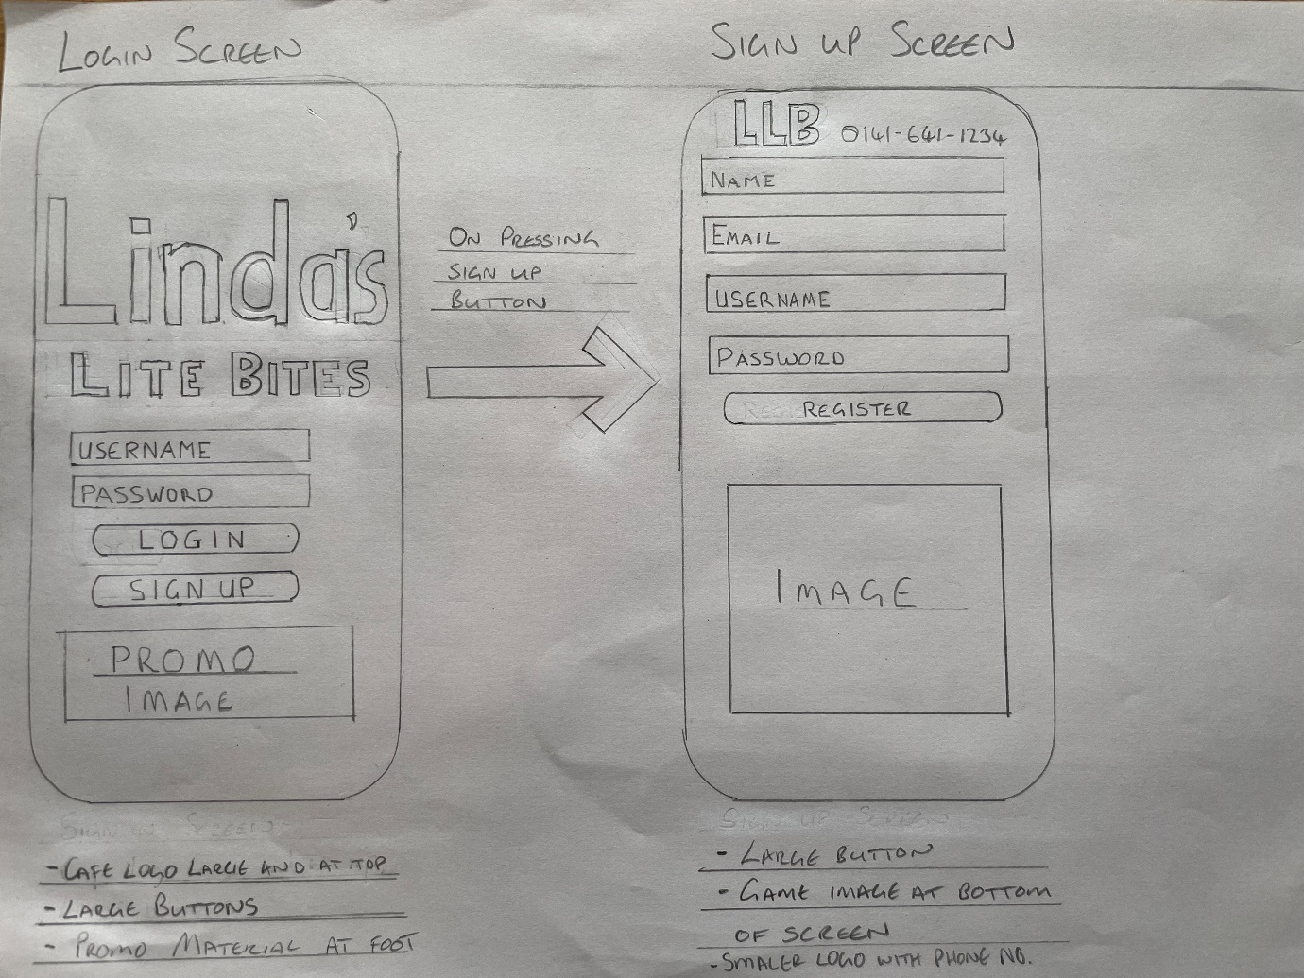
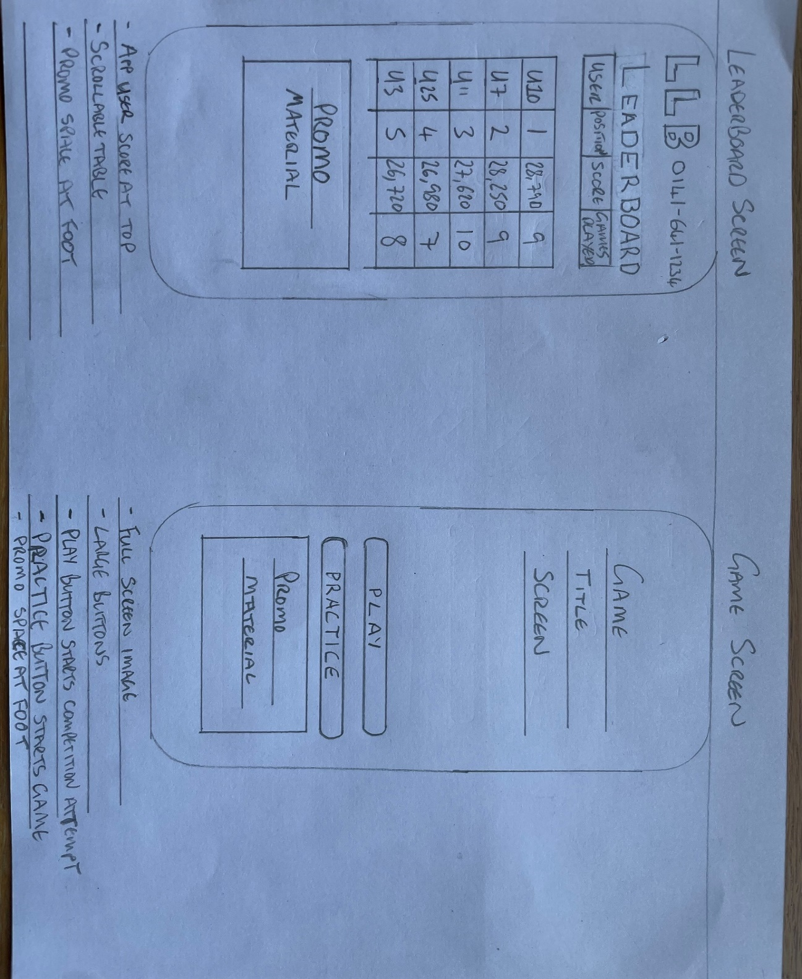
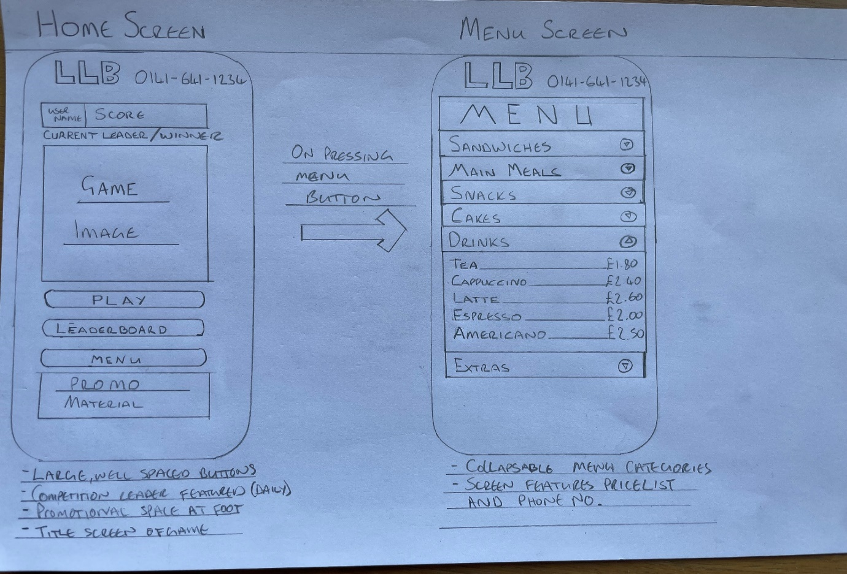

Appendix D – Updated Requirements
Updated Requirements
The User stories and Volere template below have been updated to take account of further requirements identified by the client in response to testing the first prototype of the app and in response to development issues which have made some requirements more difficult or impossible to achieve in the project timescale. Changes are shown in bold and Italics.
User Stories
- As a player I want to play my daily attempt to compete for the daily prize.
- As a player I want to check my cumulative score to see my position on the leaderboard.
- As a player I want the opportunity to practice the game to improve my skills.
* The above user story may now be omitted due in part to performance issues stemming from the integration solution used to house the game in the app which affects the speed and difficulty of the game.
- As a café customer I want to peruse the menu to help me decide on an order.
- As a café customer I want to be able to quickly call the café from the app.
- As a user I wish to be able to log into the app securely and quickly.
- As a user I wish to be able to register quickly.
- As a user I wish to be able to retrieve my password and username if I have forgotten them.
Volere Template
- Purpose of the Project
Background - Lindas Lite Bites is a small café competing for business with major fast-food chain outlets. The owner would like to commission a dedicated mobile application to promote the café.

The owner plans to capitalise on the influx of potential customers provided by a local office development project which is close to completion in close proximity to the café. The plan is to use the application as a promotional tool to draw customers to the business.

Goals -The aim of the project is to deliver a hybrid mobile application featuring a simple, points driven game which allows users the opportunity to win a daily prize of a free drink and cake. The application will also allow the user to peruse the café menu and to place a phone call to the café at the press of a button.

The idea is to encourage users to play before lunchtime each day for a chance to win a daily prize, as well as competing in an overarching yearly competition. In using the app they will be exposed to promotional materials which is hoped will drive sales. The menu availability on the app will help facilitate large orders which can be placed over the phone for collection.

Independent of the prize element the game should, through gameplay and design, encourage players to play each day.

- Stakeholders
The Client - The owner of the business, involved in requirements process and eventual determinant of project success.
Users – The two user roles are player and customer although in most cases the roles will overlap.
Employees- The employees of the café. Will benefit from increased business.
The developer – me.
Testers – Friends and family and potential customers of the café, involved in refining the game through prototyping.
- Mandated Constraints
The application must be ready by mid-August 2024.

The system must be available for iOS and Android users.

The application should require no day-to-day maintenance and minimal maintenance overall. The client should be able to simply add or remove promotional messaging.

The application shall ensure the winner of each day’s prize is decided partly at random using a score multiplier.
- Naming conventions
None at present
- Relevant facts and assumptions
Deployment of the finished product will be at the discretion of the client.
- Scope of the Work
The application will be developed for a café with one location.
- Business Data Model and Data Dictionary
Not yet considered.
- Scope of the Product
The product will be aimed at customers of the café, each user shall through interacting with the application UI:
- Access the café menu.
- View their place on the yearly scoreboard.
- Play the game/Practice the game.
- Functional Requirements
The application shall:
- Register users.
- Register users scores.
- Securely login users
- Allow Password retrieval
- Alert competition winners
- Allow only one playthrough per day
- Call the café using the app interface
- Apply arbitrary multiplier to daily scores.
- Display daily scores.
- Display Menu.
- Display promotional messages.
- Logout Users
- Non-functional Requirements
Look and Feel
- LF1 - The application UI should be colour coordinated to match the café signage.
- LF2 – The application UI should be simple with minimal buttons.
- LF3 – The game scenery should be based on the café storefront.
      - The above requirement is unrealistic given current time constraints on the project but would still be desirable to the client so may be reinstated in response to future progress
- LF4 – The game should have a retro feel to match the gameplay type, characters and art should have 90’s aesthetic.
Usability and Humanity Requirements
- U1 – The application should be simple to navigate.
- U2 – The game controls should be simple and intuitive.
Performance Requirements
- P1 – Each screen shall load within 2 seconds.
- P2 – The game shall load within 2 seconds.
- P3 – The game shall run at a consistent frame rate.
- P4 – The game shall respond immediately to user input.
- P5 – The game shall be available to play/practice offline.
      - The above requirement has proved impossible to implement due to the limitations of the React Webview component meaning that the game files must be provided from the backend server as opposed to being packaged locally.
- P6 – The game score shall register immediately after the days playthrough.
Operational Requirements
- O1 – The system shall operate on iOS and Android mobile devices.
Maintainability Requirements
- M1 – The system shall allow simple updating of promotional materials.
- M2 – The maintenance of scores and daily prizes shall occur automatically.
Security Requirements
- S1 – Only the client can access and change promotional materials.
- S2 – The only details held on each user will be a username and email address, which should be securely managed.
- S3 – Each user can register one account; one email address can be linked to one and only one account.
Cultural Requirements
- C1 – The application shall promote Linda’s Lite Bites as a friendly, happy establishment. The client shall also be portrayed in the game as friendly and happy.
Legal requirements
- The application shall hold email addresses only to verify that each user has a single account, no other data shall be held on each user without the user’s permission.

Appendix E – Updated Risk Assessment and Project Schedule
Schedule – TMA02 7/5/2024
The Gantt chart featured below sets out the schedule for the rest of the project, it shows two significant changes to the original project plan. Firstly, I have decided to develop the react application and the game concurrently, and secondly, I have changed the lifecycle model for developing the app from an incremental approach to an iterative model. Details of the reasons for these changes are contained in the risk assessment below and section 3 of this report.

Schedule – TMA03 16/7/2024
The Gantt chart below sets out the schedule for the rest of the project in terms of major tasks, the subtasks marked a priority will be the main focus of the Build Final Game/Build Final App Version/Reconfigure Database Server sections although it will be the aim to complete the tasks marked preferred also. Any tasks left over will fall into the Refinement/Troubleshooting Task.

*The Risk Assessment sections below are largely unchanged from TMA02, added elements shown in bold and italics
Risk Assessment
Financial Risk
The financial cost of the failure of individual project subtasks is not quantifiable as the project is being delivered using free resources. The project as a whole however represents potential monetary gain for the client and therefore can be quantified as potential gain should the project be successful:
- Client hopes that with the help of the app, the new offices could bring 100-300 additional transactions per week. An average of £5 per transaction would represent roughly £25k- £75k per year in revenue.
- Around 12% of sales revenue are profits making the potential profit generated by the application £3k-£9k annually.
- Linda has estimated the cost price of the daily prize at around £2, roughly £720 per year assuming all prizes are claimed.
- If the project is successful and the client decides to deploy the application, the estimated cost of running the application on physical hardware based on the current average electricity price would be approximately £1,073.10 (Sust-It, 2024).
- Apple Developer account required to offer app on AppStore costs $99 USD annually (£77 approx.) (Apple, 2024), Google Play Developer account required to offer app on Playstore costs a one-time payment of $25 USD (£20 approx.) (Google, 2024)
This means the potential yearly profit increase generated through a successful project would be approximately between £1,536 - £7,536.
*It may be cheaper to deploy the application using cloud services however deployment is outside the project remit, the above is rough estimation for illustrative purposes.
Qualitative Assessment
Each part of the project involves various risk factors which are shown in the table below. Risks are ranked low, medium, or high:

Major Task Risk Assessment Table
Project Task | Risk Level | Explanation | Action Taken
Produce Second Prototype | Medium | Games Development was initially the highest risk task, having produced the first prototype there is now a platform to progress lowering the risk factor.  The technology used (Pixi.js) is now in version 8 and so is well established as a viable technology.  There is some essential functionality which was not achieved in the first prototype meaning there is still a level of risk | Next scheduled task, giving more time to address issues that may arise.
Produce React Native Application | Medium | As with the technology used to produce the game React is a well-established framework making this a low-risk technology.  My time working with React is limited so there is a possibility that lack of experience will lead to delays completing this task. | I have changed the development model from an agile approach to an iterative model and have moved the task forward in the schedule to begin immediately. The idea is to attempt to build a basic functioning version of the application. Using the first game prototype I can experiment with integrating the game and the app during the development process, incorporating a high-risk task rather than leaving it until the end of the project as I had initially intended.
Integrate Game and Application | High | I have never combined the two technologies before meaning there is a high degree of uncertainty around this task. | As above, integration attempts will now commence earlier in the project during production of the first version of the application and continue throughout the project.  There is a dedicated section of the PIXI documentation pertaining to React applications, so material has been sourced to help handle this task
Configure Database | Medium | Could potentially be upgraded to high risk as I have no experience configuring a database for a custom application.  The second prototype and first app iteration could overrun which risks creating a time deficit for this task. | As the React app has now been brought forward the database configuration has also moved forward again allowing problems to be identified earlier.  I am currently studying database management and so have recent experience working with database technologies.  I have decided to use a NoSQL solution removing the need to define a relational schema.
Build Final Game  *details in Appendix A | High  Medium | As this is dependent on the success of the 2nd prototype until this is finished this stage of the project is high risk.  Some changes still required but the game is mostly formed. Main issue is related to performance issues due to the method of delivery; risk level is still medium as it is unclear whether these issues will be solvable. | I will write detailed notes on the development process of the 2nd prototype to decide what is realistically achievable in the final version.  I will deal with the priority issues first, before moving on and coming back to deal with the preferred and optional changes.
Build Final Application  Build Final Application / Reconfigure Database  *details in Appendix B | High | Again, dependent on the success of the first version of the application.  Will also require integrating the database/configuring API calls.  Some essential functionality still to be implemented especially retrieving scores. Some functionality will require database configuration. | As above, I will keep detailed records of difficulties faced throughout the initial app development as a way of ameliorating risk.  Application Changes will be the main focus of final stages of project. I will deal with the priority issues first, before moving on and coming back to deal with the preferred and optional changes.
Play test 2nd Prototype | Low | Simple to complete although depending on results could indicate future problems with game development tasks. | None
Refinement/Troubleshooting | Low | This section of the project will deal with mainly cosmetic and minor issues which may be left out if time dictates | None
Play test Final Game | Med | Should be simple to complete but if issues arise from testing there will be limited time to eliminate them. | Full major task schedule set to complete 6 weeks before project submission deadline which its hoped will leave enough time to deal with delays.
Test Finished Application | Med | As above, if any issues are identified it may be too late to fix them. | As Above.

Appendix F – Playtesting
Playtesting was carried out by 6 participants who were involved in each phase of playtesting. Below are example surveys from each phase.
Example completed survey of Prototype 1

How Are We Doing?
In order to ensure the project stays on track it is important to gain feedback on the quality of each stage of the game’s development.

Please rate the game in terms of fun?
1 2 3 4 5
Disappointing | Exceptional

How likely are you to play this game for one minute each day?
1 2 3 4 5
Very Unlikely | Very Likely

Please indicate which part of the game, if improved, would most improve the fun factor of the game (choose one only).
Gameplay?
Character Animation?
Background Animation?

Please comment on your answer below…
The game has challenge but would be much more fun if there was more obstacles. Also would be better if collectable items worked.

Thank you for your feedback!

Stay tuned for the next version!

Example completed survey of Prototype 2

How Are We Doing?
In order to ensure the project stays on track it is important to gain feedback on the quality of each stage of the game’s development.

Please rate the game in terms of fun?
1 2 3 4 5
Disappointing | Exceptional

How likely are you to play this game for one minute each day?
1 2 3 4 5
Very Unlikely | Very Likely

Please indicate which part of the game, if improved, would most improve the fun factor of the game (choose one only).
Gameplay?
Character Animation?
Background Animation?

Please comment on your answer below…
The skateboarder should change animation when he jumps, vehicles should be animated better and often overlap each other.

Thank you for your feedback!

Stay tuned for the next version!

Example completed survey of Final Build

How Are We Doing?
In order to ensure the project stays on track it is important to gain feedback on the quality of each stage of the game’s development.

Please rate the game in terms of fun?
1 2 3 4 5
Disappointing | Exceptional

How likely are you to play this game for one minute each day?
1 2 3 4 5
Very Unlikely | Very Likely

Please indicate which part of the game, if improved, would most improve the fun factor of the game (choose one only).
Gameplay?
Character Animation?
Background Animation?

Please comment on your answer below…
The game could use some method of recovering when hit by the truck, a direct hit almost always leads to a game over.

Thank you for your feedback!

Appendix G – Sample Project Logs
Project Log – 21/03/24
Pixi JS Learning
Time Spent - 4 hours.
Task Completed/Attempted:
- Work through rest of basic examples on Pixi.js website.
- Begin working through Pixi.js tutorials using VS code.
Notes
Worked through two tutorials, I has no trouble with the first tutorial however the second tutorial was significantly more difficult, and I was unable to complete the visual effects in the last two steps. Will attempt to complete these steps tomorrow.
Project Log – 16/04/24
Create Prototype
Time Spent – 4 hours.
Tasks completed/Attempted:
- Add vehicle sprites.
- Add item sprites.
- Add vehicle collision detection.
Notes
Tasks were completed but the vehicle sprites are generating too quickly and the item collision detection still to be implemented.
Project Log – 01/07/24
Game Prototype 2
Time Spent – 6 hours
Tasks Completed
-Item Collision
-Screen Resizing
Notes
Screen resizing achieved, solution works on most emulated screens. Item collision working but still quite glitchy, very occasional failure to collect items and frequent instances of multiple collisions on same item causing score to increment incorrectly.

Appendix H – Problem record

Problem Record
Name:
Date:
Problem Number:
Problem Information
Problem reported
Description
Solution
Workaround
Problem Template
Problem Record
Name: Daniel Cavin
Date: 16/09/2024
Problem Number: 0001
Problem Information
Problem reported | Password Retrieval not working
Description | When user presses ‘forgotten password’ button they are met with an alert asking them to bring their device in store.
Solution | Replace alert with implementation of password retrieval system
Workaround | The following set of steps can be followed to reset the user’s password manually.  - Go to http://account.mongods.com  - Login using the username dcavin@gmail.com and password ShK.6AQhhjrFxFX  - Click on the ‘Browse Collections’ button then ‘UserInfo’ collection  - Locate document containing desired username and take note of cumulative score  - Click ‘remove document’ button and click ‘Delete’ to confirm  - Ask user to re-register on app  - Refresh MongoDB page and locate users document  - Click ‘edit document’ and replace cumulative_score value with value noted at step 4  - Click ‘Update’ to confirm

Appendix I – Usability Test Summary
Usability testing was carried out using friends and family members, 10 participants were involved and used for all three scenarios. Below is the test process, test definitions, example tests and test summaries for all three usability scenarios.
Test Process
Environment | - All tests are undertaken in a quiet setting without distraction  - All tests are undertaken using the same device (iPhone 12)
Monitoring | - All tests are monitored personally be me  - All tests are timed using the same stopwatch
Guidelines | - Test data required for login/registration will consist of the test participants name (name: full name, Username: first name, email: firstname@gmail.com)  - Each test participant shall use the same password (password123)  - Each test participant is permitted to read the full test scenario before timing begins  - No special coaching will be given, each test will begin when the participant is sure they understand the test scenario and are ready to begin

Scenario 1 | Type of Value | Actual Value
Source | End user | First time user
Stimulus | User wants to:  - Register  - Login | Registration of new account successfully completed; new user logs in
Artefact | Hybrid App | Linda’s Lite Bites App
Environment | Mobile Device, | iPhone 8, normal use
Response | - Supporting efficient use | Registration and login process is easily understandable to a first-time user
Measure | - Task time  - Success rate | - Registration and login of first-time user within 2 minutes  - Less than two mistakes (a failed attempt at registration or login)

Usability Test – Scenario 1
Name | *withheld
Age | 38
Instructions | -Registration details:  Name: full name  Username: first name  Email: firstname@gmail.com  Password: password123
Time Taken | 0:35
No. Mistakes | 0

Usability Test - Scenario 1 Results
No. of Participants | 10
Best Time | 0:32
Worst Time | 2:16
Average Time Taken | 1:02
Median No. Mistakes | 1

Scenario 2 | Type of Value | Actual Value
Source | End User | New Registered User. Has not yet attempted a login
Stimulus | User wants to:  - Login  - Play Game  - Check Score | User logs in; navigates to game; completes playthrough; navigates to leaderboard screen
Artefact | Hybrid App | Linda’s Lite Bites App
Environment | Mobile Device, | iPhone 8, normal use
Response | - Supporting efficient use | Navigation and game playthrough are easily achievable for new user
Measure | - Task time  - Success rate  - User Satisfaction | - Login, playthrough and check score all completed in under 3 minutes  - Less than two mistakes in process (a mistake can be either invalid login details or incorrect navigation)  - User scores experience with process 1-5 (1: Very easy, 5: Very Hard

Usability Test – Scenario 2
Name | *withheld
Age | 45
Instructions | -Login using credentials supplied in test scenario 2  -Navigate to game screen and play game  -Navigate to Leaderboard screen and check score
Time Taken | 1:02
No. Mistakes | 1
User Satisfaction | 1
Example Test
Usability Test - Scenario 2 Results
No. of Participants | 10
Best Time | 0:42
Worst Time | 1:47
Average Time Taken | 1:06
Median No. Mistakes | 0
Median User Satisfaction | 2

Scenario 3 | Type of Value | Actual Value
Source | End User | New Registered User. User only experiences with app are usability scenarios 1 and 2
Stimulus | User wants to:  - Check menu for Food Item and Drink Item  - Calculate Price  - Call store | User logs in; navigates to menu; finds predetermined items; calculates cost; clicks phone number link at top right of screen
Artefact | Hybrid App | Linda’s Lite Bites App
Environment | Mobile Device, | iPhone 8, normal use
Response | - Supporting efficient use | Process of finding items and calling store is easy to achieve for new user
Measure | - Task time  - Success rate  - User Satisfaction | - Correct items are found, and call initiated within 90 seconds  - Less than two mistakes in process (a mistake can be either invalid login details or incorrect navigation)  - User scores experience with process 1-5 (1: Very easy, 5: Very Hard

Usability Test – Scenario 3
Name | *withheld
Age | 50
Instructions | -Login with registered details  -navigate to menu screen  - find ham sandwich, chips, cappuccino and calculate price  - find the phone number on the app screen and press
Time Taken | 0:29
No. Mistakes | 0
User Satisfaction | 1

Usability Test - Scenario 3 Results
No. of Participants | 10
Best Time | 0:29
Worst Time | 1:08
Average Time Taken | 0:46
Median No. Mistakes | 0
Median User Satisfaction | 1

Identifier and Name | UC1 – Register new user
Initiator | New User
Goal | New users’ details are saved in the database
Preconditions | None
Post Condition | A new document will be added to the MongoDB ‘users’ collection containing valid details for the fields, name, username, email, password
Assumptions | The user will be using a mobile device to access the application and register the details. The new user will have no guidance in the registration process
Main Success Scenario
- User presses the sign-up button and is taken to the registration screen
- User inputs valid values into the fields required
- User presses the register button and receives an alert confirming the registration is successful
- User is navigated to the login screen
- Details registered are used to login and login is successful
Extensions
3.a.1. Name is already on record – registration successful
3.b.1. Username is already on record – registration rebuked
3.c.1. Email address is already on record – registration rebuked
3.d.1. Email address invalid – registration rebuked
Appendix J – System Testing

Test No. | Scenario | Test Data | Expected Result | Actual Result | Test Outcome | Comments
UC1-1 | Main Success Scenario | Name: Reg Test  email: regtest1@gmail.com  Username: RegTest1  Password:  regtestpassword1 | - User will be navigated to the login page  -User will receive alert that registration was successful  -MongoDb cluster will contain a new document containing test data  - username and password will facilitate login | -Alert and navigation to login page occurred immediately  -MongoDB document added to the database  -Login with test data successful | Pass | None
UC1-2 | Name already on record | Name: Reg Test  email: regtest2@gmail.com  Username: RegTest2  Password:  regtestpassword2 | - User will be renavigated to the login page  -User will receive alert that registration was successful  -MongoDb cluster will contain a new document containing test data  - username and password will facilitate login | -Alert and navigation to login page occurred immediately  -MongoDB document added to the database  -Login with test data successful | Pass | This is the expected result as the name field refers to an actual person’s name which could easily be duplicated eg. John Smith
UC1-3 | Username already on record | Name: Reg Test3  email: regtest3@gmail.com  Username: RegTest1  Password:  regtestpassword3 | -User will be alerted that username is taken  -Input fields will be cleared  -No new documents will be added to the MongoDB cluster  -Details will not facilitate login | -Alert presented to user  - registration fields cleared  -No new document created  -Details fail to login user | Pass | None
UC1-4 | Email address is already on record | Name: Reg Test4  email: regtest1@gmail.com  Username: RegTest4  Password:  regtestpassword4 | -User will be alerted that email address is taken  -Input fields will be cleared | -Alert presented to user  - registration fields cleared  -No new document created  -Details fail to login user | Pass | None
UC1-5 | Email address is invalid | Name: Reg Test5  email: regtest5.com  Username: RegTest5  Password:  regtestpassword5 | -Email field will alert user that email address is invalid | -red text appears below email field alerting user | Pass | I would have preferred this red text outcome to be the outcome in tests UC1-3 and UC1-4 however this was more difficult to implement
UC1-6 | Name field under 3 characters long | Name: RT6  email: regtest6@gmail.com  Username: RegTest6  Password:  regtestpassword6 | -Red text will appear under name field to alert user that name data must be at least 4 characters long | -red text appears as expected | Pass | None
UC1-7 | Fields left blank | None | -Red text will appear under each field prompting user to enter data | -red text appears as expected | Pass | None

Identifier and Name | UC2 – Login User
Initiator | Registered User
Goal | User is logged in
Preconditions | User details already registered
Post Condition | User details will be retrieved and logged in the console
Assumptions | The user will be using a mobile device to access the application
Main Success Scenario
- User inputs valid username
- User inputs valid password
- User presses login button and receives alert that login was successful
- User is navigated to the application home screen

Extensions
1.a.1. Username is invalid – login unsuccessful
1.b.1. Password is invalid – login unsuccessful
3.a.1. User presses ‘forgotten password’ – Receives alert

Test No. | Scenario | Test Data | Expected Result | Actual Result | Test Outcome | Comments
UC2-1 | Main Success Scenario | Name: Reg Test  email: regtest1@gmail.com  Username: RegTest1  Password:  regtestpassword1 | - User will be navigated to the Home Screen  -User will receive alert that login was successful  -Users details will be retrieved and logged to the console | -Alert and navigation to Home Screen occurred immediately  -Details logged in console  -Login with test data successful | Pass | None
UC2-2 | Username invalid | Usernames  : [RegTest, regtest1, Regtest1] | -User will receive an alert that username is invalid  -Username and password fields will be cleared | -Alert received and fields cleared in all cases | Pass | None
UC2-3 | Password Invalid | UserName: RegTest1  Password: [regtestpassword, Regtestpassword1] | -Login will not be successful | -Login Unsuccessful (Nothing Happened) | Pass | Due to complications in development with regards to token authentication, similar feedback to the invalid username could not be implemented
UC2-4 | User Presses Forgotten Password | None | -User receives alert advising them to enquire in store | -Alert received as expected | Pass | Password retrieval was not implemented due to time constraints on the project. A guide to manually reset user details has been provided to the client.

Identifier and Name | UC2 – Login User
Initiator | Registered User
Goal | User is logged in
Preconditions | User details already registered
Post Condition | User details will be retrieved and logged in the console
Assumptions | The user will be using a mobile device to access the application
Main Success Scenario
- User inputs valid username
- User inputs valid password
- User presses login button and receives alert that login was successful
- User is navigated to the application home screen

Extensions
1.a.1. Username is invalid – login unsuccessful
1.b.1. Password is invalid – login unsuccessful
3.a.1. User presses ‘forgotten password’ – Receives alert

Test No. | Scenario | Test Data | Expected Result | Actual Result | Test Outcome | Comments
UC2-1 | Main Success Scenario | Username: RegTest1  Password:  regtestpassword1 | - User will be navigated to the Home Screen  -User will receive alert that login was successful  -Users details will be retrieved and logged to the console | -Alert and navigation to Home Screen occurred immediately  -Details logged in console  -Login with test data successful | Pass | None
UC2-2 | Username invalid | Usernames  : [RegTest, regtest1, Regtest1] | -User will receive an alert that username is invalid  -Username and password fields will be cleared | -Alert received and fields cleared in all cases | Pass | None
UC2-3 | Password Invalid | UserName: RegTest1  Password: [regtestpassword, Regtestpassword1] | -Login will not be successful | -Login Unsuccessful (Nothing Happened) | Pass | Due to complications in development with regards to token authentication, similar feedback to the invalid username could not be implemented
UC2-4 | User Presses Forgotten Password | None | -User receives alert advising them to enquire in store | -Alert received as expected | Pass | Password retrieval was not implemented due to time constraints on the project. A guide to manually reset user details has been provided to the client.

Identifier and Name | UC3 – Play the Game
Initiator | Registered User
Goal | User plays the game and registers a score for the day
Preconditions | User details already registered; user is logged in.
Post Condition | Users cumulative score will be incremented by their unmultiplied score, users daily score will be set to the multiplied score
Assumptions | The user will be using a mobile device to access the application
Main Success Scenario
- User navigates to the game screen
- User presses play button to initiate game
- User plays until game over and score is displayed on screen
- User is returns to home screen
- User navigates to leaderboard screen to check score; score has been logged correctly
- User logs out
Extensions
5.a.1. User navigates game screen
5.a.2. User plays again
5.a.3. User navigates to leaderboard screen – score is unchanged

Test No. | Scenario | Test Data | Expected Result | Actual Result | Test Outcome | Comments
UC3-1 | Main Success Scenario | 1: [Username: RegTest1  Password:  regtestpassword1  Daily Score: 0  Yearly Score: 0]  2: [Username: RegTest1  Password:  regtestpassword1  Daily Score: 111  Yearly Score: 111] | - User will be navigated to the Game Screen  -User will initiate game start  -User logs score  -User navigates to leaderboard page  -User scores are correctly amended in accordance with random multiplier | 1: -User navigates successfully  -plays game and receives score of 62 with multiplier of 400  -User successfully navigates to leaderboard page, yearly score set to 62, daily score set to 24800 (62 * 400)  2: -User navigates successfully  -plays game and receives score of 386 with multiplier of 527  -User successfully navigates to leaderboard page, yearly score set to 497 (111 + 386), daily score set to 203422 (386 * 527) | Pass | Score difference between test data confirms scores are correctly incremented and not simply reset.
UC3-2 | User Plays again | Username: RegTest1  Password:  regtestpassword1  Daily Score: 203422  Yearly Score: 497] | - User will be navigated to the Game Screen  -User will initiate game start  will be cleared  -User navigates to leader board  -score is unchanged | -User successfully navigates to game  -user plays game, receives score of 139 with a multiplier of 433  -User navigates to leaderboard and scores remain the same as test data | Pass | This test used the outcome of the previous test

Identifier and Name |  | UC4 – Check Scores/Winner
Initiator |  | Registered User
Goal |  | User logs in and checks the winner of the prize
Preconditions |  | User details already registered; database server refreshed on day of test.
Post Condition |  | None
Assumptions |  | The user will be using a mobile device to access the application
Main Success Scenario
- User logs in between 11am and 6pm
- User navigates to the home screen
- Home screen displays username and daily score of winner at top of the screen

Extensions
1.a.1. User logs in before 11am
1.a.2. User navigates to home
1.a.3. Winner and username displayed as ‘???’
1.b.1. User logs in after 6pm
1.b.2. User navigates to home
1.b.3. Winner and username displayed as ‘???’
1.b.4. User navigates to leader board screen
1.b.5. Daily score is reset to 0
Test No. | Scenario |  | Test Data | Expected Result | Actual Result |  | Test Outcome | Comments
UC4-1 | Main Success Scenario |  | 1: [Username: RegTest1  Password:  regtestpassword1  Daily Score: 203422  Yearly Score: 497  Time: 11:01]  1: [Username: RegTest1  Password:  regtestpassword1  Daily Score: 203433  Yearly Score: 497  Time: 12:00]  2: [Username: RegTest1  Password:  regtestpassword1  Daily Score: 203433  Yearly Score: 497  Time: 17:59] | -user navigates to home screen  -winner and score are displayed as ‘RegTest1 – 203422’ | 1: -user navigates to home screen  -winner and score are displayed as ‘RegTest1 – 203422’  2: -user navigates to home screen  -winner and score are displayed as ‘RegTest1 – 203422’ |  | Pass | -Scores used are actual scores logged during UC3 tests.  -Application also holds data on other players scores  -Time parameters chosen to test edge cases
UC4-2 | Logs in Before 11am |  | 1: [Username: RegTest1  Password:  regtestpassword1  Daily Score: 203433  Yearly Score: 497  Time: 10:50]  2: [Username: RegTest1  Password:  regtestpassword1  Daily Score: 203433  Yearly Score: 497  Time: 10:59] | -user navigates to home screen  -winner and score are displayed as ‘???’ | -user navigates to home screen  -winner and score are displayed as ‘???’ |  | Pass | -Scores used are actual scores logged during UC3 tests.  -Application also holds data on other players scores  -Time difference in test data chosen to check edge cases.
UC4-3 | Logs in After 6pm |  | 1: [Username: RegTest1  Password:  regtestpassword1  Daily Score: 203433  Yearly Score: 497  Time: 18:01] | -user navigates to home screen  -winner and score are displayed as ‘???’  -User navigates to leaderboard screen  -Daily scores are reset to 0 | -user navigates to home screen  -winner and score are displayed as ‘???’  -User navigates to leaderboard screen  -Daily scores are reset to 0 |  | Pass | -Scores used are actual scores logged during UC3 tests.  -Application also holds data on other players scores  -Time difference in test data chosen to check edge cases.  -Scores reset at 6pm each day

Appendix K – Original Work Schedule
Week | Tasks | Outside Factors | Hours Available
1 – 4th March | Requirements – GDD, App Wireframe, User Stories | TM470 TMA due 5th of March  TM351 TMA due 14th of March | 5
2 - 11th March | Learn Game Engine/Design Framework |  | 5
3 – 18th March | Learn Game Engine/Design Framework |  | 15
4 – 25th March | Begin 1st Prototype |  | 15
5 - 1st April |  | Holiday from 1st – 6th of April | 0
6 – 8th April | Complete 1st Prototype |  | 15
7 – 15th April | - Play testing  - Update requirements/GDD  -Begin 2nd prototype |  | 15
8 – 22nd April | -Continue 2nd prototype development  -TMA2 | TM470 TMA2 due 7th of May | 15
9 – 29th April | -Continue 2nd Prototype Development  -TMA 2 | TM470 TMA2 due 7th of May | 15
10 - 6th May | Complete 2nd Prototype |  | 15
11 – 13th May | -Playtest  -update requirements/GDD | TM351 EMA due 4th of June | 15
12 – 20th May | -Refine final game | TM351 EMA due 4th of June | 5
13 – 27th May | -Refine final game | TM351 EMA due 4th of June | 5
14 – 3rd June | -Refine final game  -React Native learning | TM351 EMA due 4th of June | 15
15 – 10th June | -Test Final Game  -React Native learning |  | 20
16 – 17th June | 1st Sprint  -Build User Interface  Including menu screen, login/signup  -Gather feedback |  | 20
17 – 24th June | 2nd Sprint  -Refine 1st sprint output  -Database and API’s  -Authorisation  - Gather feedback |  | 20
18 – 1st July | 3rd Sprint  -refine 2nd sprint output  -Add message board  -Add Scoreboard  -Gather feedback  -TMA 3 | TM470 TMA03 due 16th of July | 20
19 – 8th July | 4th Sprint  -Act on feedback to refine final product  -Test  -TMA3 | TM470 TMA03 due 16th of July | 10
20 - 15th July | Free |  | 20
21 – 22nd July | Free |  | 20
22 – 29th July | Free |  | 20
23 – 5th August | -Integrate and Test |  | 20
24 – 12th August | -Integrate and Test |  | 20
25 – 19th August | -Integrate and Test |  | 20
26 – 26th August | -Complete application |  | 20
27 – 2nd September | -Final Report |  | 20
28 – 9th September | -Final Report |  | 20
29 – 16th September | -Final Report |  | 20
30 – 23rd September | Submission |  | 20

Appendix L – Application Code
Main File (App.js)
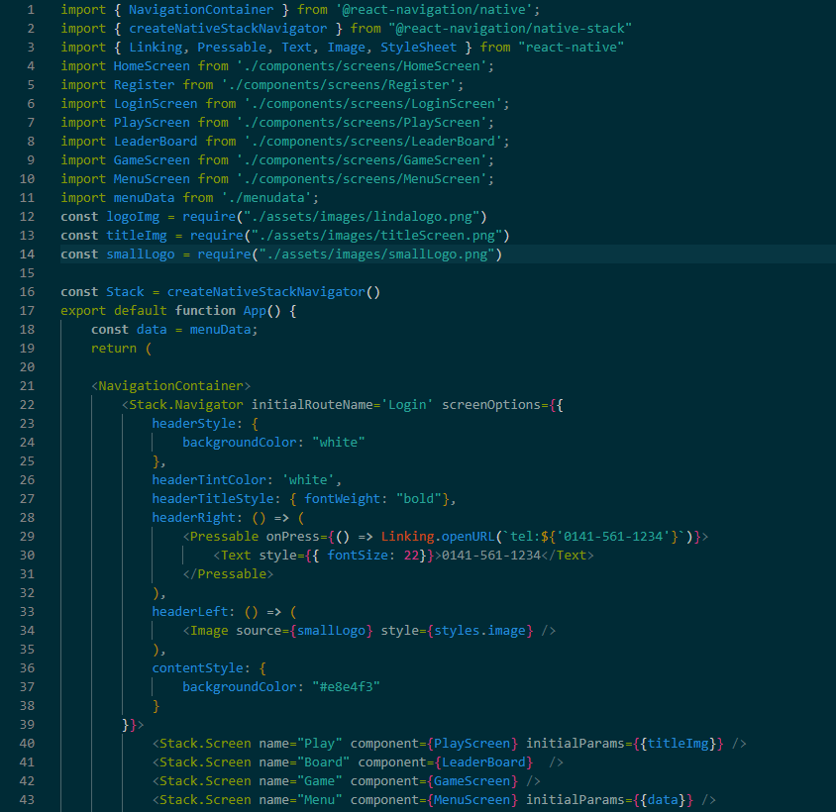
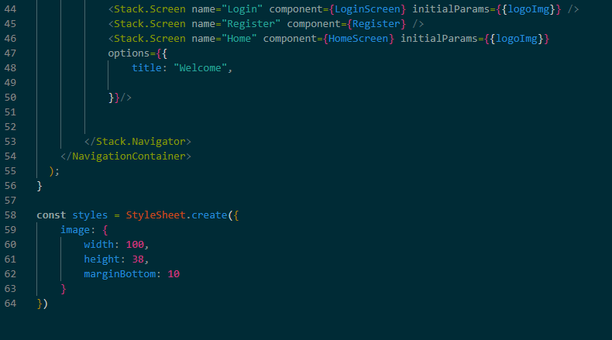
Component Files - Screens
Back.js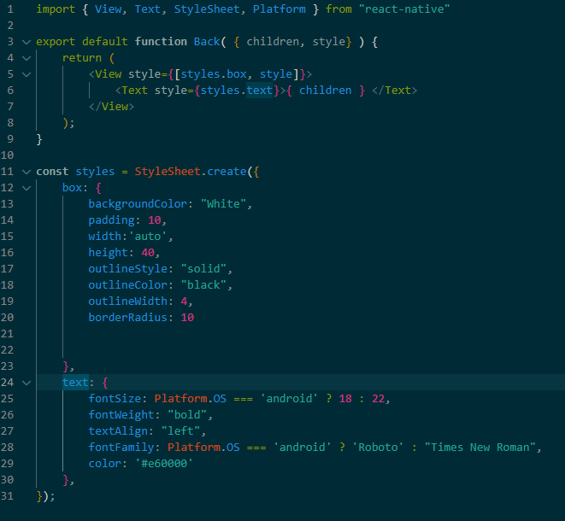
Box.js
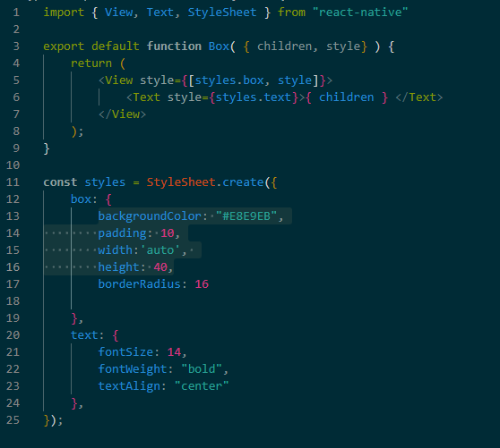
GameScreen.js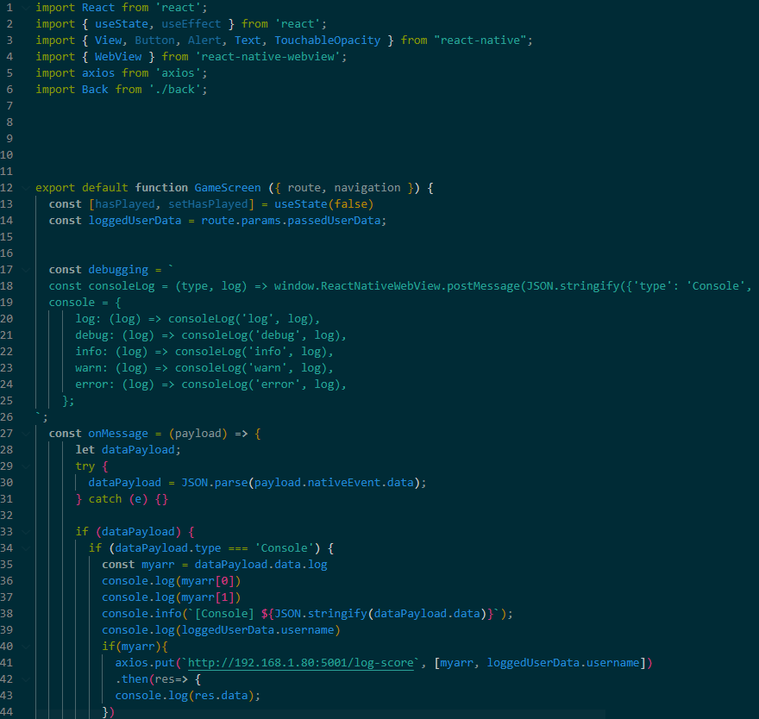
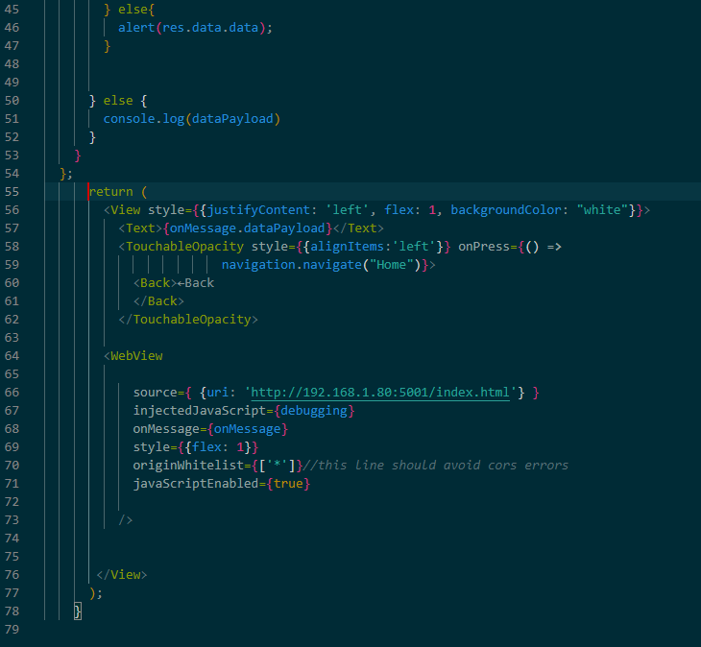
HomeScreen.js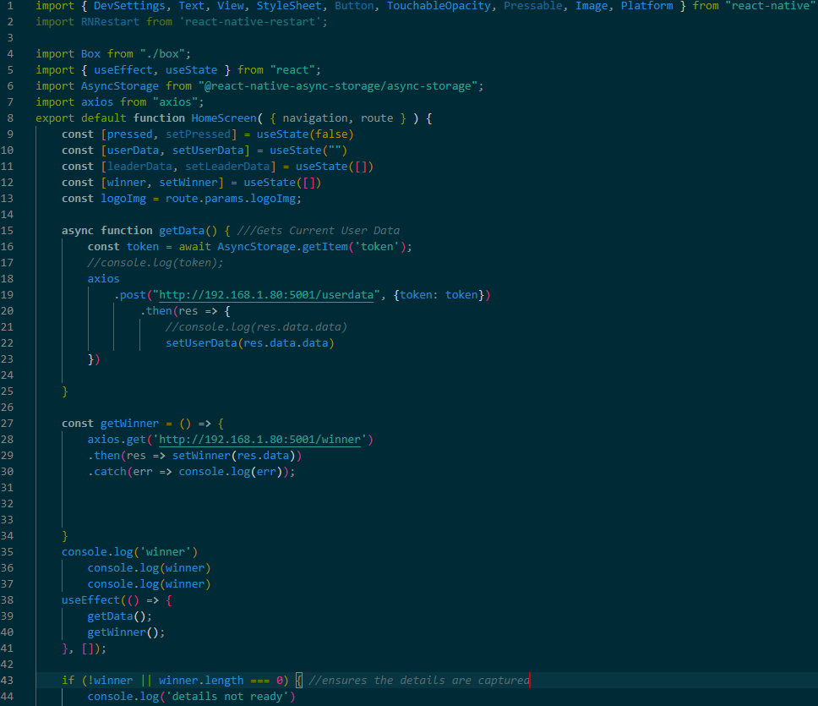
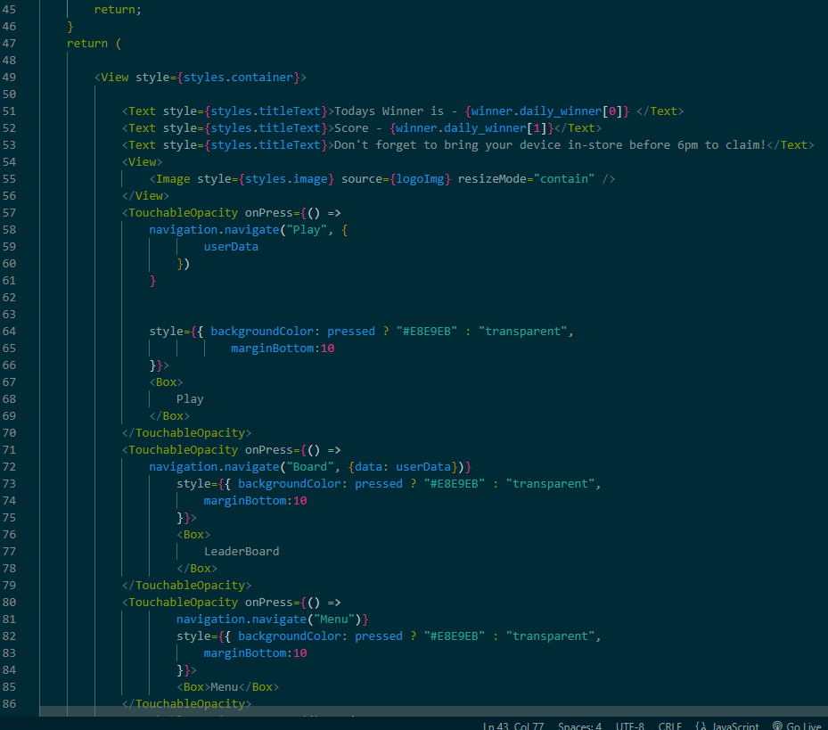

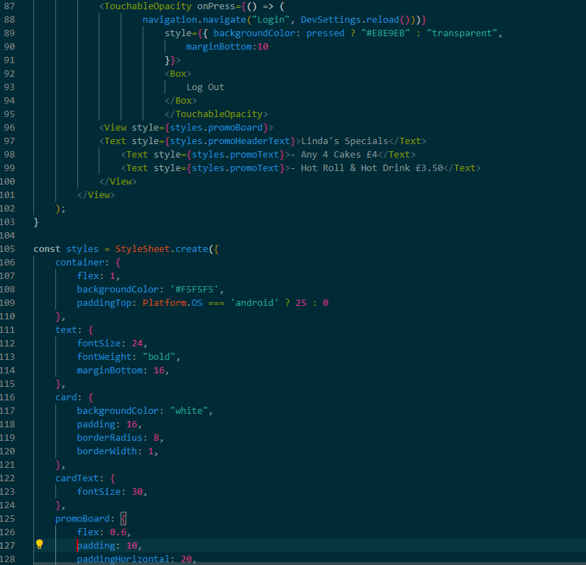
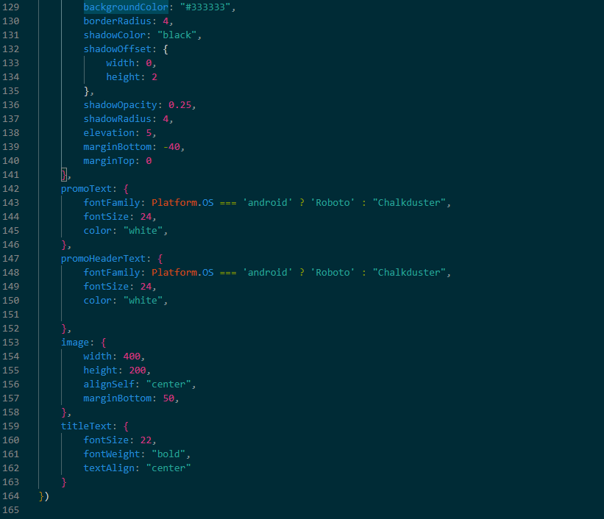
LeaderBoard.js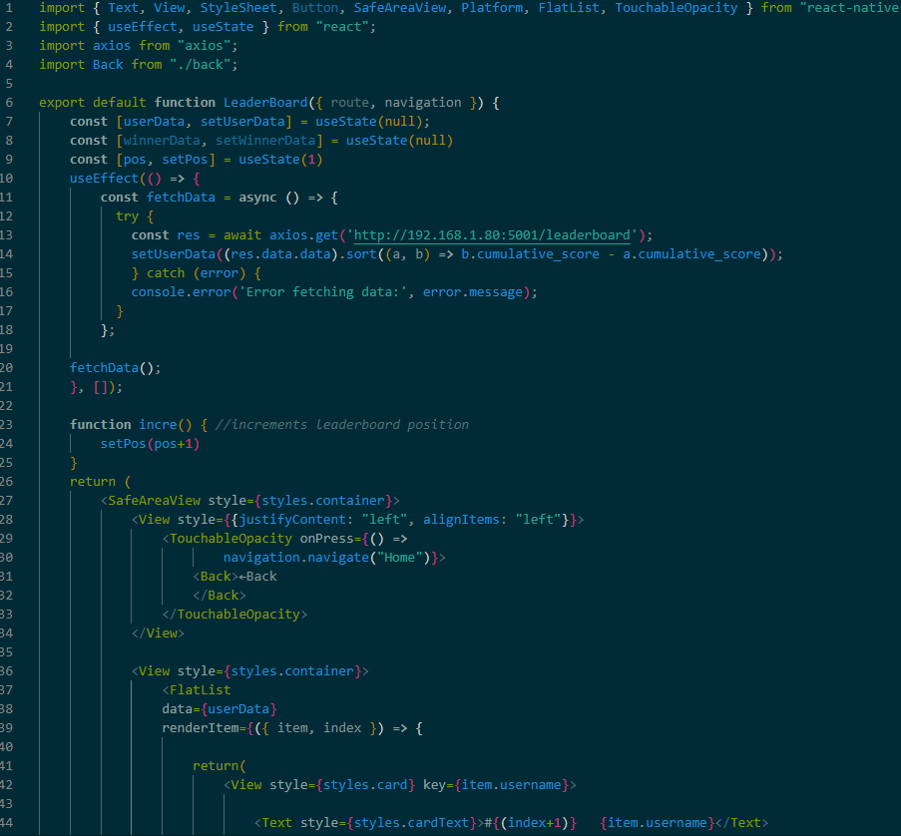
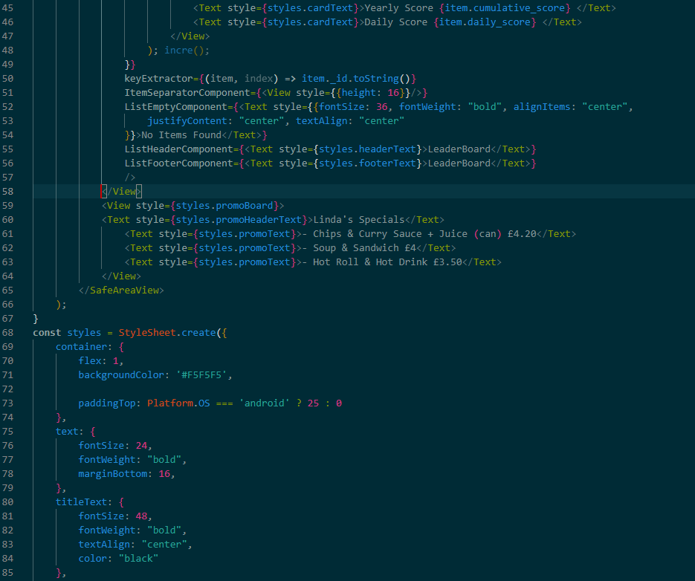
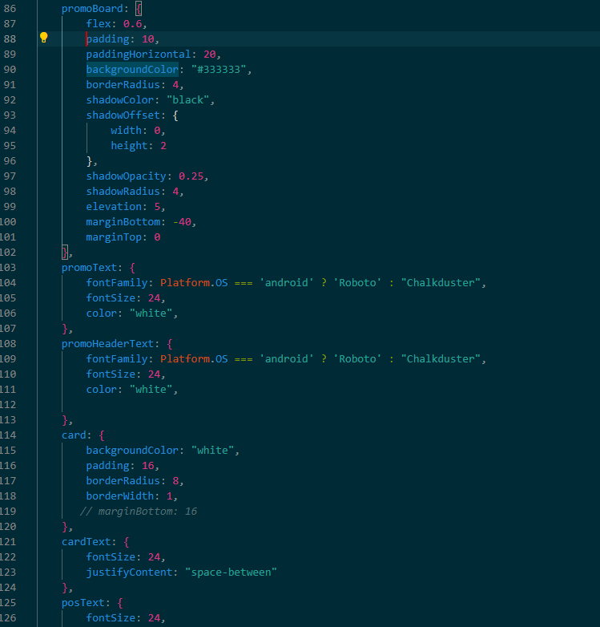


LoginScreen.js
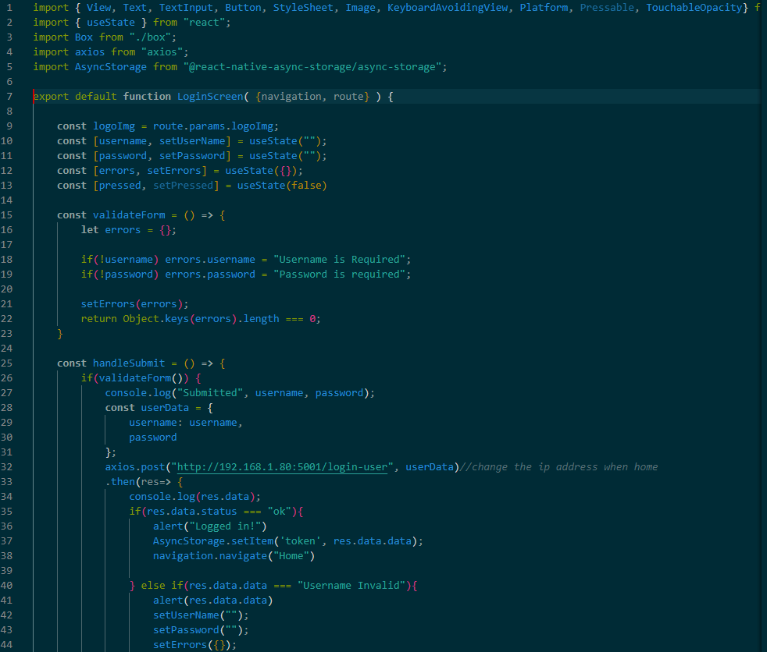
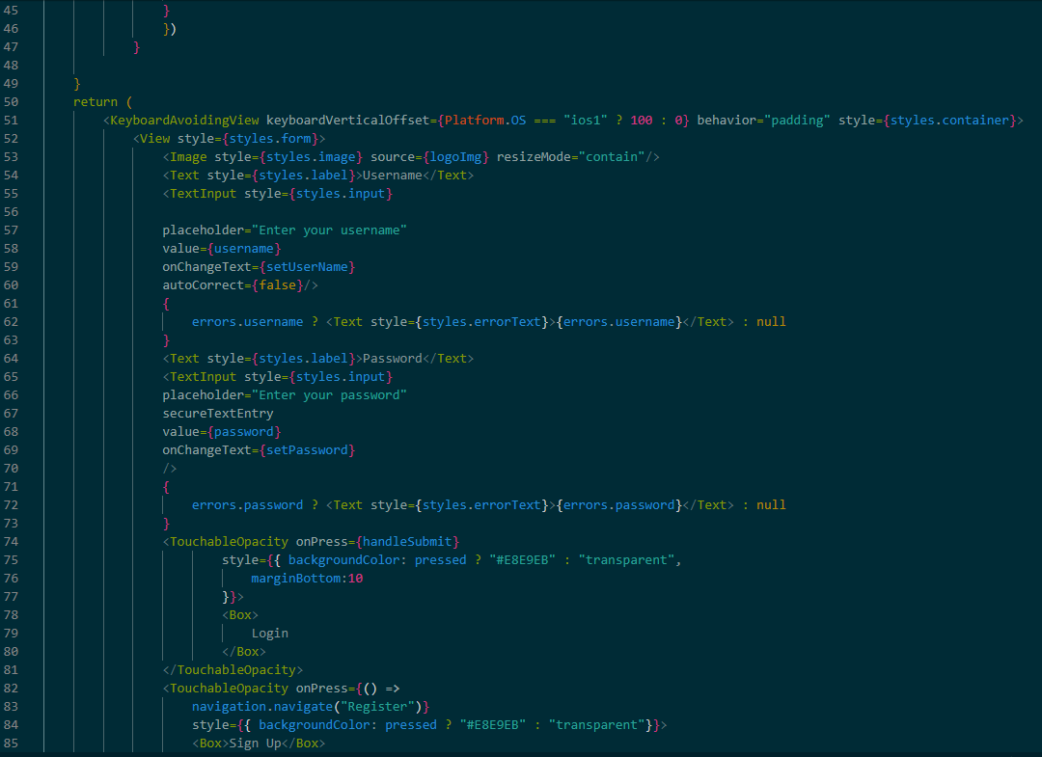
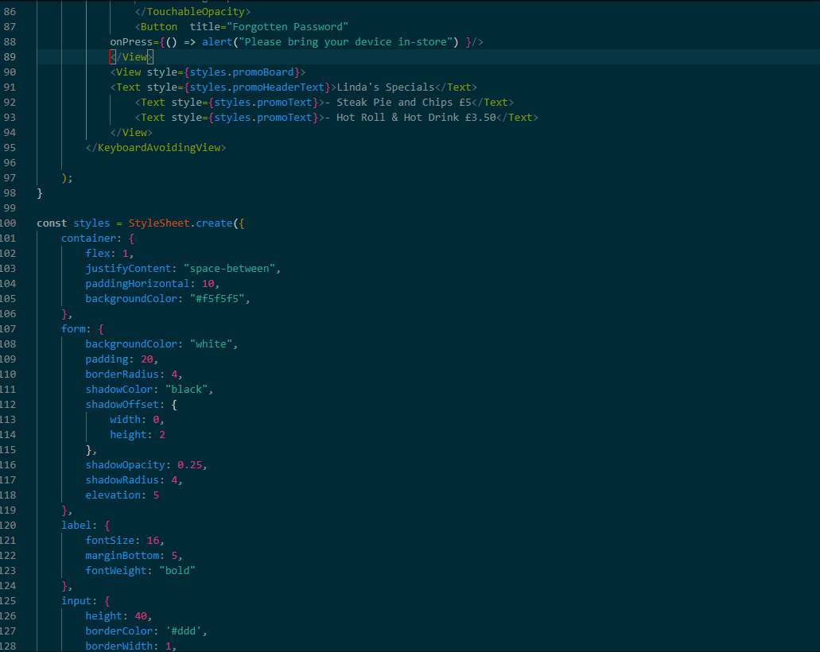
MenuScreen.js
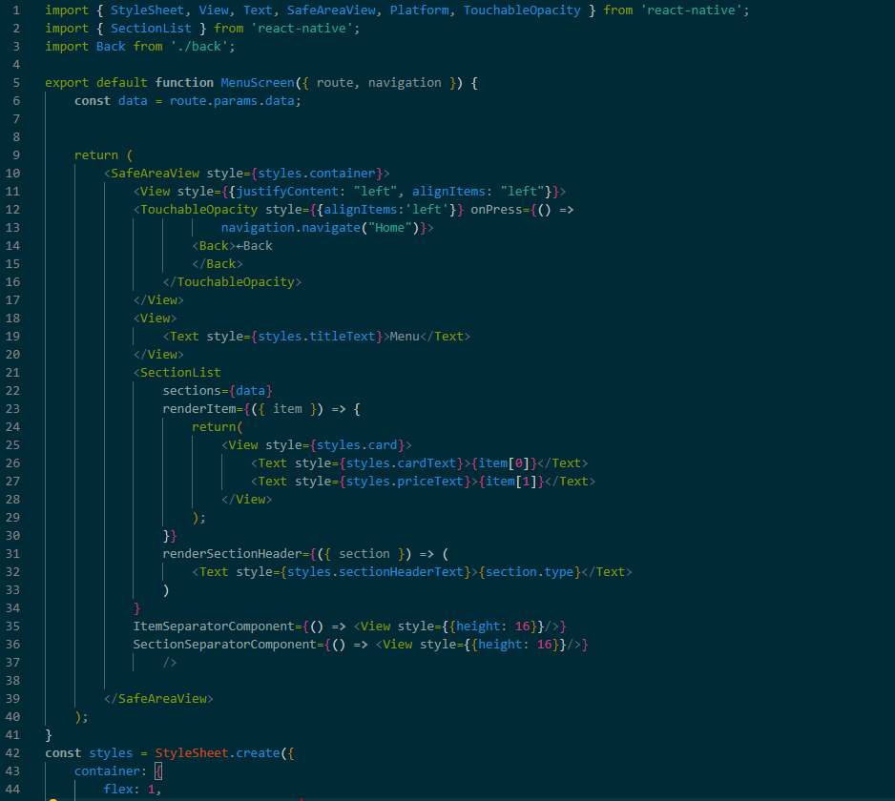
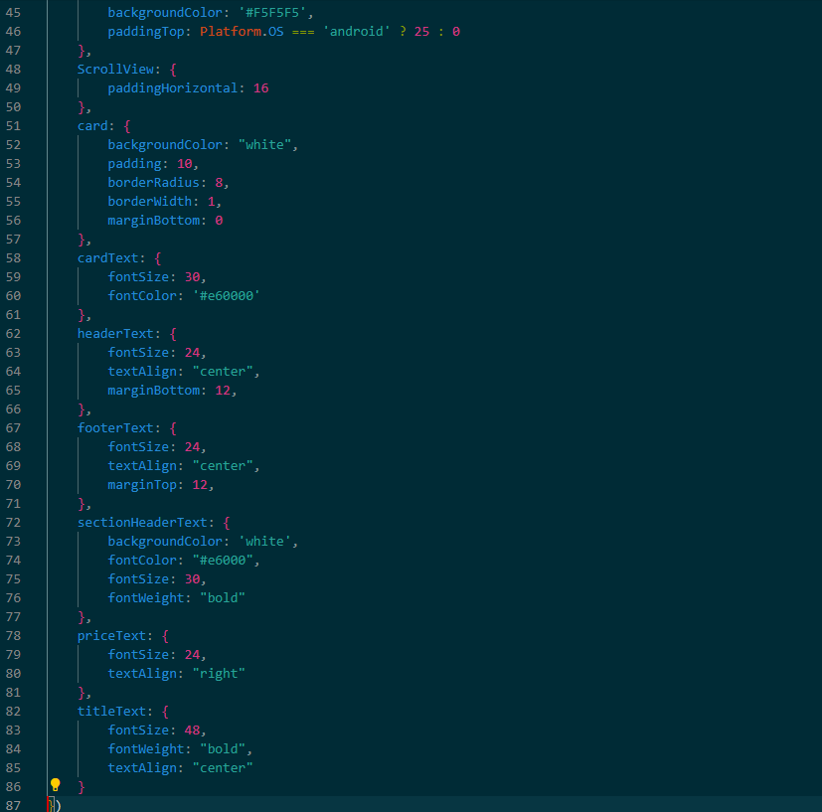

PlayScreen.js
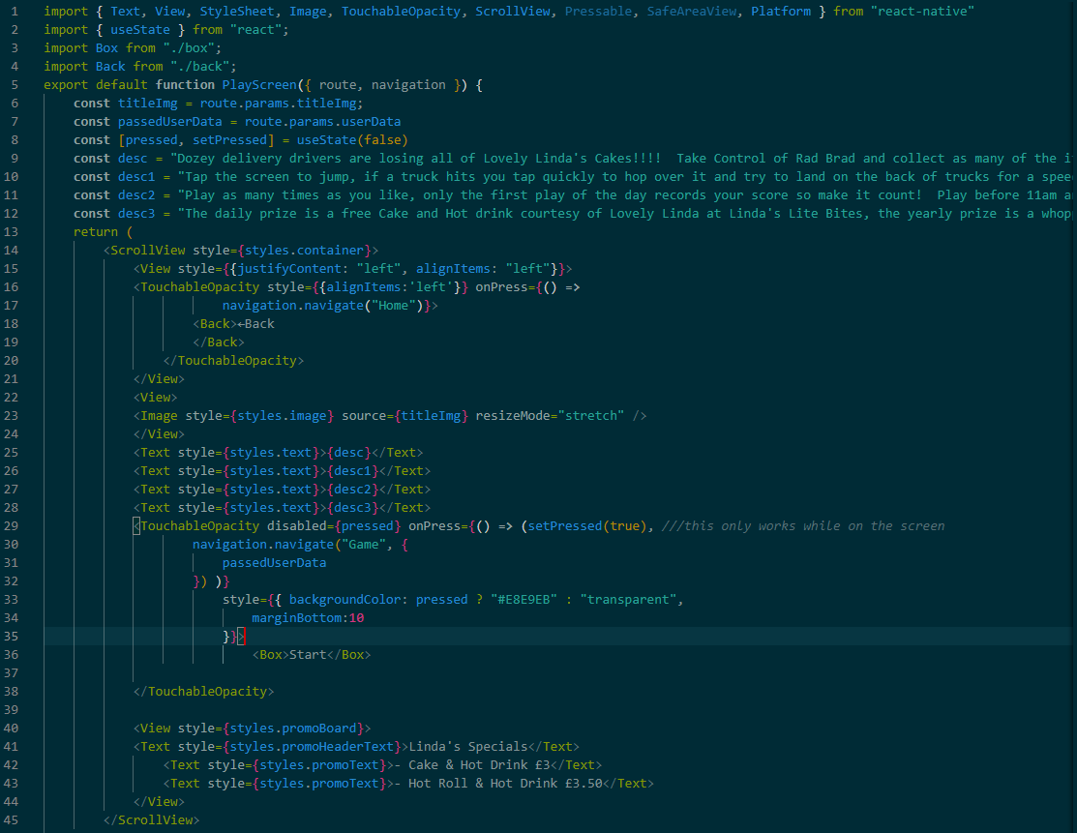
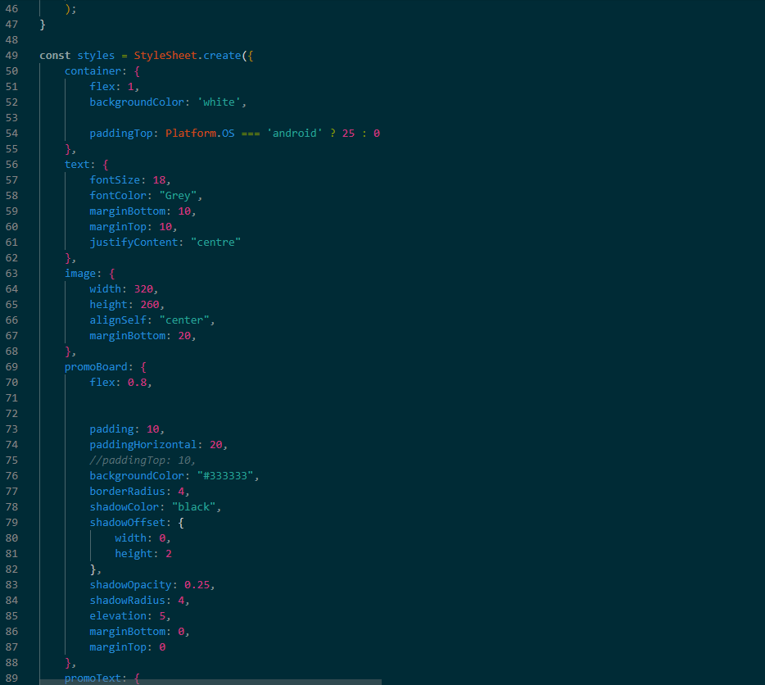
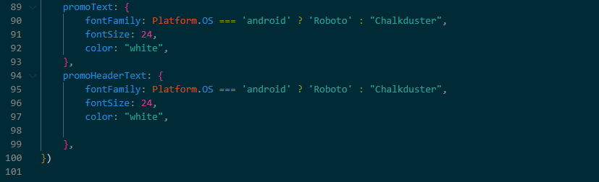

Register.js
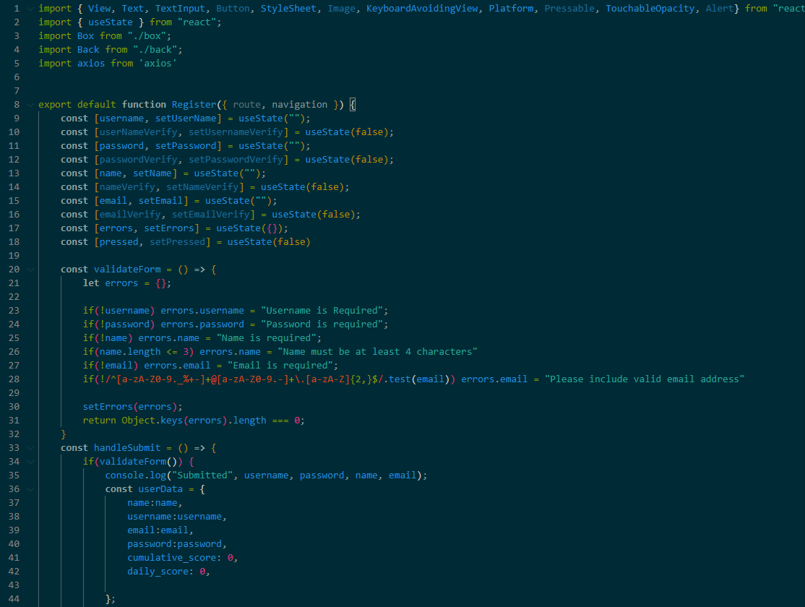
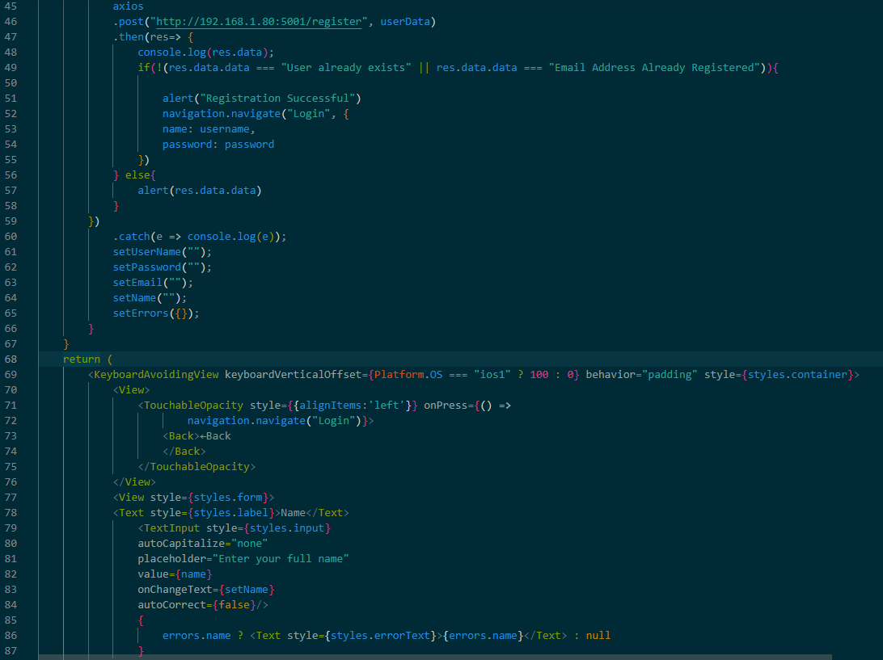
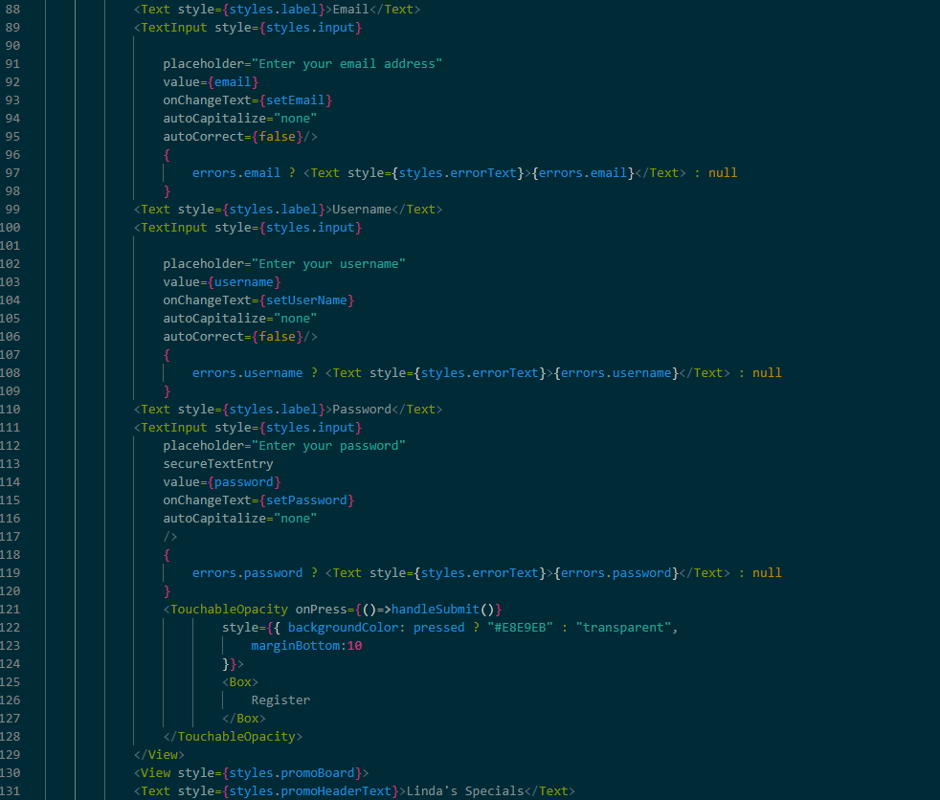
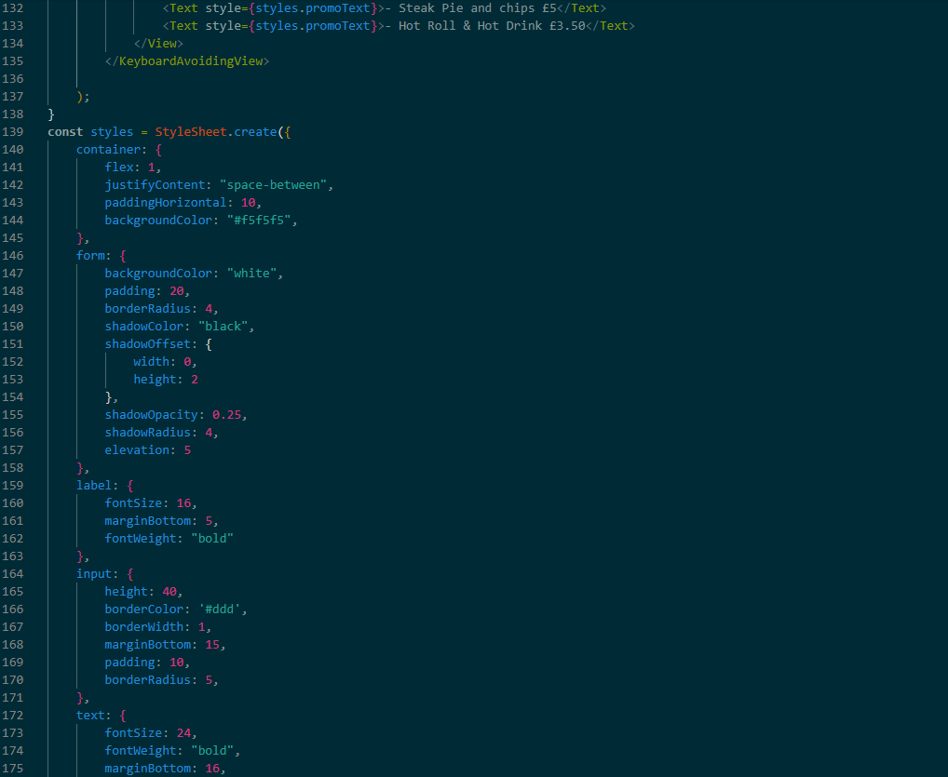
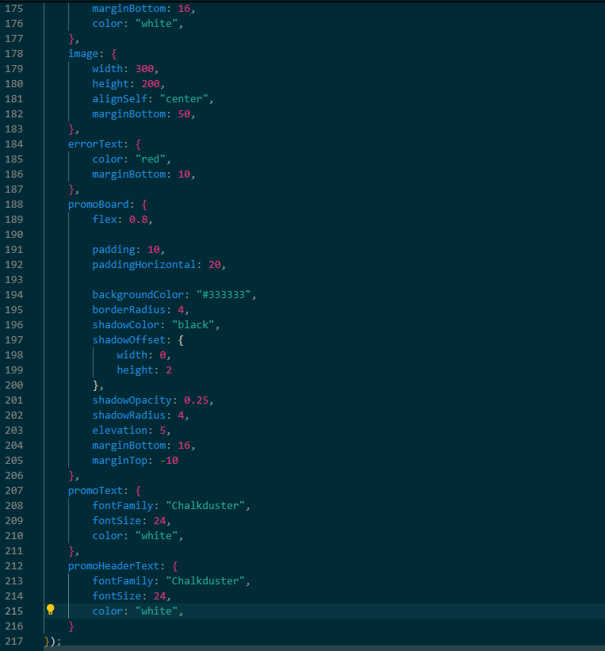

Appendix M – Database Code
App.js (main file)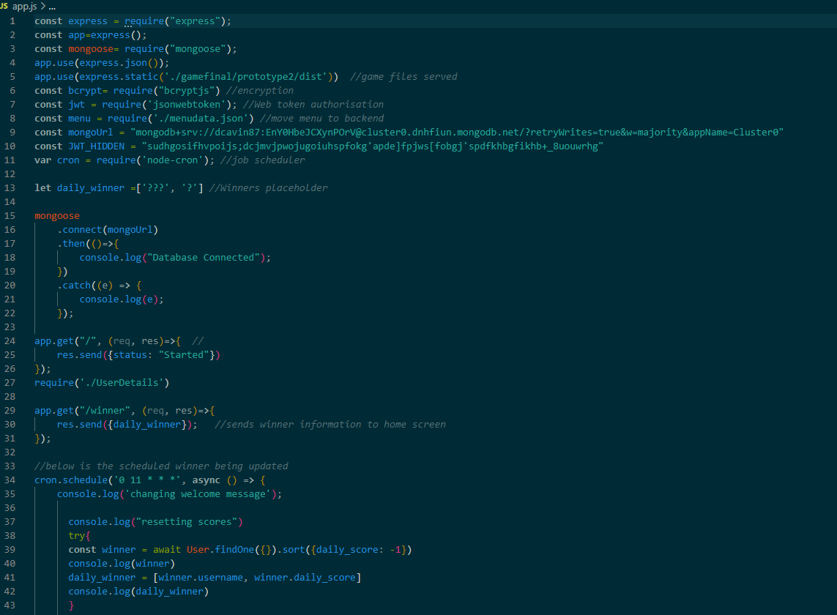
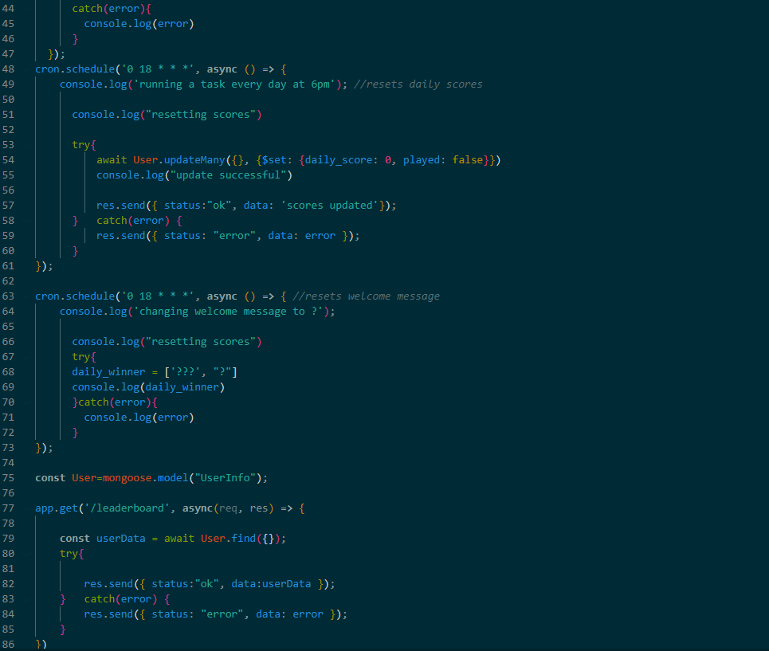
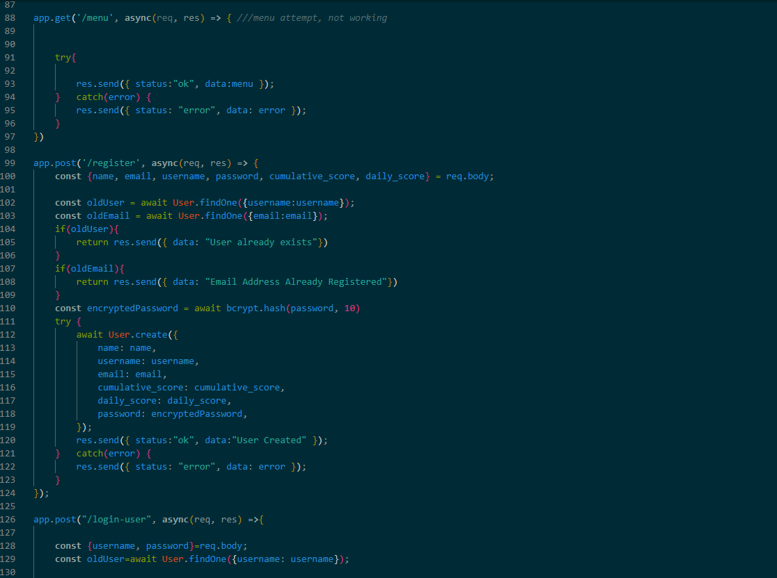
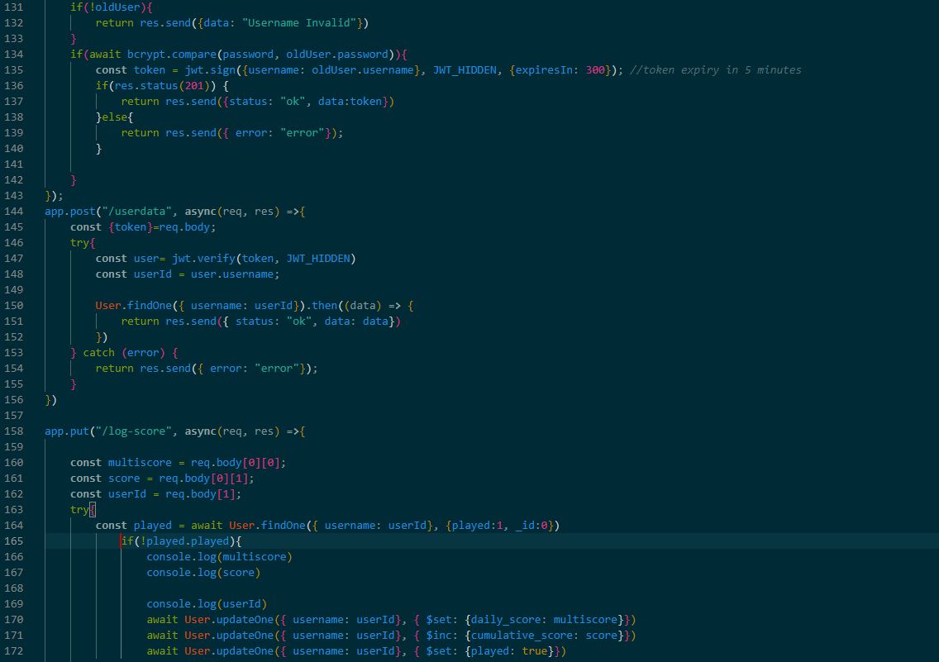
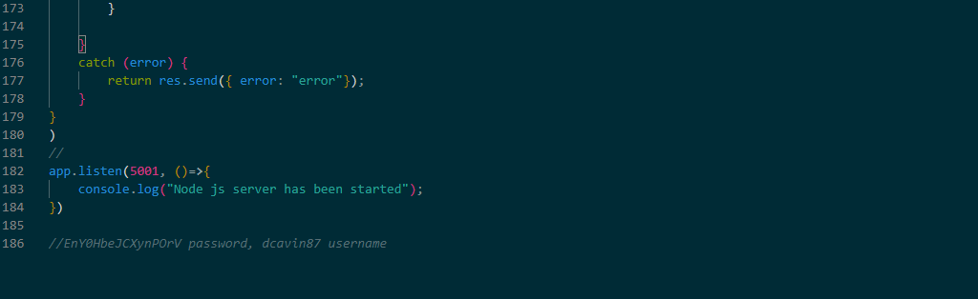
UserDetails.js (data model definition)
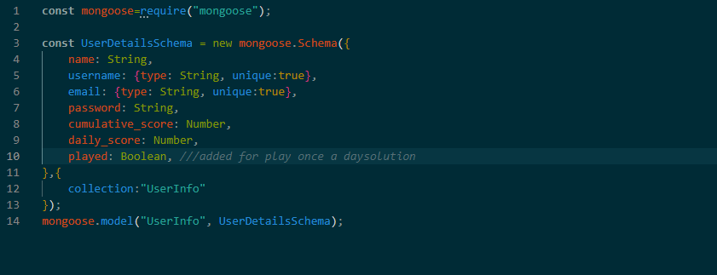

Appendix N – Game Code
Index.js (main file)
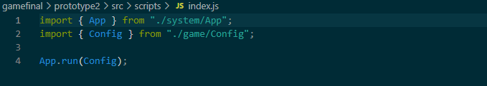
Config.js
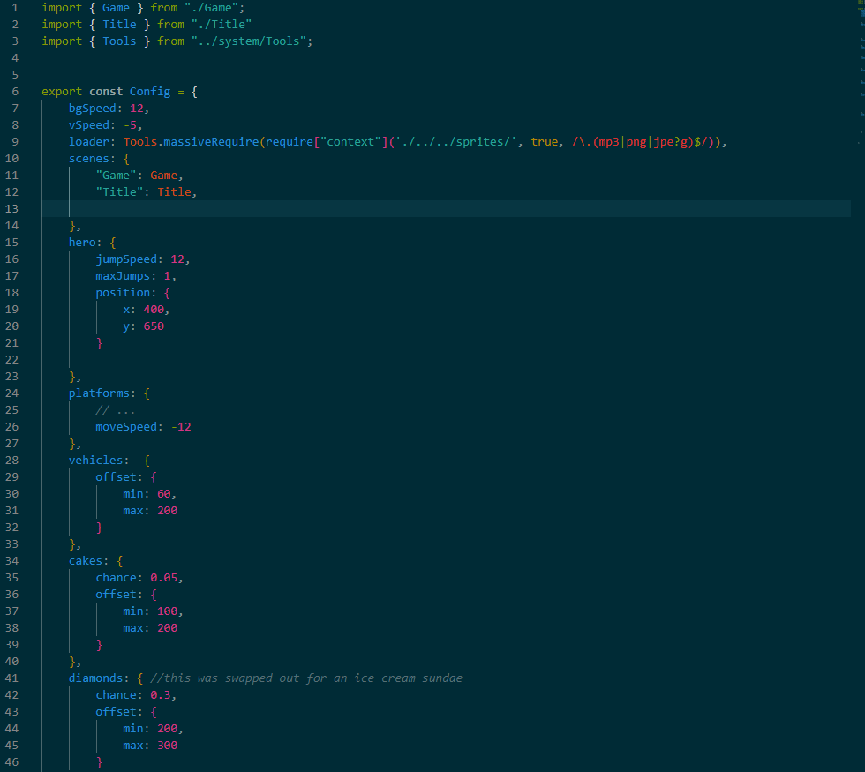
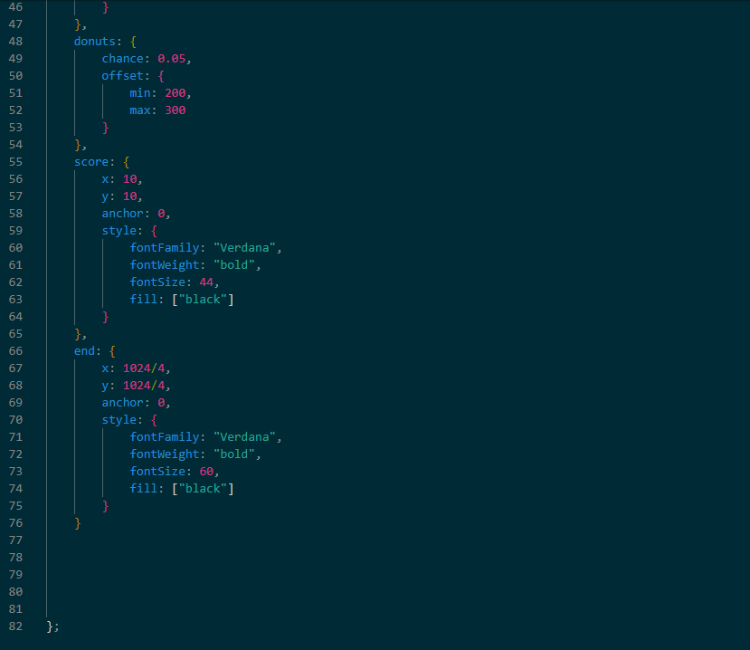
App.js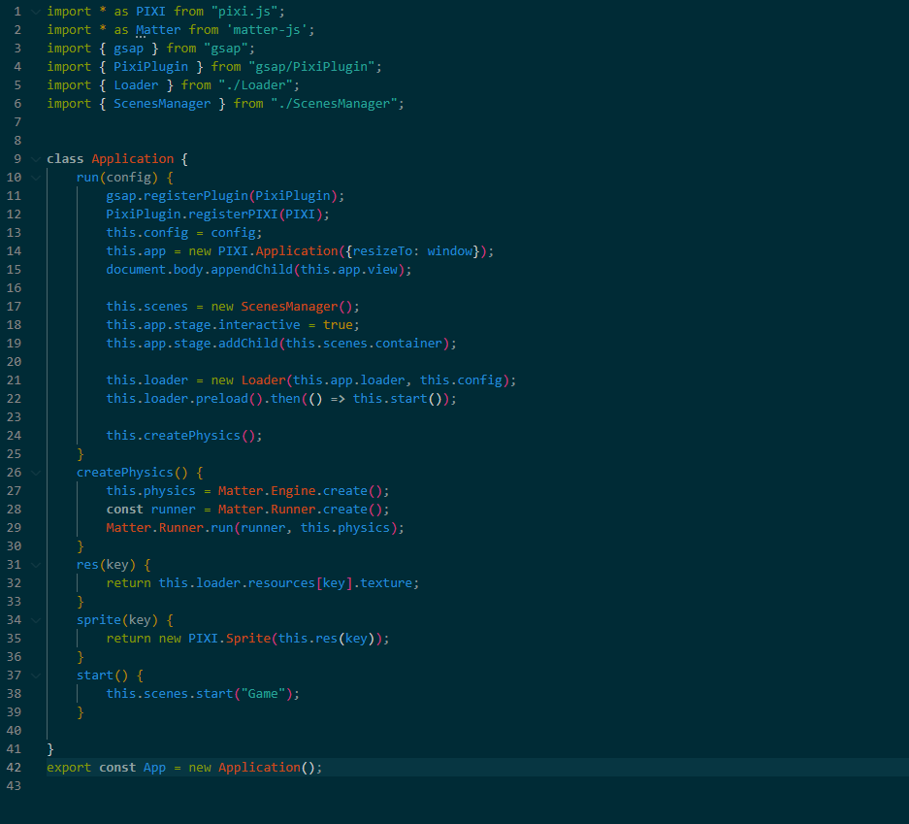

Background.js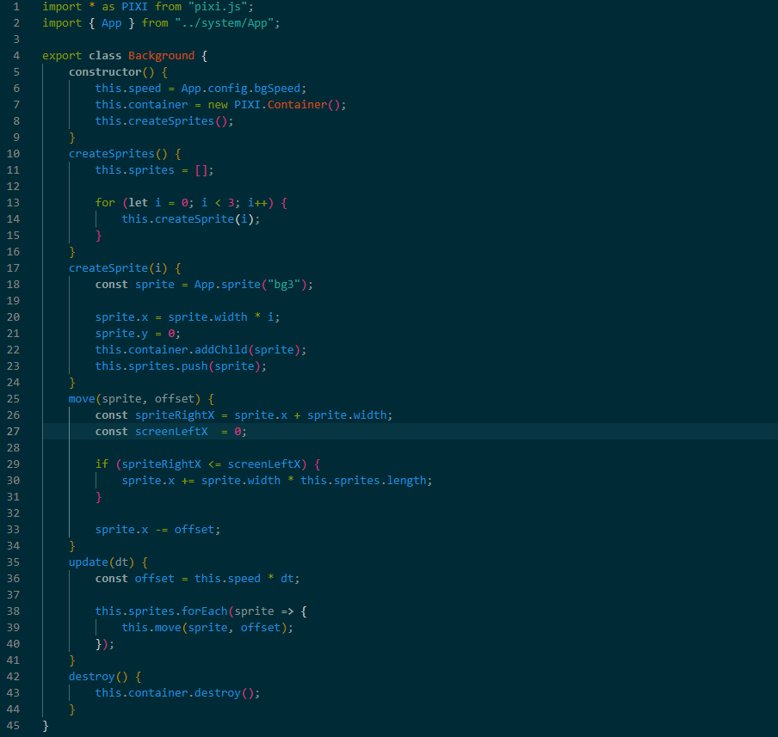
Hero.js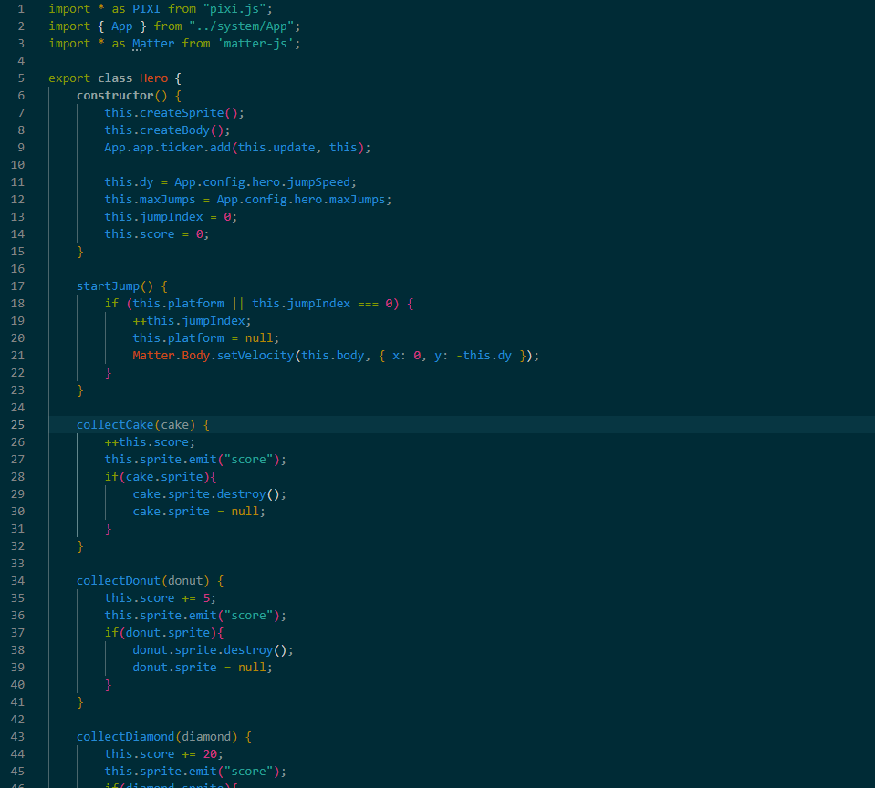
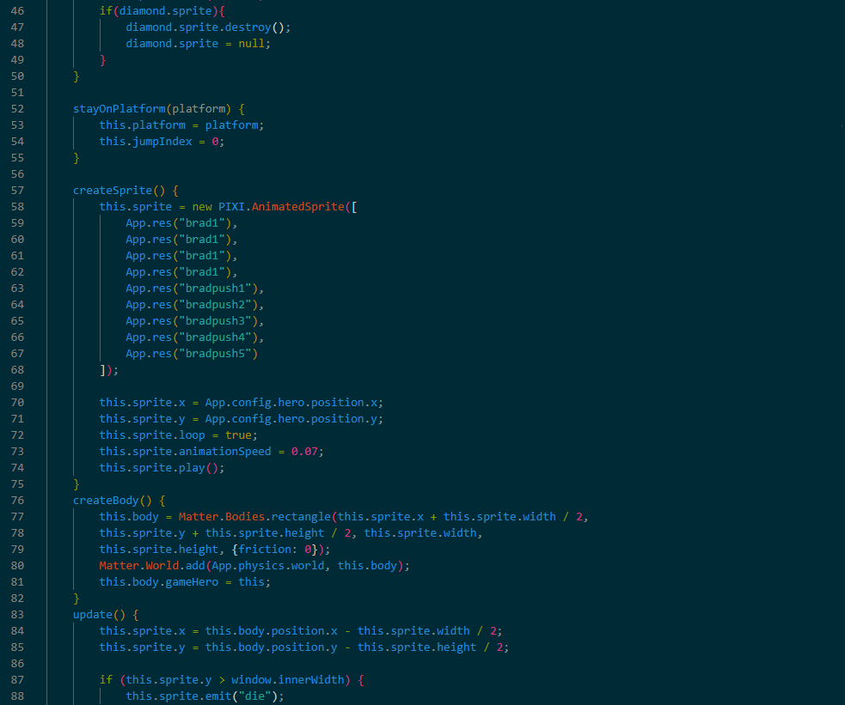
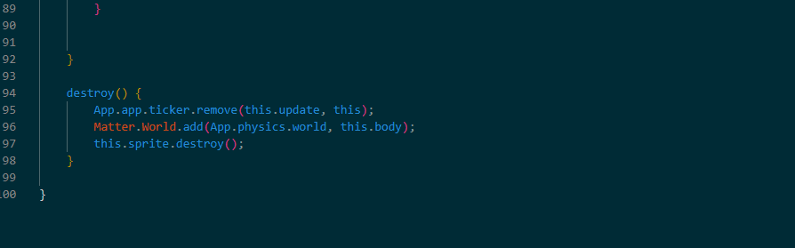
Game.js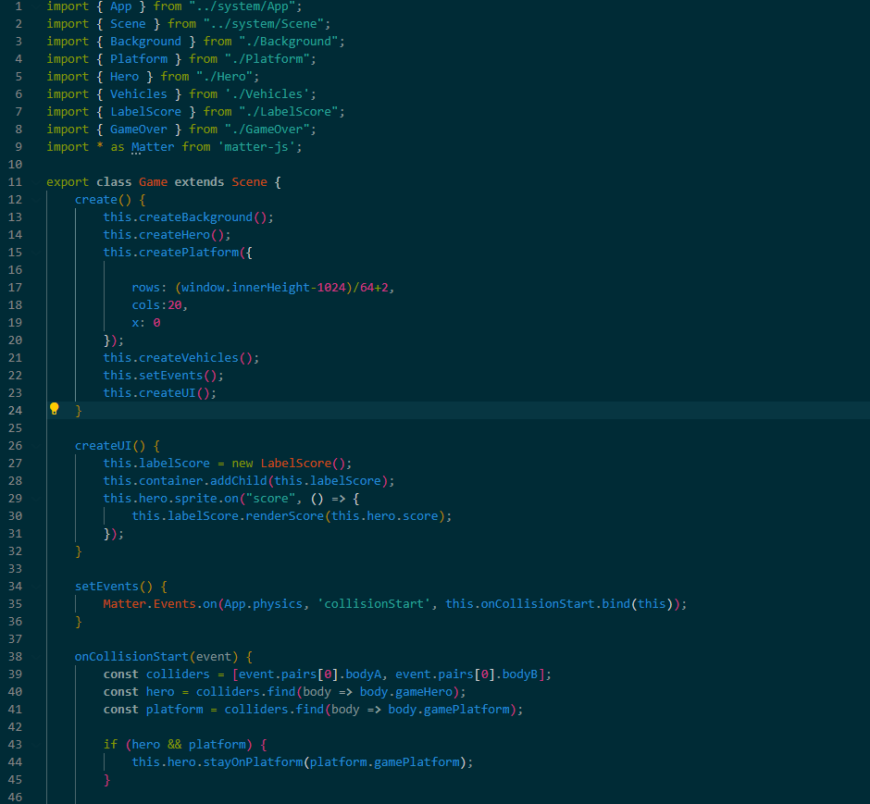
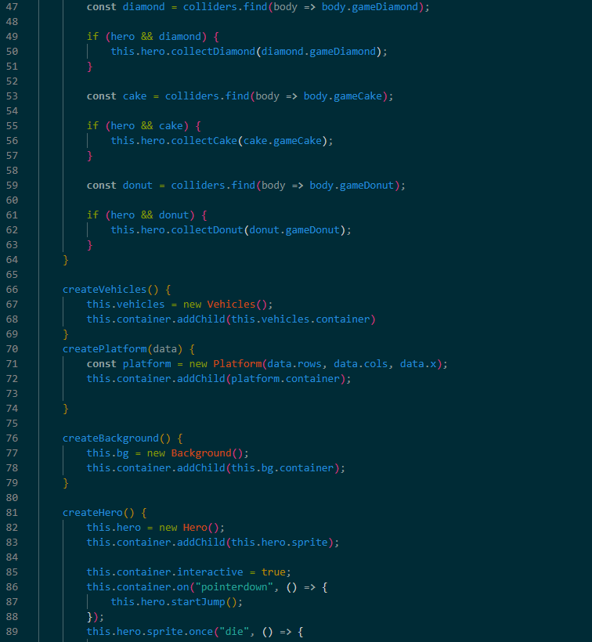
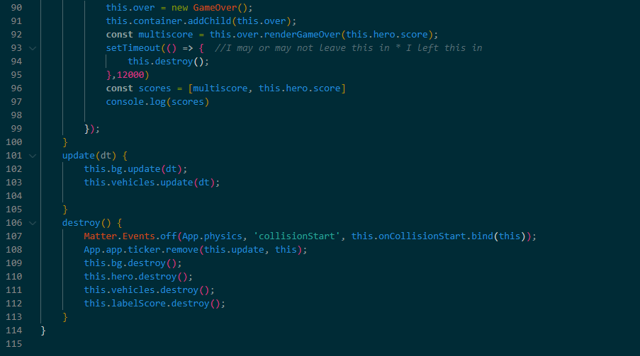
Scene.js
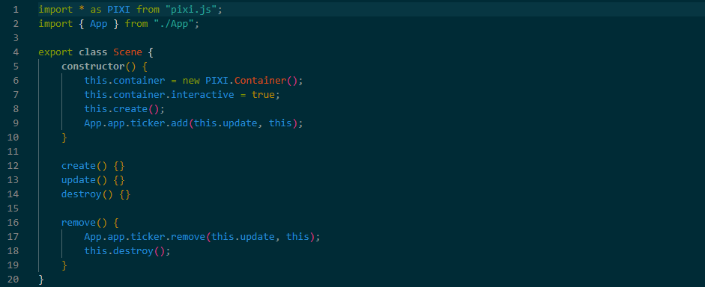

Cake.js
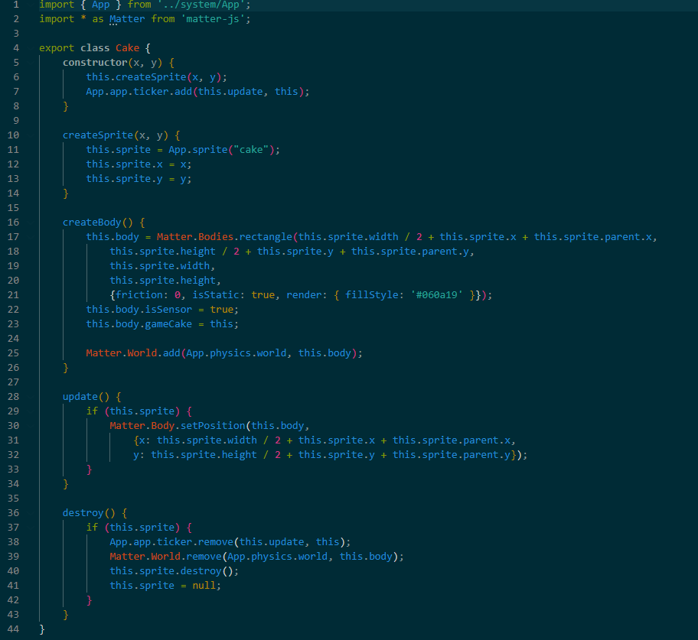
Diamond.js
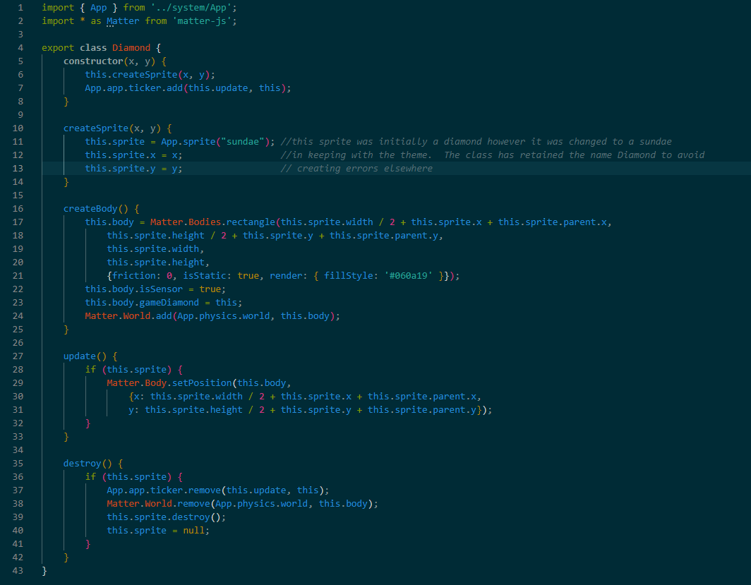
Donut.js 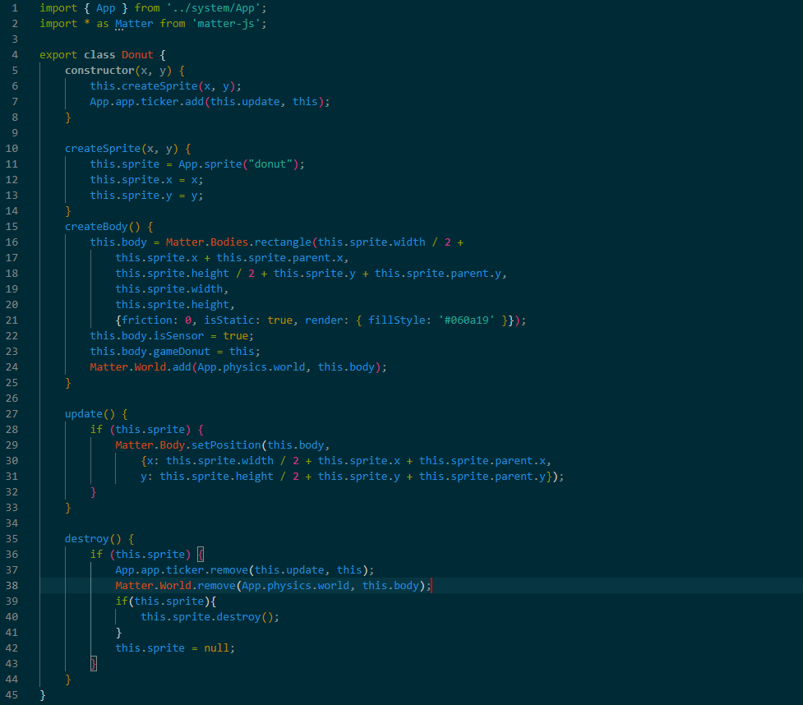GameOver.js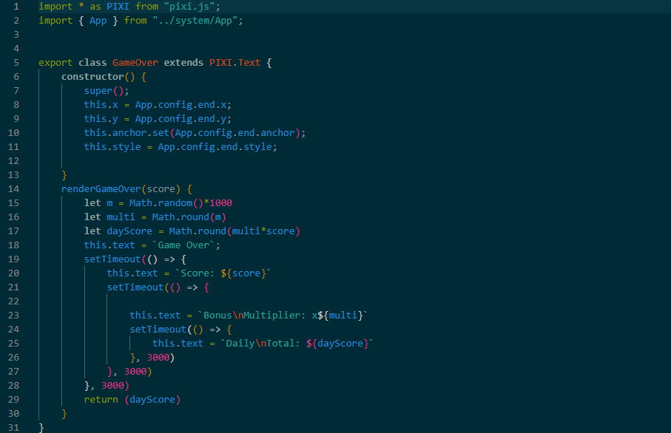
LabelScore.js
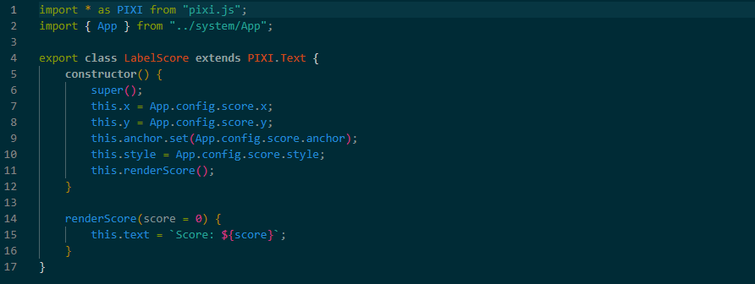
Platform.js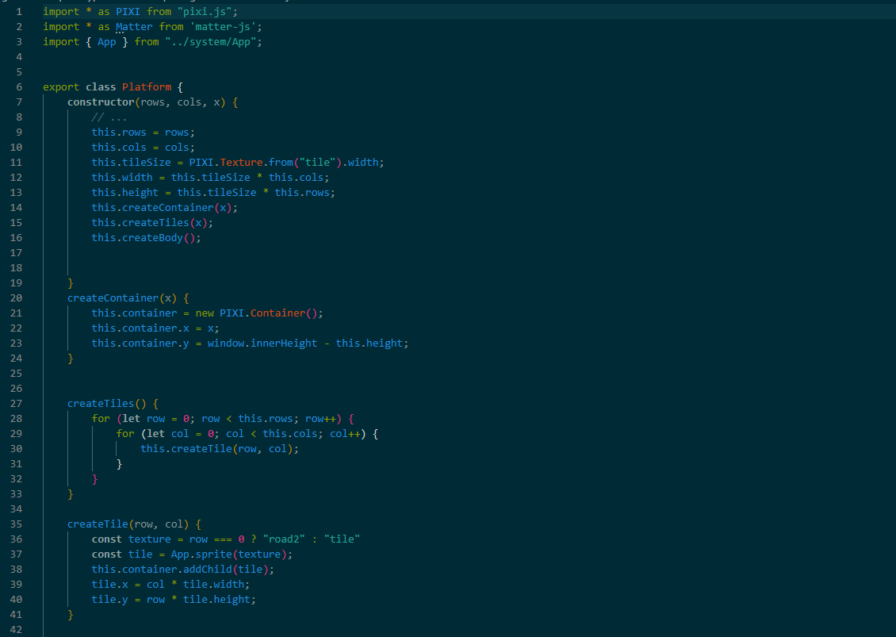
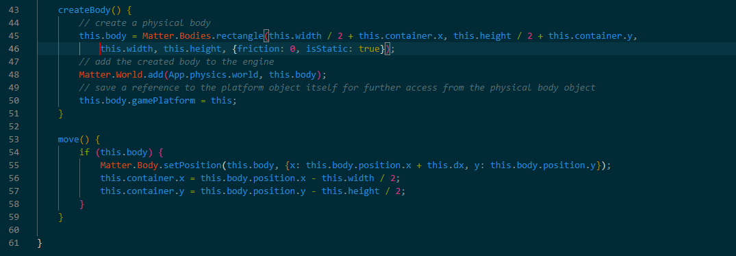
Vehicle.js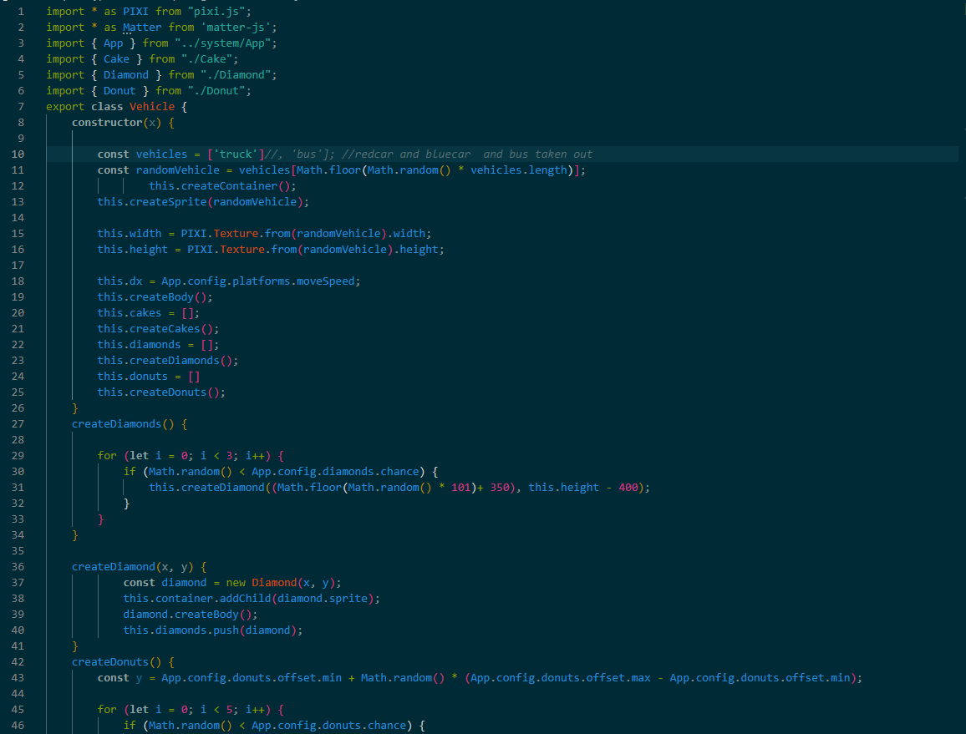
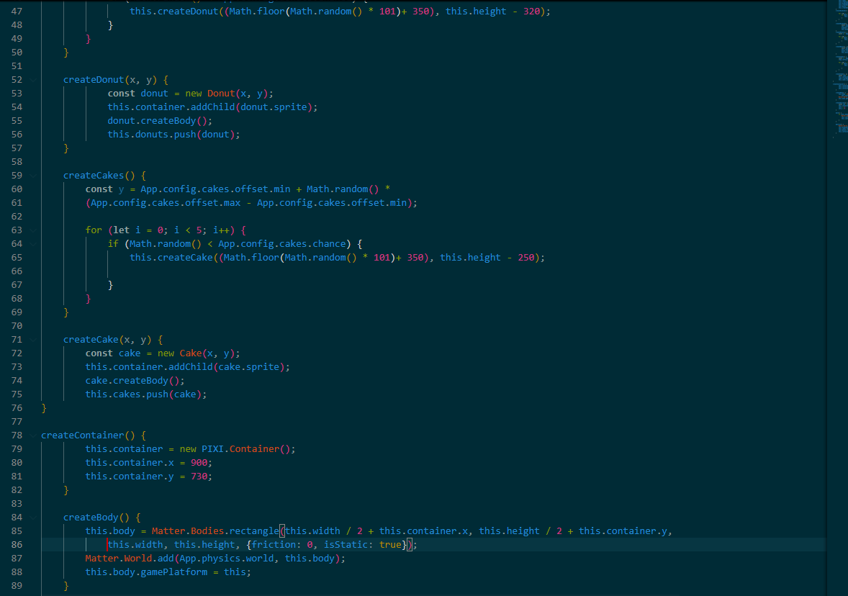
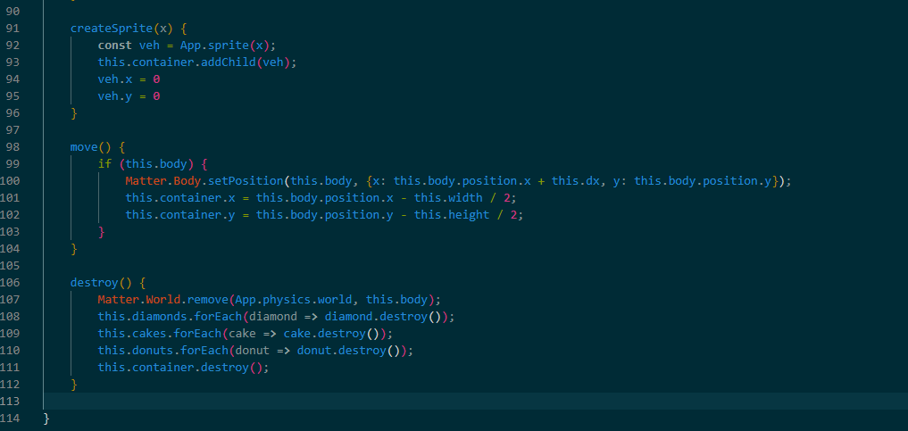
Vehicles.js
